

数据库课程设计报告

——物业管理系统

姓名：庄恩瑜

学院：计算机科学与技术

专业：计算机科学与技术

班级：2017级2班

任课教师：梁文革

实验教师：梁文革

目录

1. 系统开发平台
2. 数据库规划

2.1任务陈述

2.2任务目标

1. 系统定义

3.1系统边界

3.2用户视图

1. 需求分析

4.1用户需求说明

4.1.1数据需求

4.1.2事务需求

4.2系统需求说明

1. 数据库逻辑设计

5.1E-R图

5.2数据字典

1. 数据库物理设计

6.1索引

6.2视图

6.3安全机制

1. 应用程序设计

7.1功能模块

7.2界面设计

7.3事务设计

1. 测试和运行
2. 总结

9.1系统优点

9.2系统不足

9.3系统改进

9.4经验与收获

附：参考文献

前言

近年来，随着国民生活水平的提高、生活质量的提高，整个全球现代科学的高速发展，我们已经步入信息化、数字化的时代，web办公、“互联网+”已经成为时代的主流。与此同时，我国房地产企业逐步走向成熟，物业管理也由萌芽到发展再到深入，开始趋于蓬勃发展的局面。我国物业管理中引入了新型的物业管理体系，对原有的老旧的物业管理模式进行了一次深刻的变革，对物业管理公司朝着正规化科学化的发展起到了有力的推动作用。

随着我国经济的发展和城市化的逐步深入，住宅小区已经越来越成为人们生活居住的主流。小区的物业管理系统是针对目前这一居住形式的市场应运而生的。本物业管理系统是为物业管理部门所需而设计的网页式数据库管理系统，它能够将小区物业管理部门的日常管理登记工作信息化，管理系统主体以物业管理部门为中心，以业主为服务对象，实施各种服务项目，较为全面地反映了小区物业管理单位与物业职工、业主之间的各种业务往来，使得各项业务的办理流程大大缩短，提高业务办理的准确率，也提高了小区物业管理的工作效率。

物业管理日常工作涉及的管理范围较宽，管理内容冗杂。若使用非信息化的管理登记流程（采用传统的纸质登记），一是数据不便于保管和调用（毕竟登记簿可能会弄丢并且查询时十分不便）；二是在登记时需要等待的时间太长，物业管理的办事效率不高；三是涉及到费用明细登记时容易出错，不够精确。有时还会因为其他变动因素，日常工作需要消耗大量的人力物力。而采取现代化电脑管理可以有效解决上述非信息化管理流程所带来的一系列问题：

1. 适用面广，可同时管理多栋大楼
2. 计算机完整的工程档案与服务档案可以使物业管理人员随时了解最新情况，可以更有效地规范维护、服务标准
3. 计算机收费管理灵活又准确
4. 强大的查询功能，提高查询与生成费用明细表单的效率

本物业管理系统涵盖了物业管理的服务范围：

一、业主基本信息（身份证号、楼号、房号、姓名、工作单位、联系电话、建筑面积）；

二、生成业主的综合信息表（所有业主有费用综合信息表、单个业主信息表）；三、记录月水电煤气抄表数据并打印业主交费通知单，包括水电煤气有线电视费 通知单、供暖费通知单、物业管理费通知单

四、记录业主交费情况并打印交费单，包括水电煤气费、供暖费、物业管理费、分期付款；

五、统计业主信息月、季和年报表，包括：物业实收费用汇总表、物业应收未收汇总表、应交未交费用业主信息表、月度房款还款名细表、单用户年度应收代款还款表。

一、系统开发平台

1.1开发平台简介

本物业管理系统采用C-S架构，使用C#的技术路线，遵守MVC Model模型。

Model模型层使用数据库作为持久性储存结构，选用的后台数据库MySQL5.7。这是业界领先的开源数据库，在开源产品中具有比较高的市场占有率。本数据库开放源代码，具有免费使用，比较稳定的特点，适合于小型系统的持久性存储。

View视图层使用C#语言在Visual Studio2017上实现。这基于C#可以在含有.net的Microsoft旗下的Visual Studio中使用，同时在Visual Studio的开发环境下可以用C#来绘制出窗体应用界面的这一功能特性实现的。物业管理系统中严格控制界面代码中的业务逻辑部分，实现了很好的业务和表现分离。

1.2开发语言：C#

C#是微软公司发布的一种面向对象的、运行于.NET Framework之上的高级程序设计语言。C#包括了诸如单一继承、接口、与Java几乎同样的语法和编译成中间代码再运行的过程，它借鉴了Delphi的一个特点，与COM（组件对象模型）是直接集成的，而且它是微软公司 .NET windows网络框架的主角。

C#是一种安全的、稳定的、简单的、优雅的，由C和C++衍生出来的面向对象的编程语言。它在继承C和C++强大功能的同时去掉了一些它们的复杂特性（例如没有宏以及不允许多重继承）。C#综合了VB简单的可视化操作和C++的高运行效率，以其强大的操作能力、优雅的语法风格、创新的语言特性和便捷的面向组件编程的支持成为.NET开发的首选语言。

C#是面向对象的编程语言。它使得程序员可以快速地编写各种基于MICROSOFT .NET平台的应用程序，MICROSOFT .NET提供了一系列的工具和服务来最大程度地开发利用计算与通讯领域。——摘自“百度百科”

1.3开发工具：Visual Studio2017

1.4数据库：MySQL5.7

1.5操作系统：Microsoft Windows 10

二、数据库规划

2.1任务陈述

物业管理系统是一个小区不可缺少的部分，它的内容对于业主住户和物业管理人员来说都十分重要。随着我国经济的逐步发展，人民生活水平的提高、城市化的深入，越来越多的人涌入到城市中；同时，我国房地产企业也在深入发展，不断成熟，也吸引了许多到城市打拼的人来入住各式各样的小区中。业主增多，有关业主的各种信息量也成倍增长。面对庞大的信息量需要有物业管理系统来提高物业管理工作的效率。一个完善的物业管理系统能够极大地提高业主信息管理的效率，具有检索迅速、查找方便、可靠性高、存储量大、更新快、寿命长、成本低等优点。

本物业管理系统包括基本设置、业主信息管理、房屋信息管理、抄表管理、缴费管理、清洁管理、报修管理、车位管理这几大模块并及时记录各个环节信息的变更，以便管理、查询、显示、输出。本系统考虑到对业主信息的保密性以及防止有篡改抄表数据而漏交相关费用的行为，所以本系统只有管理员模式一种。管理员可以拥有完全的权限管理系统，可以完成对业主信息、清洁信息、缴费信息、报修信息以及车位信息的查询、修改、增加、删除。

2.2任务目标

|  |  |  |
| --- | --- | --- |
| 模块 | 功能名称 | 具体描述 |
| 基本设置 | 用户登录 | 物业管理组成员在登陆后拥有对数据库进行操作的所有权限 |
| 小区基本信息管理 | 查看小区的基本信息 | 既可以出现在管理员视图又可以出现在业主视图中，方便小区内部管理人员和业主查看小区的基本信息，加强小区与业主之间的联系 |
| 业主信息管理 | 登记业主信息 | 登记业主基本信息，并且可以实现对这些信息最基本的增删改查。包括：业主ID；姓名；身份证号；楼号；房号；工作单位；联系电话 |
| 楼宇信息管理 | 登记小区所拥有的楼宇 | 方便物业管理人员更清晰地了解小区现已拥有的楼宇的基本情况 |
| 房屋信息管理 | 登记业主房屋信息 | 登记业主的房屋信息，并且可以实现对这些信息最基本的增删改查。包括：房号；业主ID；楼号；建筑面积 |
| 缴费管理 |  |  |
|  | 一年12月各位业主的应收费用明细（其中月份以及其他随月份不同而数值不同的内容可以更改） | 记录本月各项目收费明细。包括：业主ID；业主姓名；楼号；房号；月份；本月水费；本月电费；本月有线电视费用；停车费；物业管理费；总计 |
| 清洁管理 | 清洁人员信息 | 清洁时段只能是上午和下午（晚上的话考虑到清洁人员也需要休息并且晚上打扫卫生会影响业主的休息），一共是6个楼梯口，一人负责一个楼梯口一个时段，共需要12名清洁人员。该项功能包括：保洁员id；保洁员姓名；负责楼号；工作时段；工资；联系方式 |
| 报修管理 | 报修登记 | 业主平时在居住的过程中或多或少会遇上漏水跳闸等需要反映给物业进行报修的情况。物业管理者要及时记录（添加），修好后就把记录及时删除。包括：业主id；姓名；楼梯口标号；房号；联系电话；报修项目；报修日期；维修人员 |
| 车位管理 | 车位实况 | 物业管理人员及时记录车位情况，业主承包的车位中，电动车停车位收费10元；小轿车收费20元，这些都算在物业管理费用的停车费一项中。临时车位没有满还可以让外来人员暂时停车并且收取相应的临时停车费用，否则不允许外来人员停车。不允许外来人员将车停在私用车位上。外借车位仅允许几个，方便管理。包括：车位号；车位类型；承租人ID（业主ID）；承租人姓名；承租人联系电话；费用 |
| 外来人员进出登记 | 登记日常外来人员进出小区的情况以及有关事宜 | 包括：外来人员姓名；身份证号；联系方式；进入时间；出去时间；入小区事由 |

三、系统定义

3.1系统边界

//什么是系统边界？看例子的时候我没看明白

3.2用户视图

**管理员（Administrator）用户视图**

1. 基本设置

管理人员登录，拥有操作本物业管理系统的所有权限

1. 业主信息管理

查询、修改、添加业主信息

1. 房屋信息管理

查询、修改、添加房屋信息

1. 抄表管理

查询、修改、添加抄表所得数据

1. 缴费管理

查询、修改、增加（生成报表）业主的各项收费通知情况

1. 清洁管理

查询清洁人员信息

1. 报修管理

添加、查询、修改、删除业主报修信息

1. 车位管理

查询、修改车位状态信息

1. 外来人员管理

添加、查询、修改外来人员的身份以及进出小区的相关事宜

1. 小区基本情况记录

查看小区的有关信息

四、需求分析

4.1用户需求说明

**4.1.1数据需求**

其中需求数据为：

1. 给系统用户（管理员与业主）设的账号和密码
2. 业主基本信息记录：

业主id；姓名；身份证号；联系电话；楼号；房号；工作单位；车辆类型；车牌号

1. 楼宇信息记录：

楼号；层数；建成时间

1. 房屋信息记录：

业主id；楼号；房号；建筑面积

1. 缴费信息记录：
2. 业主停车费用应交：业主ID；业主姓名；楼号；房号；月份；费用
3. 一年12月各位业主的应收费用明细：业主ID；业主姓名；楼号；房号；月份；本月水费；本月电费；本月有线电视费用；停车费；物业管理费；总计
4. 各季度各业主的应收费用明细：业主ID；业主姓名；楼号；房号；季度；季度消费总计
5. 本年度各业主的应收费用明细：业主ID；业主姓名；楼号；房号；季度；年度消费总计
6. 月度业主应交未交费用情况：业主ID；业主姓名；月份；本月需交费用；已缴费用；未缴费用；是否分期付款
7. 季度业主应交未交费用情况：业主ID；业主姓名；季度；本月需交费用；已缴费用；未缴费用；是否分期付款
8. 年度业主应交未交费用情况：业主ID；业主姓名；年度；本月需交费用；已缴费用；未缴费用；是否分期付款
9. 清洁人员信息记录：

清洁人员id；清洁人员姓名；负责楼号；工作时段；工资；联系方式

1. 报修登记：

业主姓名；楼梯口标号、房号、联系电话、报修项目、报修日期、维修人员

1. 车位管理登记：

车位编号；车位类型（电动车/小轿车）；承包人ID；承包人姓名；费用

10、外来人员进出登记

外来人员姓名；身份证号；联系方式；进入时间；出去时间；入小区事由

**4.1.2事务需求**

1. **数据录入**

业主基本信息记录：

业主id；姓名；身份证号；联系电话；楼号；房号；工作单位；车辆类型；车牌号

楼宇信息记录：

楼号；层数；建成时间

房屋信息记录：

业主id；楼梯口标号；房号；建筑面积

抄表读数登记：

（1）水表：业主ID；业主姓名；楼号；房号；月份；上月读数；本月读数； 本月使用；费用

（2）电表：业主ID；业主姓名；楼号；房号；月份；上月读数；本月读数； 本月使用；费用

（3）有线电视：业主ID；业主姓名；楼号；房号；月份；上月读数；本月读数；本月观看时长；费用

缴费信息记录：

1. 停车费用应交：业主ID；业主姓名；楼号；房号；月份；费用
2. 一年12月各位业主的应收费用明细：业主ID；业主姓名；楼号；房号；月份；本月水费；本月电费；本月有线电视费用；停车费；物业管理费；总计
3. 各季度各业主的应收费用明细：业主ID；业主姓名；楼号；房号；季度；季度消费总计
4. 本年度各业主的应收费用明细：业主ID；业主姓名；楼号；房号；年度；年度消费总计
5. 月度业主应交未交费用情况：业主ID；业主姓名；月份；本月需交费用；已缴费用；未缴费用；是否分期付款
6. 季度业主应交未交费用情况：业主ID；业主姓名；季度；本季度需交费用；已缴费用；未缴费用；是否分期付款
7. 年度业主应交未交费用情况：业主ID；业主姓名；年度；本年度需交费用；已缴费用；未缴费用；是否分期付款

清洁人员信息记录：

清洁人员id；清洁人员姓名；负责楼号；工作时段；工资；联系方式

报修登记：

业主姓名；楼梯口标号、房号、联系电话、报修项目、报修日期、维修人员

车位管理登记：

车位号；车位类型；承租人ID（业主ID）；承租人姓名；承租人联系电话；费用

外来人员进出登记：

外来人员姓名；身份证号；联系方式；进入时间；出去时间；入小区事由

1. **数据更新/删除**
2. 业主信息的更新（因为会有房子转让出售的情况）
3. 房屋对应业主的更新
4. 抄表读数的更新（记录错误需要修改）
5. 缴费通知单表格的更新
6. 清洁人员情况的更新、删除、添加（换班，保洁员辞职，新的保洁员来任职）
7. 报修情况的更新、删除
8. 车位的更新
9. 外来人员相关情况的更新
10. **数据查看**

**管理员用户视图如下：**

见3.1用户视图

4.2系统需求说明

该物业管理系统需要较强的数据处理功能，理论上应该能够容纳200人左右的数据资料，并且在搜索方面理应具有较快的响应速度，能够处理多方面的数据请求。系统能够有效地处理各种异常，具有较好的健壮性。

**4.2.1初始数据库的大小**

（1）有6栋楼，每栋楼有8层，暂时有12名业主

（3）共有12名保洁人员

（4）共有12个停车位，其中10个汽车车位，2个电动车车位

**4.2.2网络和共享需求**

必须能够支持至少4名用户同时访问，要考虑多用户并发访问的许可要求

**4.2.3安全性**

（1）数据库有口令保护

（2）每个用户分配特定的用户视图所应有的访问权限

（3）用户只能在适合他们完成工作需要的窗口中看到需要的数据

**4.2.4备份和恢复**

每天24点备份

**4.2.5用户界面**

菜单驱动，联机帮助

**4.2.6法律问题**

对用户信息管理，遵守法律

五、数据库逻辑设计

**5.1E-R图**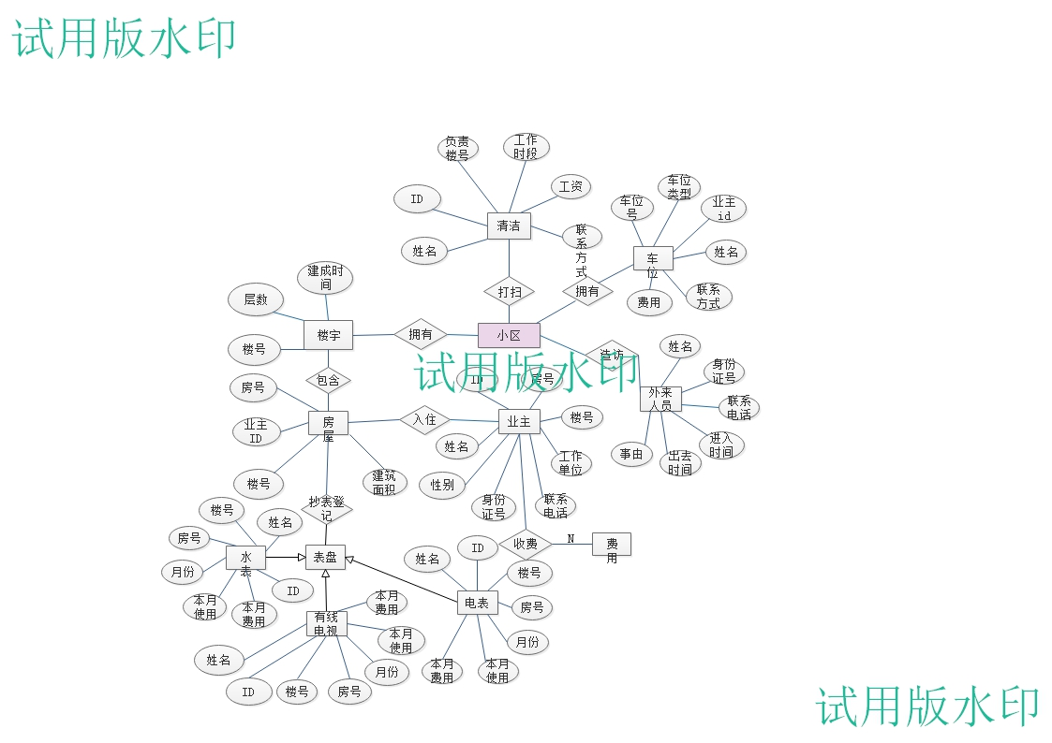

**5.2数据字典**

**5.2.1从数据字典中抽取出来的系统实体描述：**

业主实体表：

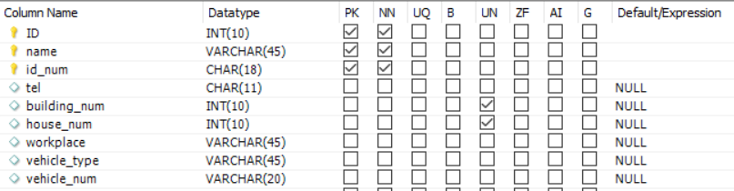

楼宇实体表：



房屋实体表：

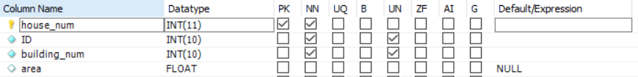

收费管理：

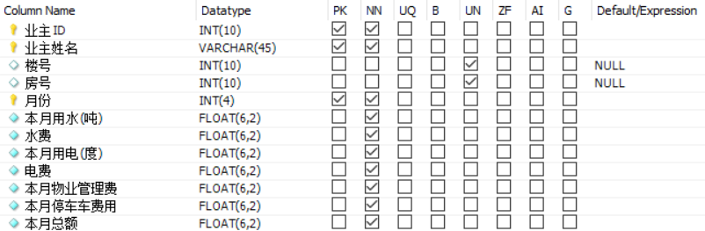

保洁员实体：

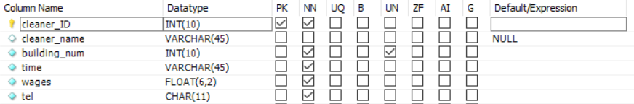

报修实体：

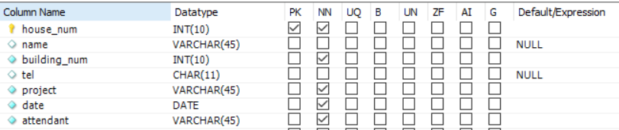

车位实体：

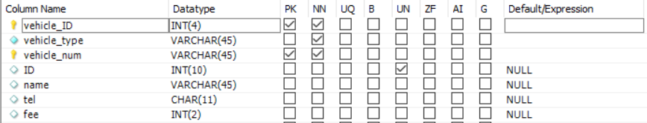

外来人员实体：

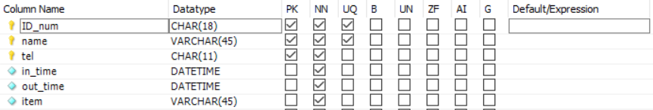

六、数据库物理设计

**6.1索引**

数据库中的索引：

|  |  |  |
| --- | --- | --- |
| 表名 | 主键 | 外键 |
| annually_charge | ID | building_num,house_num |
| building_information | building_num |  |
| cleaner_information | cleaner_ID | building_num |
| house_information | house_num | ID,building_num |
| migrants_information | ID_num,name,tel |  |
| owner_information | ID,name,id_num | building_num,house_num |
| parking_information | vehicle_ID,vehicle_num | ID |
| repair | house_num | house_num,building_num |

这八张表中绝大部分是只有一个主键的，对于这样的表我在设计对于此表的界面时单独设它的索引为它的主键。在删除和修改的时候利用这个索引修改对应元组的选定属性值。

而对于有多个主键的表，我只是选择了最关键的主键当做整张表的索引，migrants_information的索引是ID_num(身份证号), parking_information的索引是vehicle_ID，owner_information的索引是ID(业主ID)。

**6.2视图**

我设计的这个物业管理系统一共有八个表，我给这个管理系统设定的用户为物业管理人员，因而他们拥有物业这八张表增删改查的所有权限。

**6.3安全机制**

本物业管理系统在主界面实现功能的代码语句中使用了try-catch块，当输入有异常时会出现出错提示。实现删除功能时，选中想要删除的行，点击“删除”按钮，弹出“确定要删除该内容吗？”的对话框；实现修改功能时，修改成功，也会弹出“修改成功！”对话框。在登录进入管理系统时也对登录提示信息进行了有关处理，如果没有输入内容就想登录，系统会弹出提示输入完整内容的对话框，而用户名密码登录错误了就会在输入内容中自动清空先前输入的内容，并且不会进入到管理系统。

七、应用程序设计

此物业管理系统的主要功能如下图所示：

退出系统

房屋信息管理

楼宇信息管理

外来人员管理

收费信息管理

保洁信息管理

车位信息管理

维修信息管理

业主信息管理

菜单界面（日历、小区基本信息、百度地图、功能模块选项）

登录系统

物业管理系统

**7.1功能模块**

本物业管理系统共有业主信息管理、维修信息管理、车位信息管理、保洁信息管理、收费信息管理、外来人员管理、楼宇信息管理、房屋信息管理八大模块，具体模块的功能实现如下：

**7.2界面设计**

**7.2.1登录界面**

用户在登录界面输入用户名和密码并经过系统验证后，可以进入主服务界面进行相关操作（账号密码为初始设定好的值）

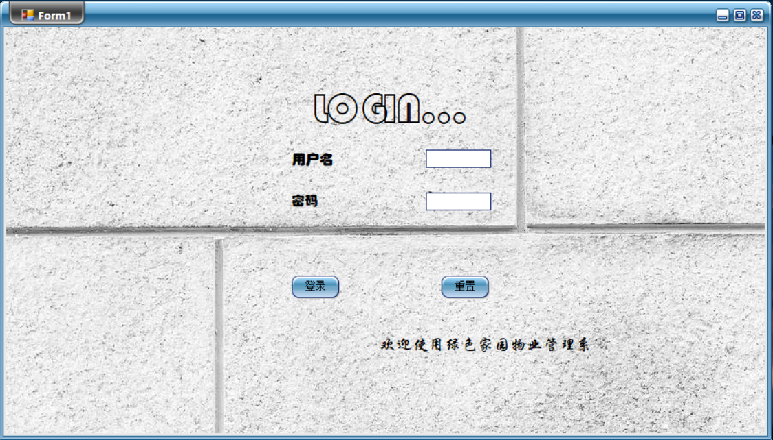

**7.2.2主服务界面**

在输入正确的账号密码后进入主服务界面，主服务界面提供了通往目的功能的按钮，在按下按钮后主服务界面hide，显示新的界面。

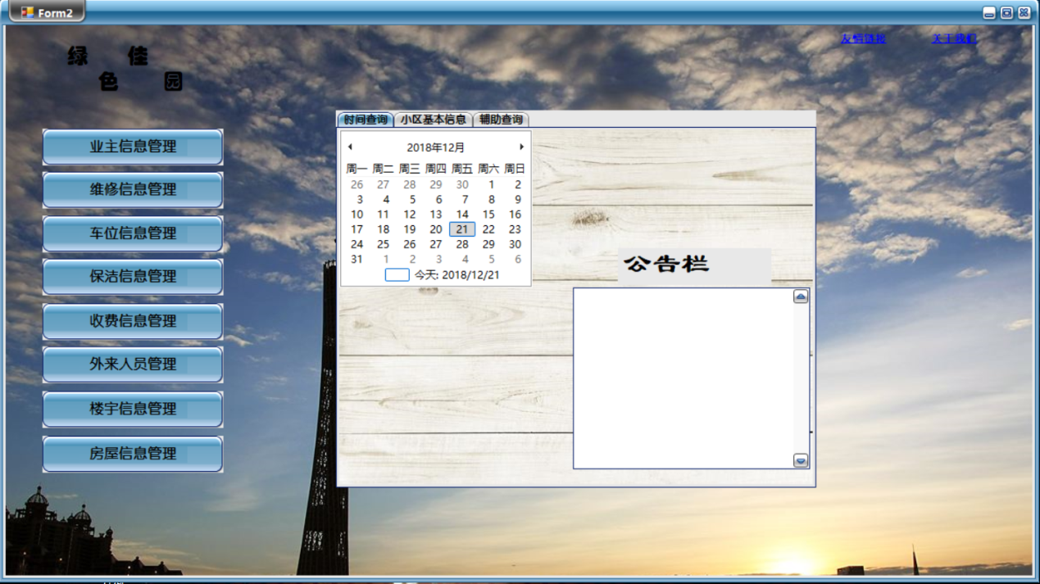

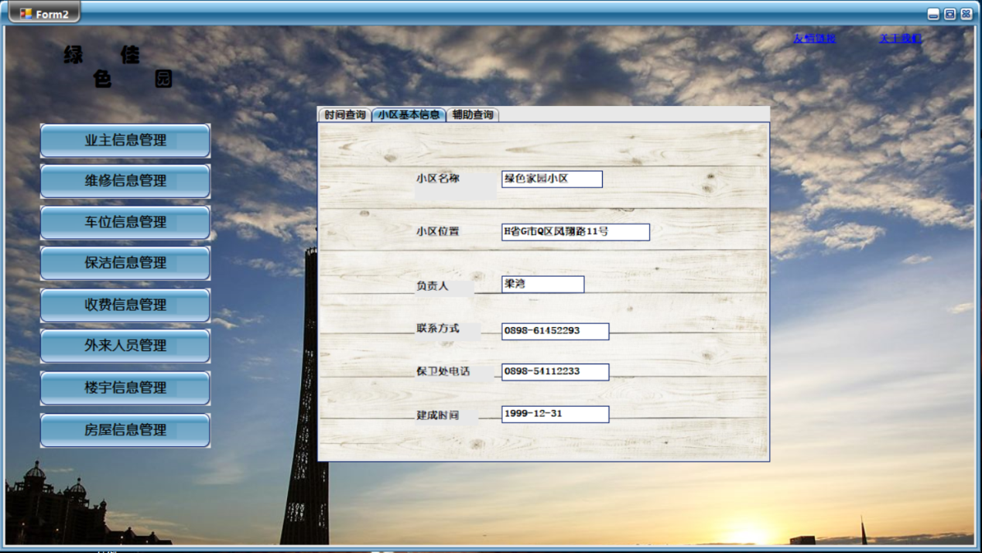

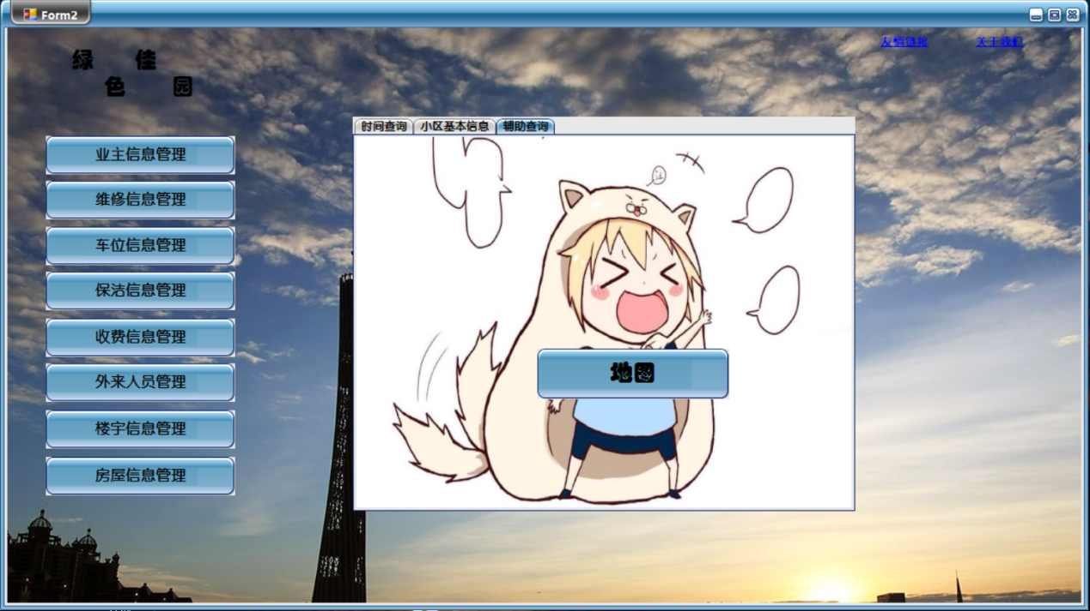

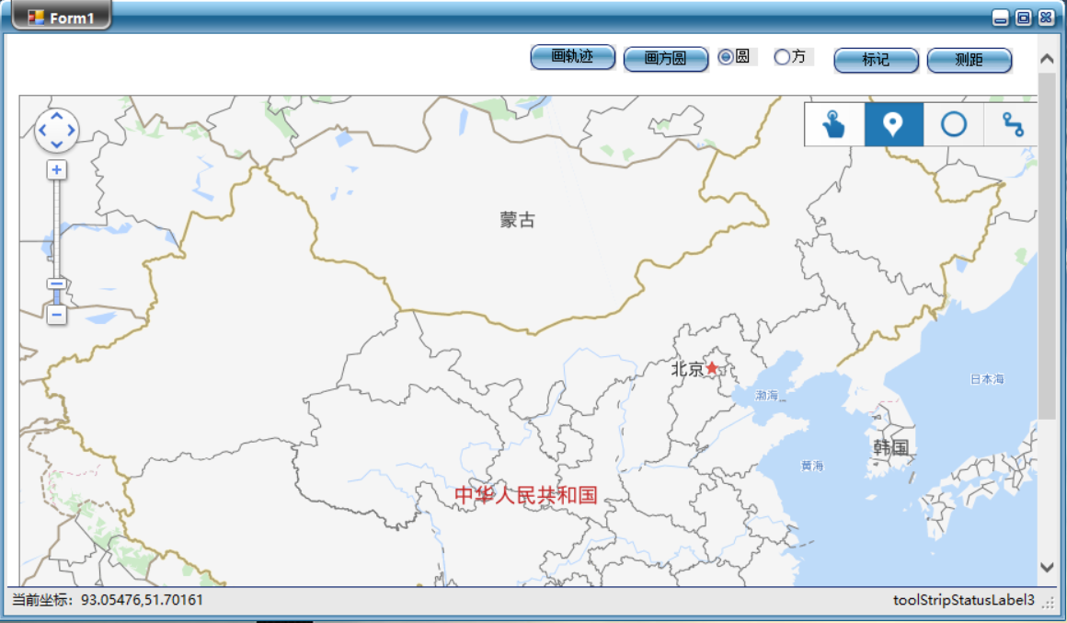

**7.2.3业主信息管理**

业主信息管理界面如下所示：

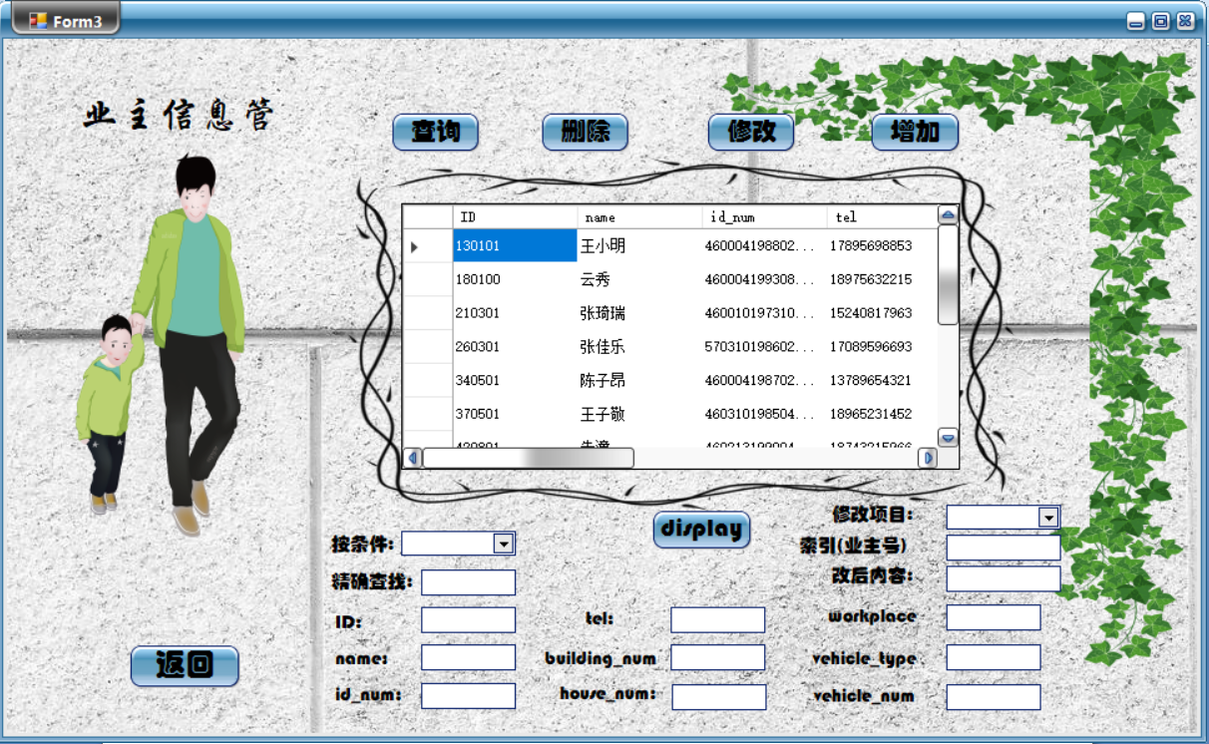

1. 查询业主ID

选择索引查询业主ID，输入查找内容，如果查找不到，屏幕上不会显示什么内容。但是查找到了，就会将查到的元组那一行单独列出来。

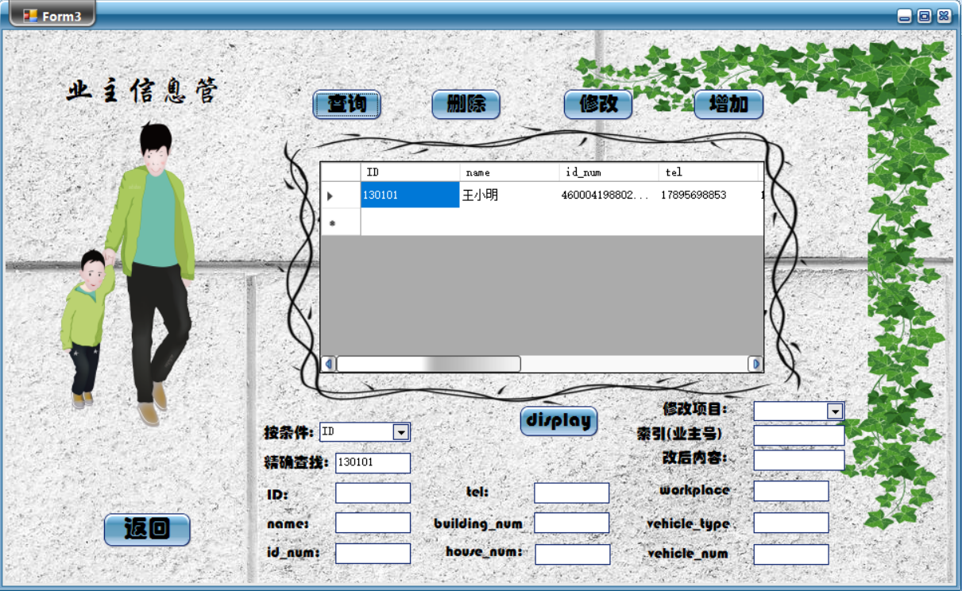

1. 修改数据库的某个内容（以修改ID130101的业主姓名为例）

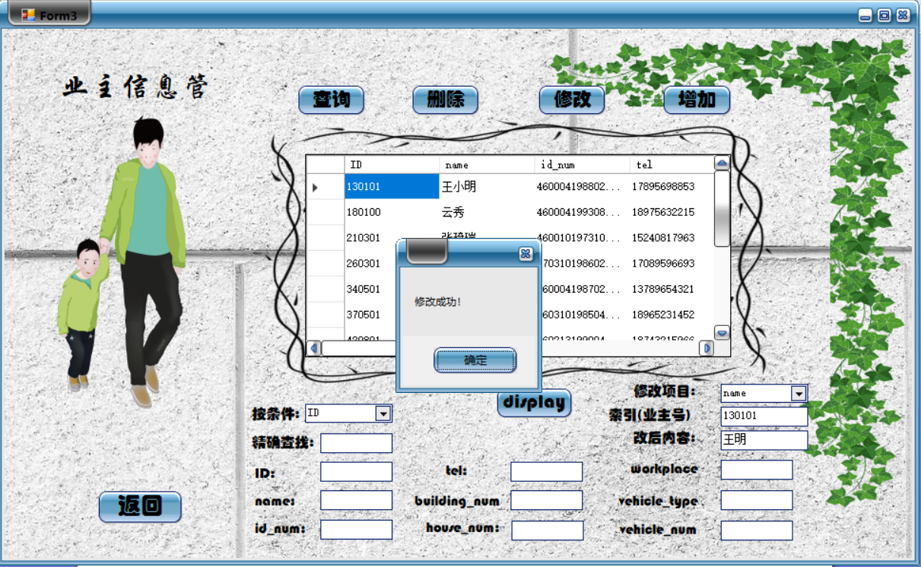

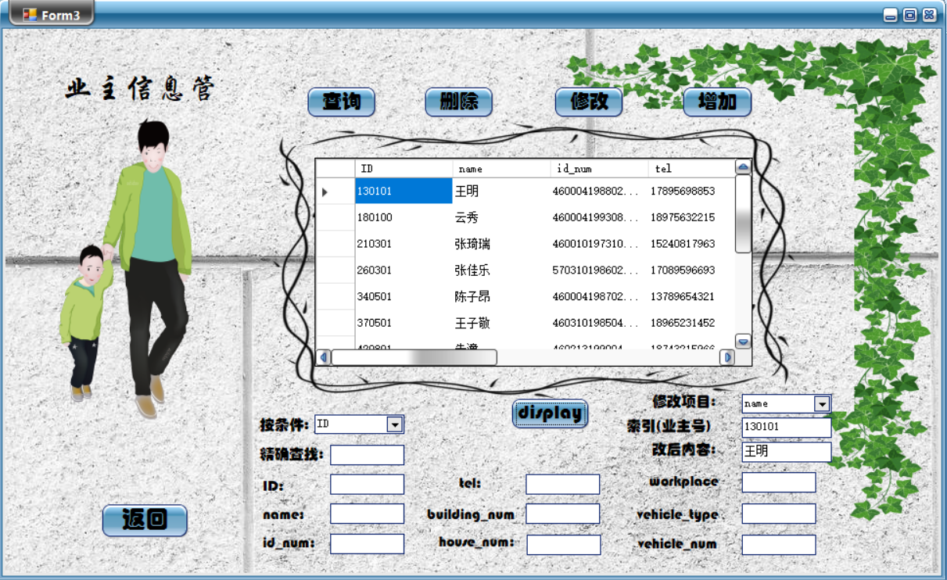

数据库后台对应变化：

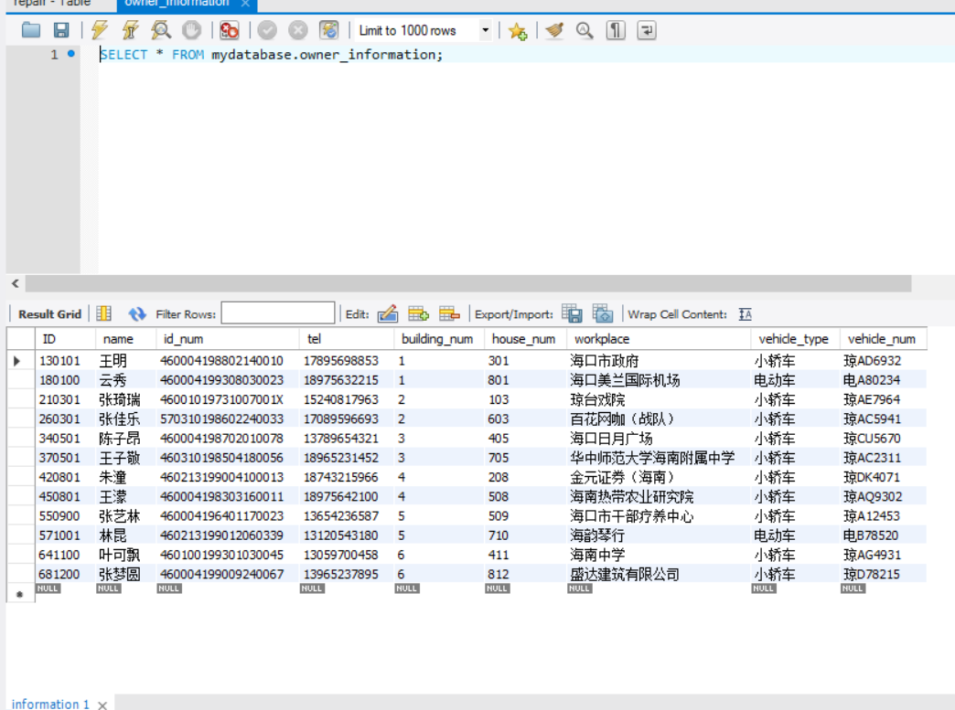

1. 增加一个新的业主信息

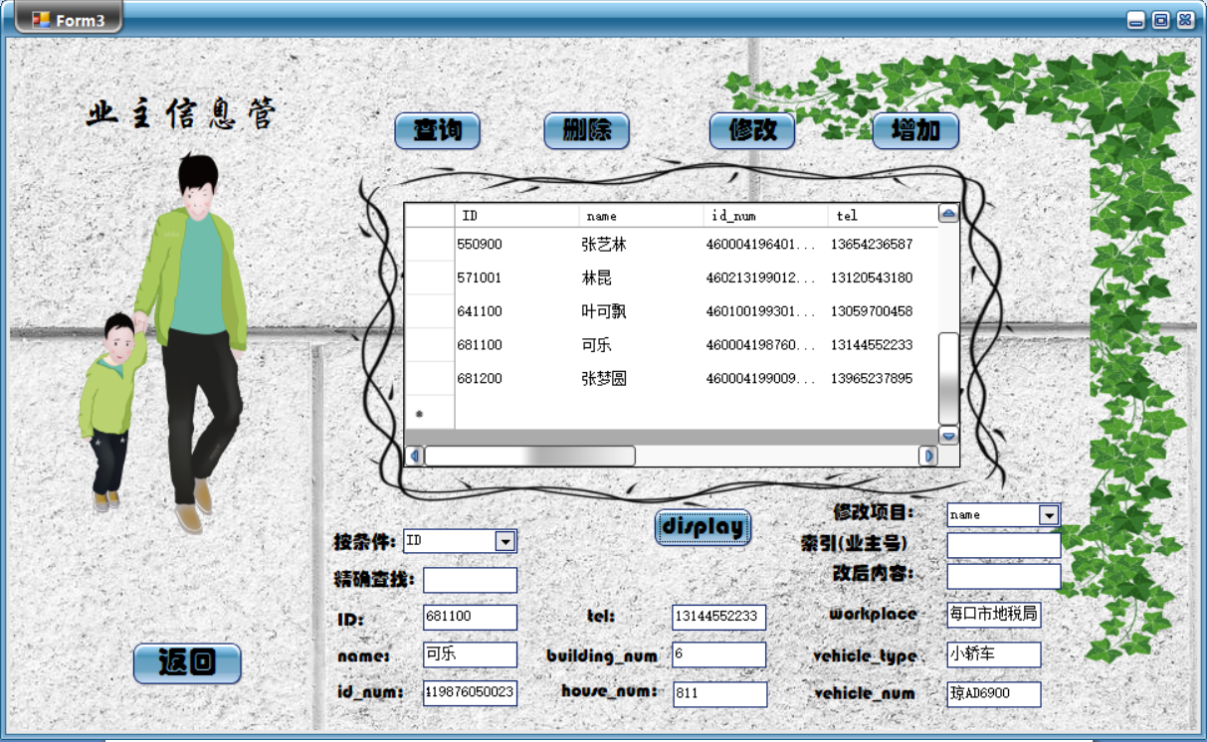

增加了新业主——“可乐”，按display刷新当前页面，新业主可乐的信息也显示出来了。

数据库后台对应变化：

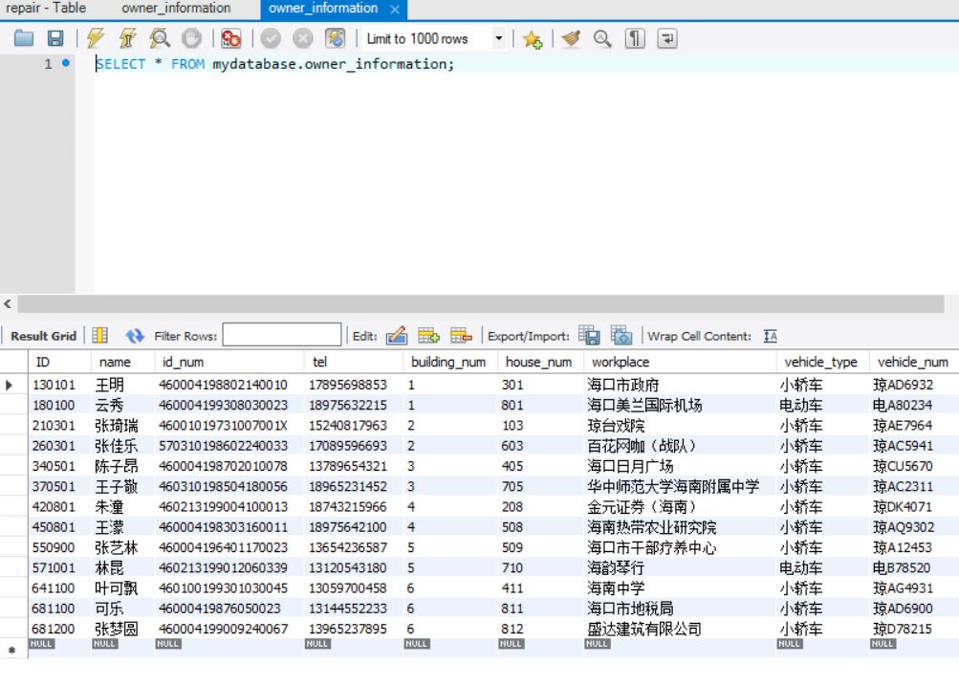

1. 删除选中的业主信息

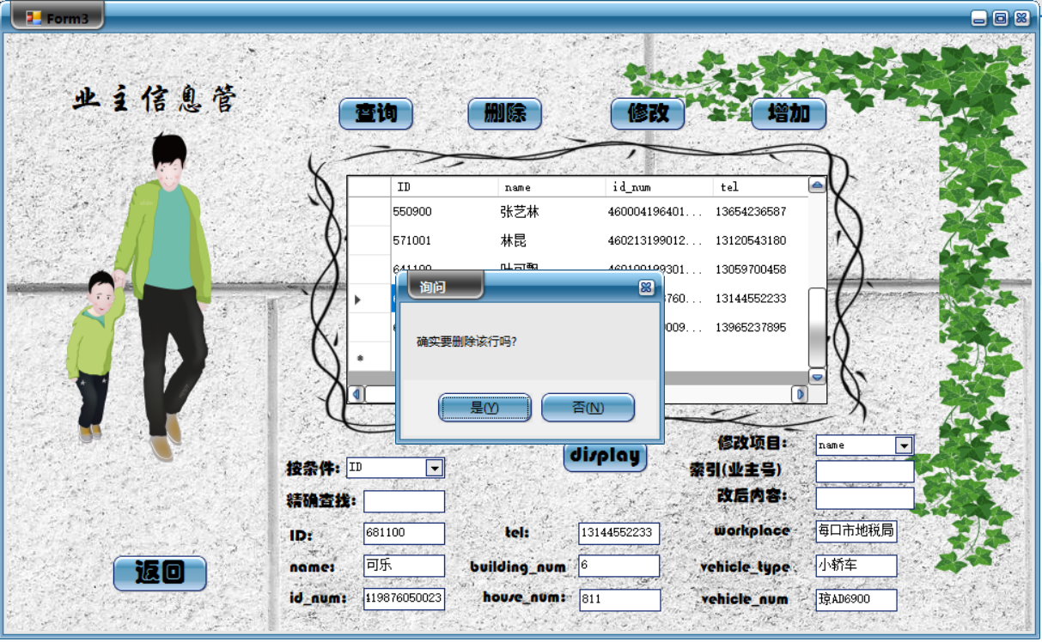

选中“可乐”的ID，按“删除”

数据库后台对应变化：

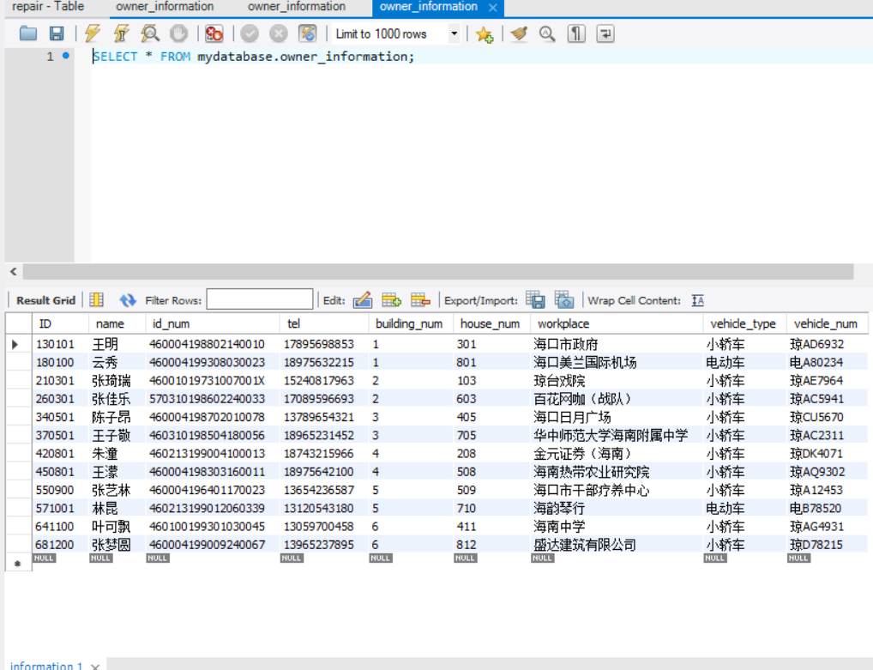

**7.2.4维修信息管理**

维修信息管理界面如下所示：

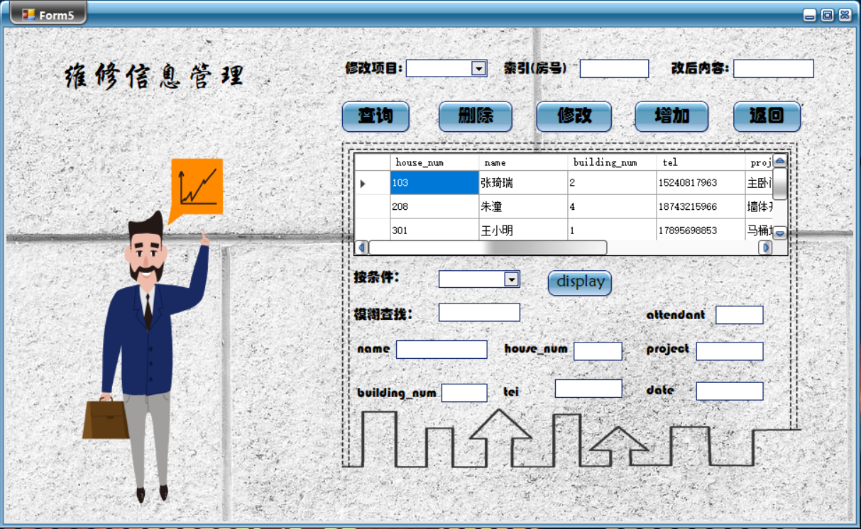

1. 查询

查询所有有维修需求的张姓业主：

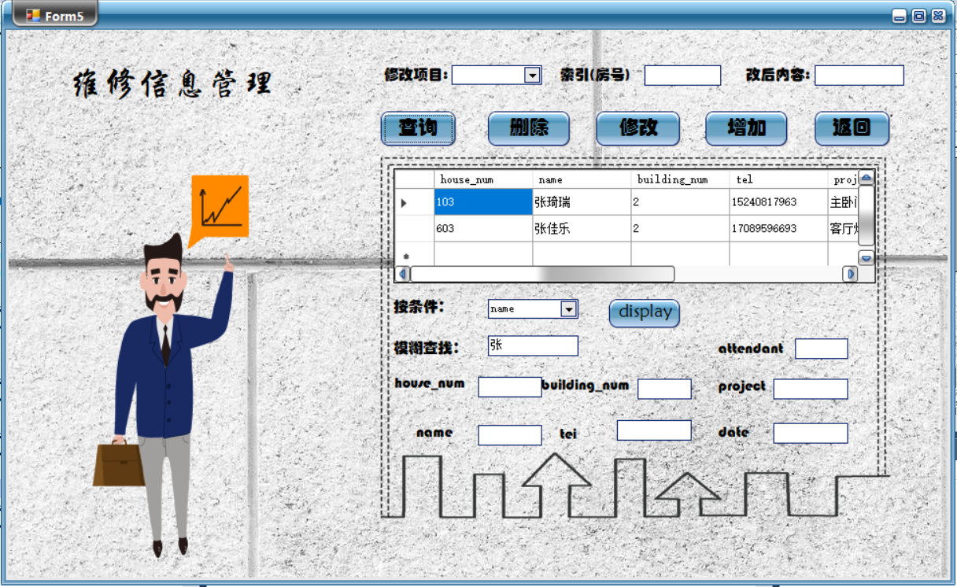

1. 增加

增加新的有维修申请的业主情况——“可乐”

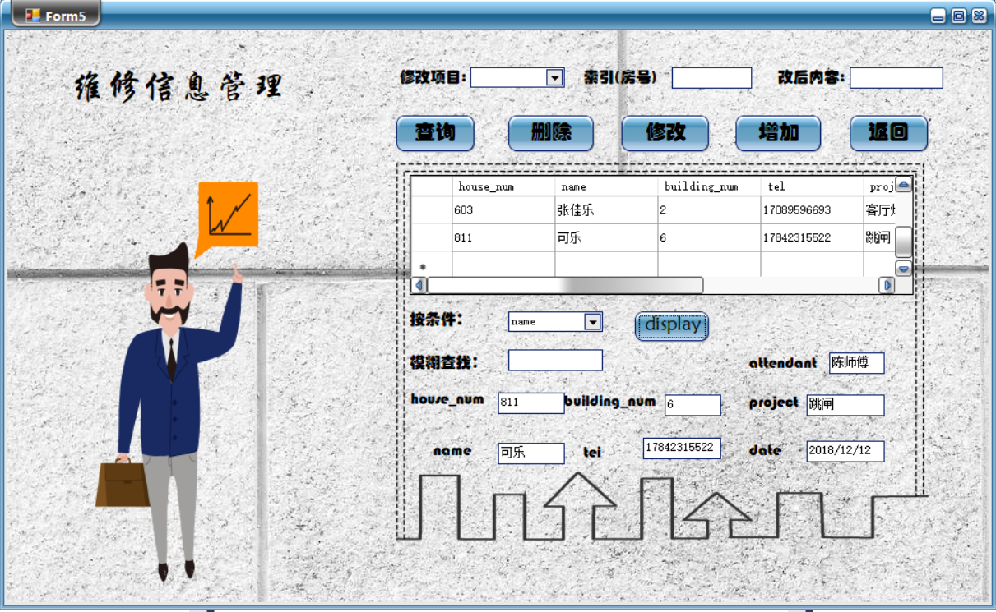

1. 修改

修改业主可乐要报修的项目

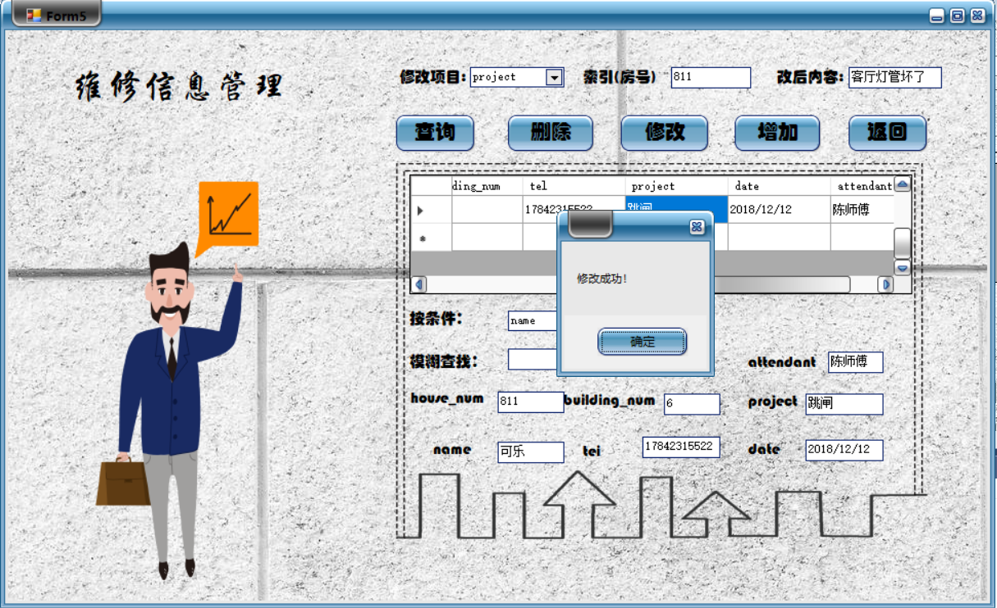

数据库后台：

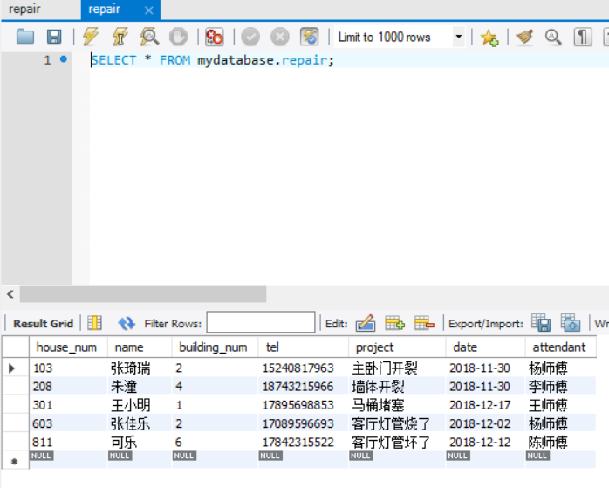

1. 删除

删除业主可乐的报修信息

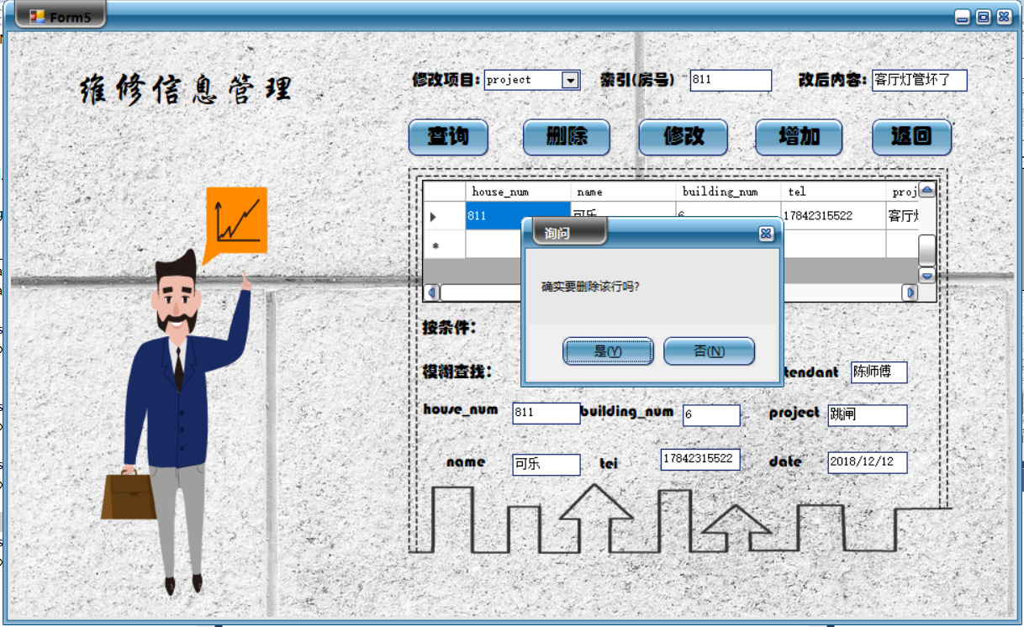

数据库后台：

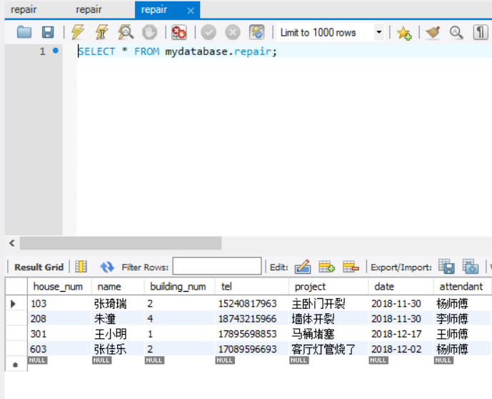

**7.2.5车位信息管理**

车位信息管理界面如下所示：

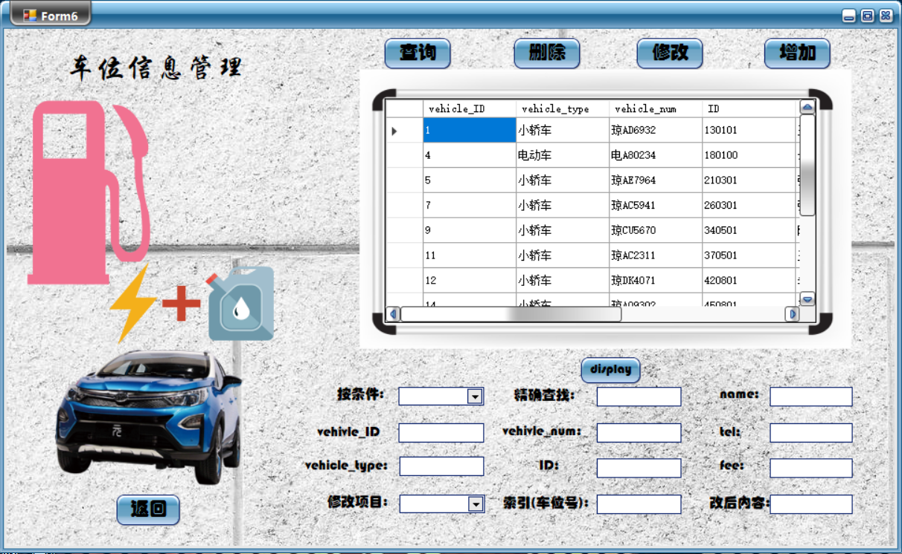

1. 模糊查询（本系统精确查询模糊查询都支持）

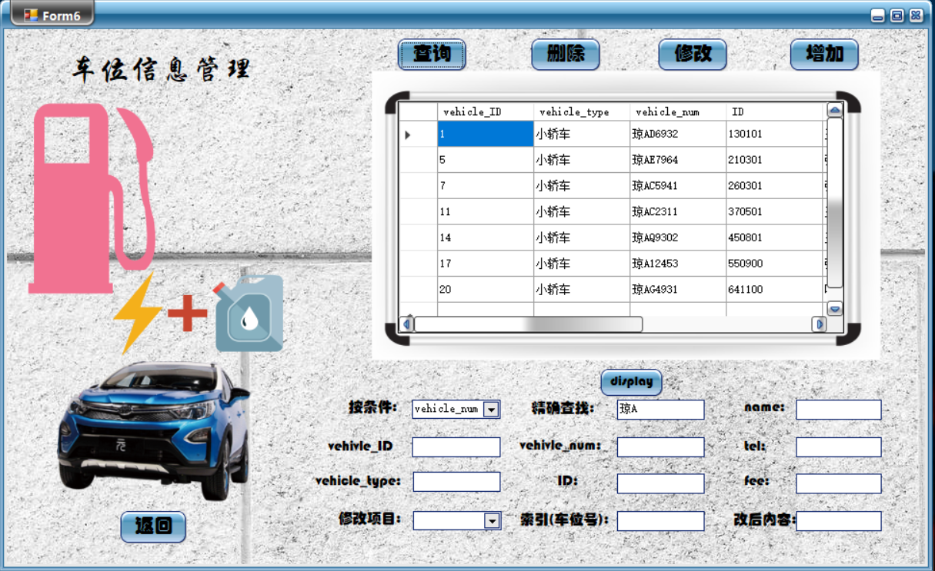

列出的是所有车牌号含“琼A”的全部元组信息

1. 插入新用户“可乐”

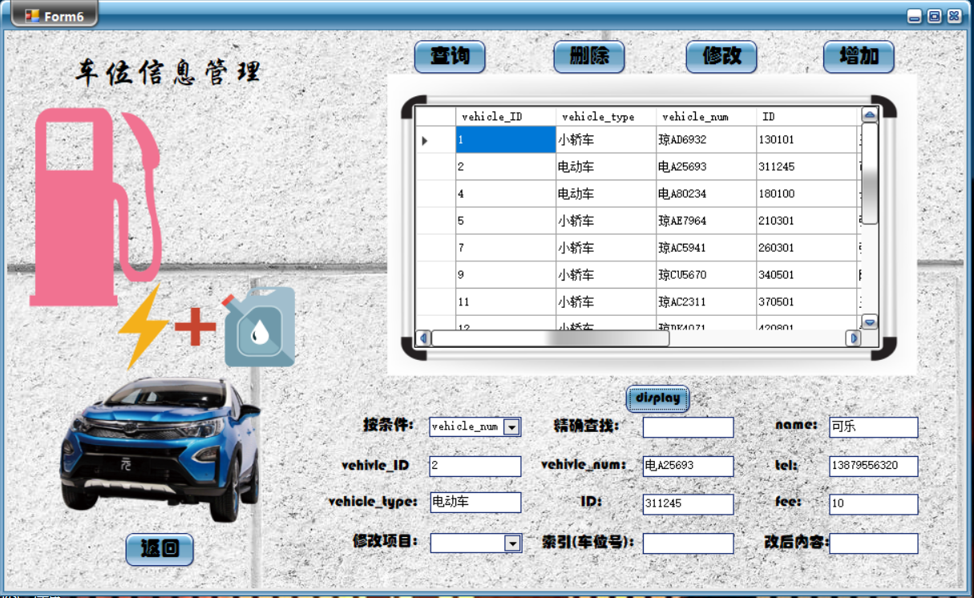

数据库后台：

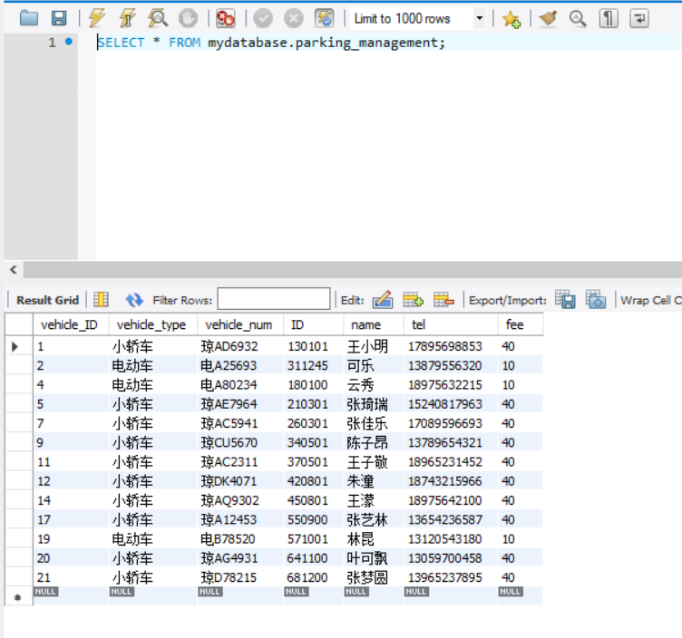

1. 修改新用户“可乐”的有关信息

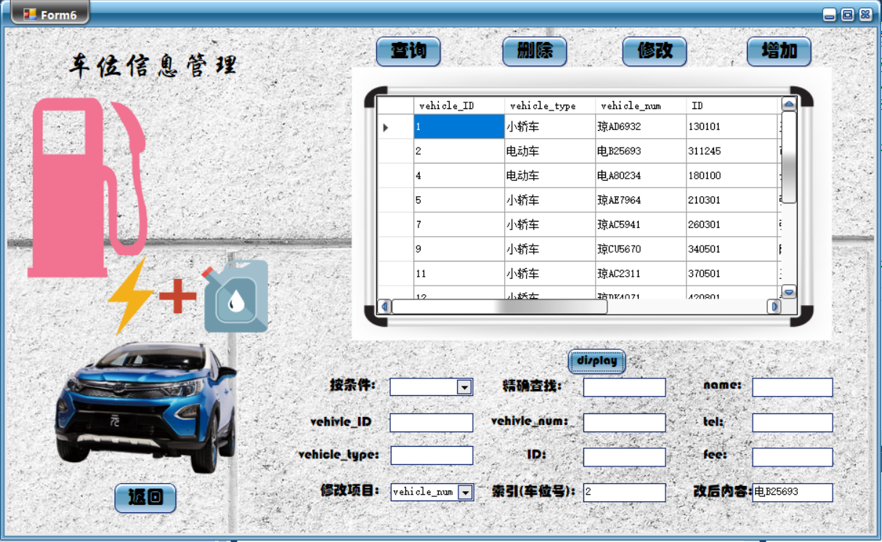

修改车牌号

数据库后台：

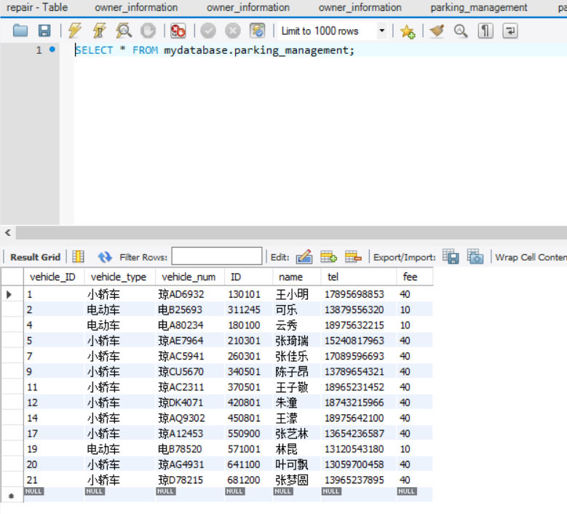

1. 删除用户“可乐”的相关车位信息

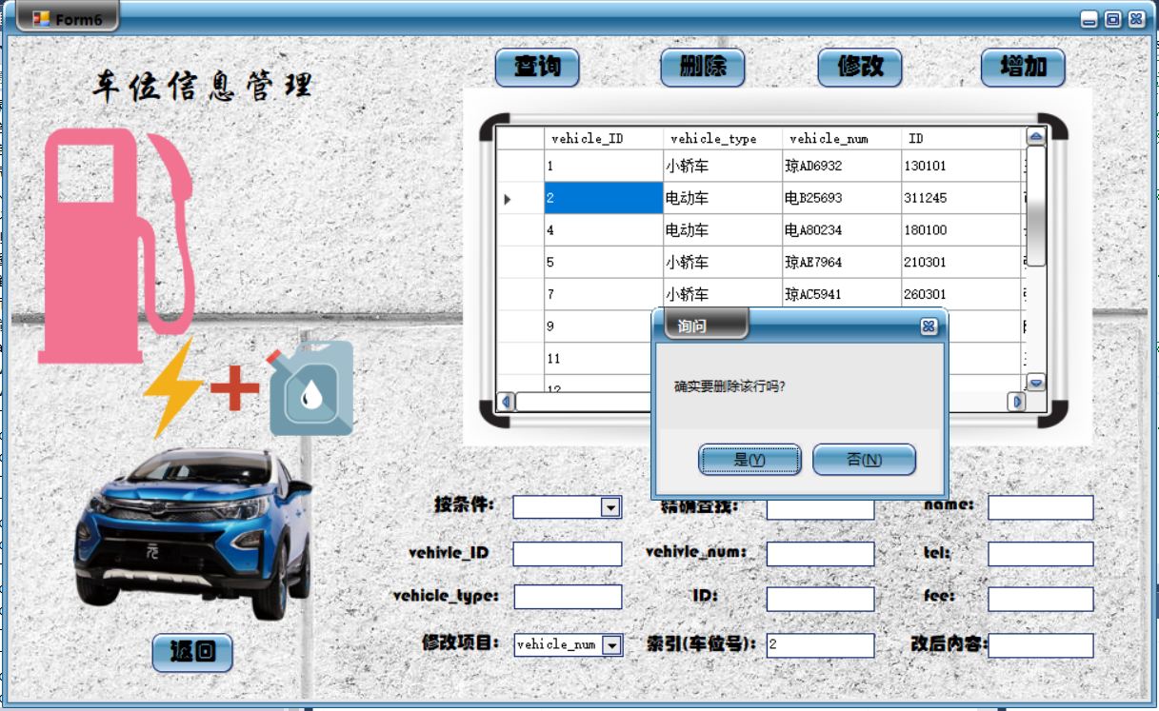

数据库后台：

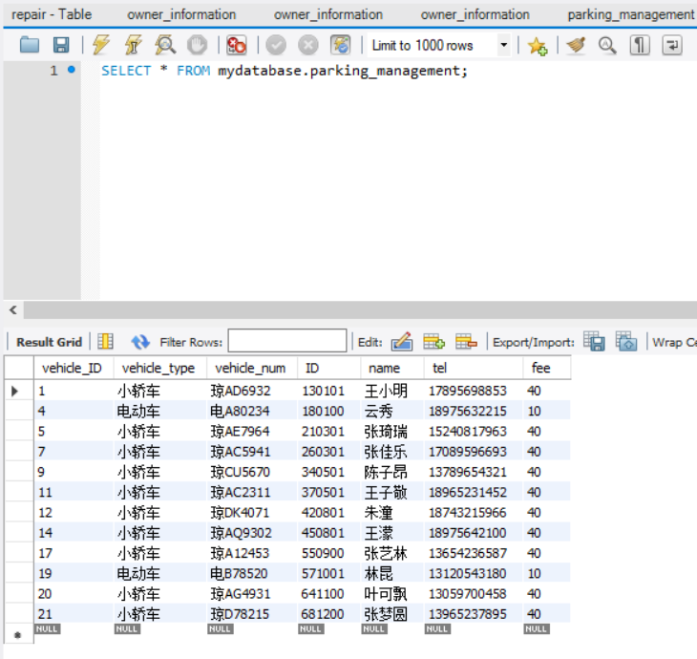

**7.2.6保洁信息管理**

保洁信息管理界面如下所示：

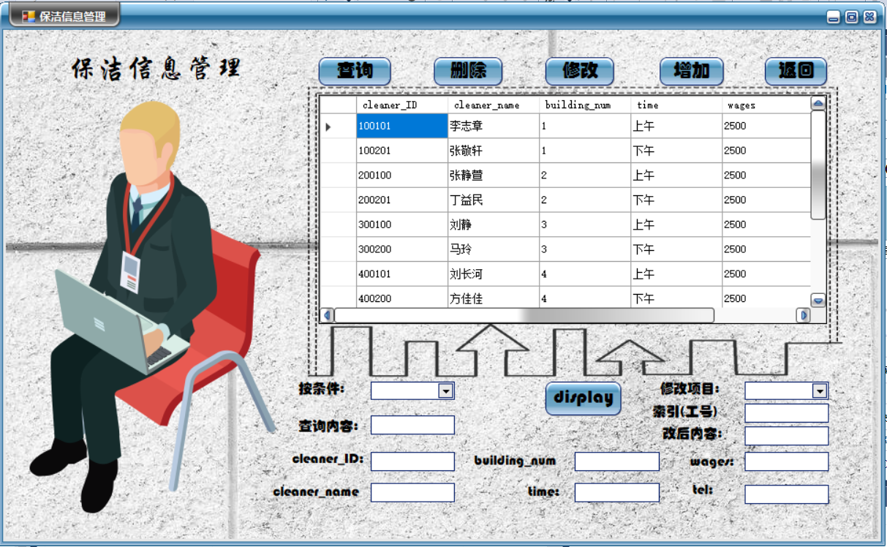

1. 查询

查询所有在上午时段工作的清洁员工的信息：

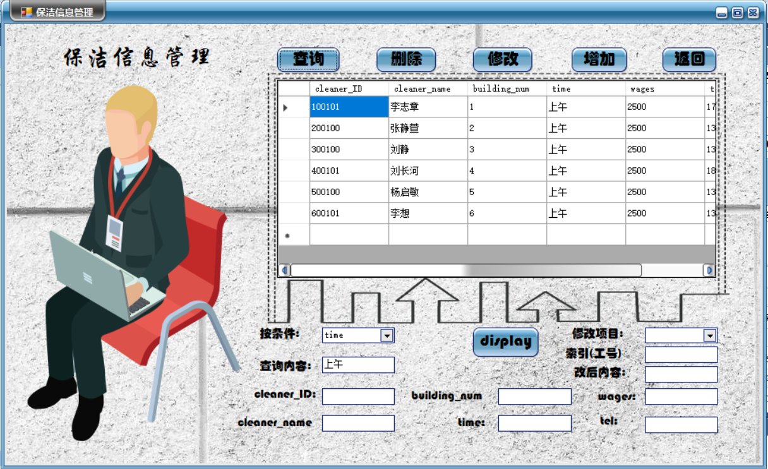

1. 修改

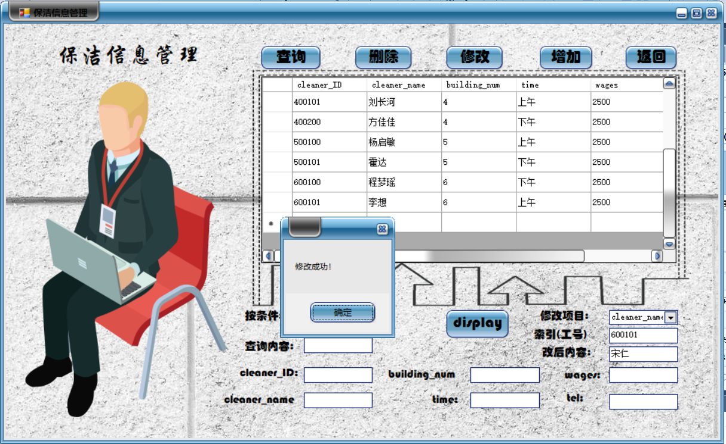

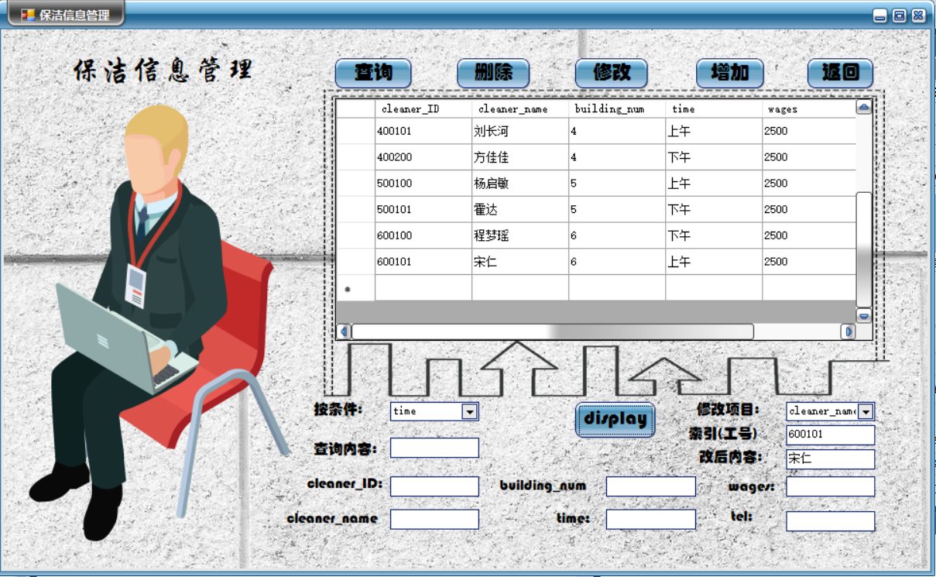

数据库后台：

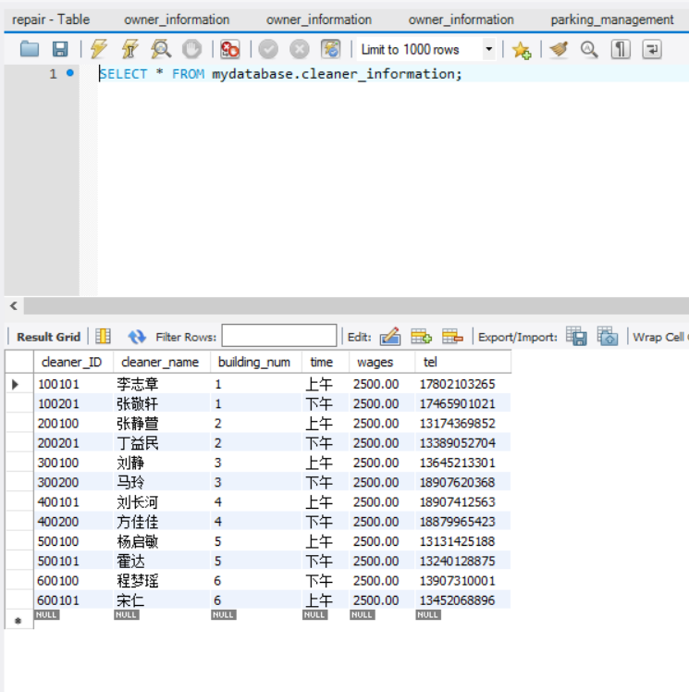

1. 增加

添加“李轩”

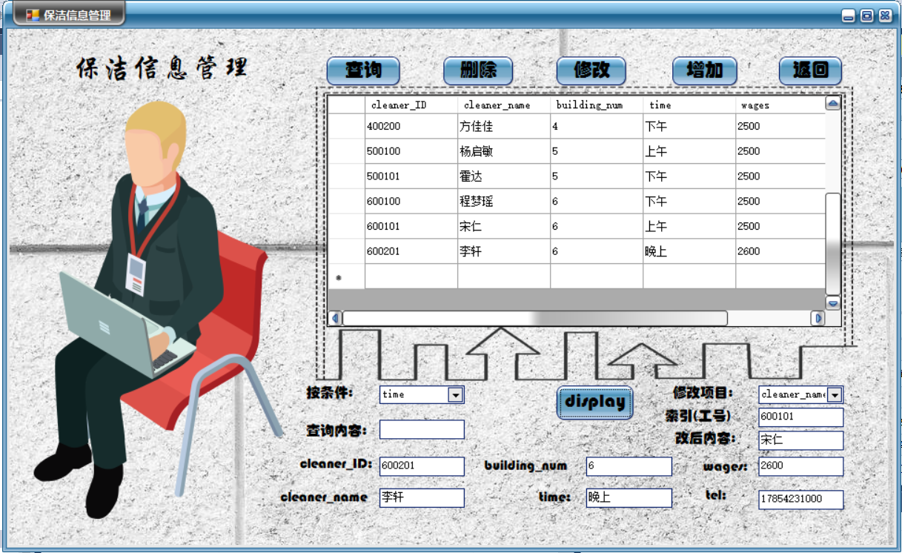

数据库后台：

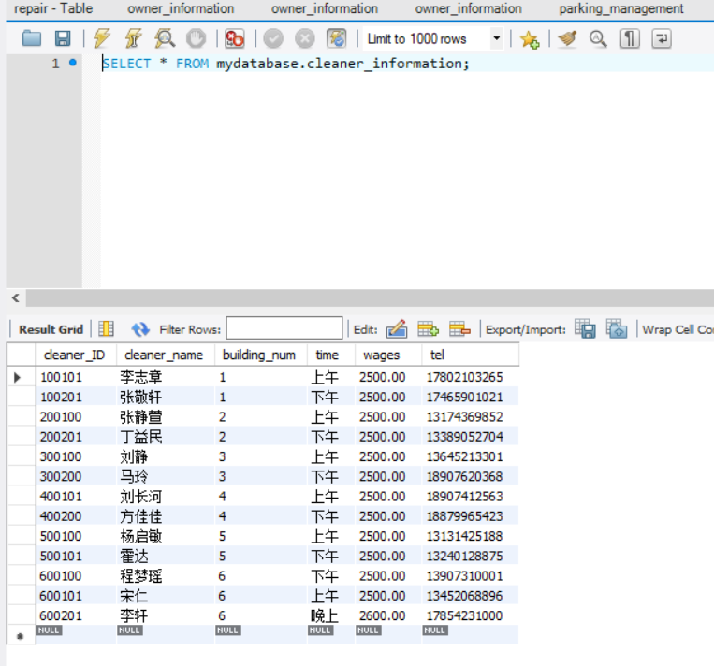

1. 删除

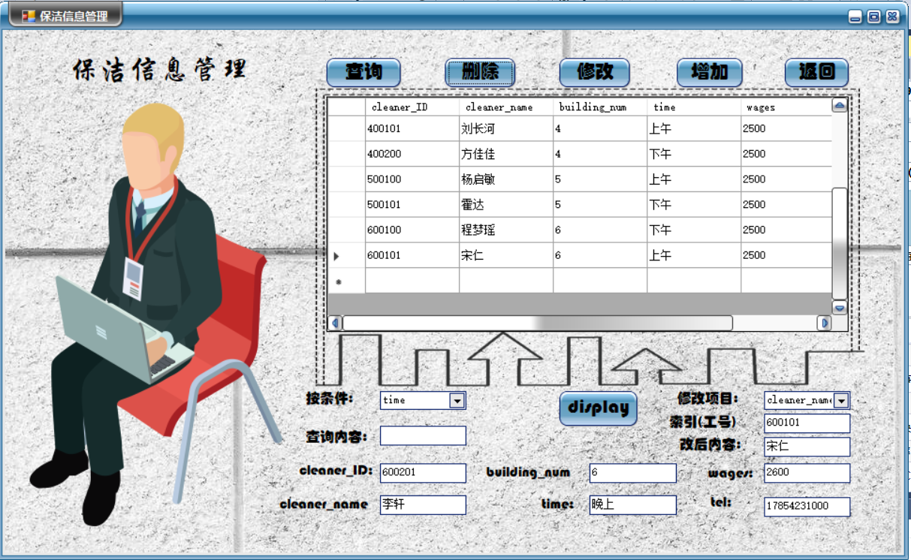

数据库后台：



**7.2.7收费信息管理**

收费信息管理界面如下所示：

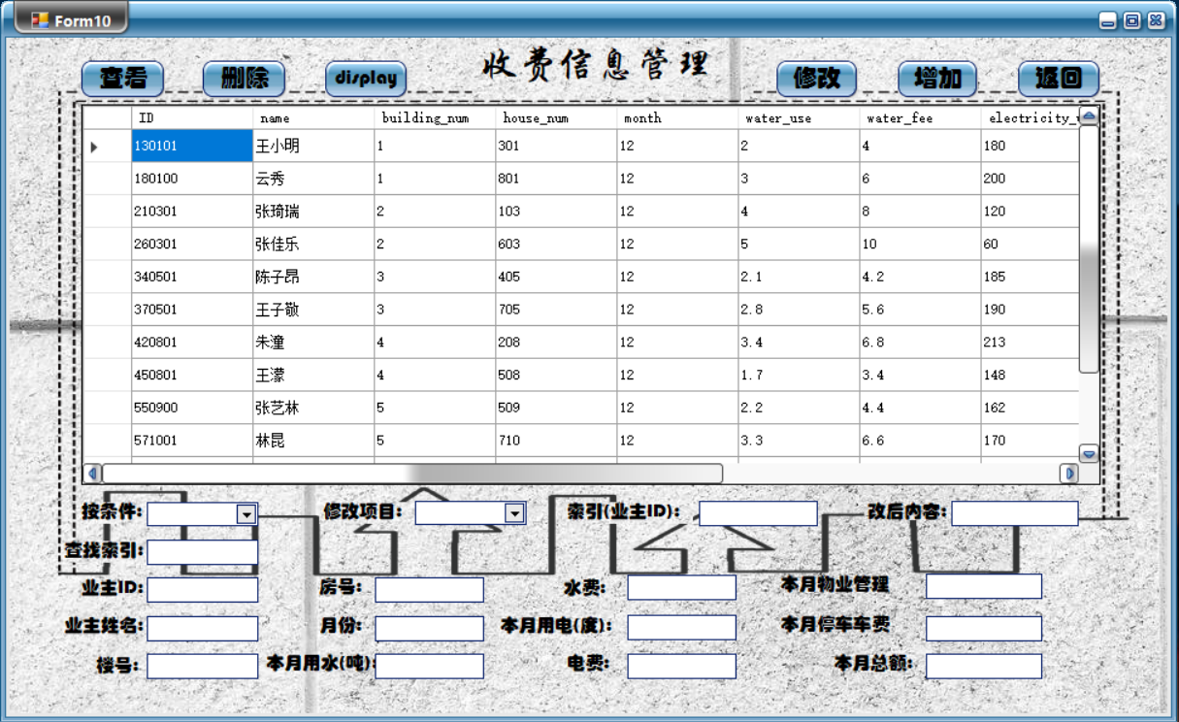

1. 查询

模糊查询——查找该小区中所有王氏业主的收费情况，只用输入一个“王”，就会出来相关信息：

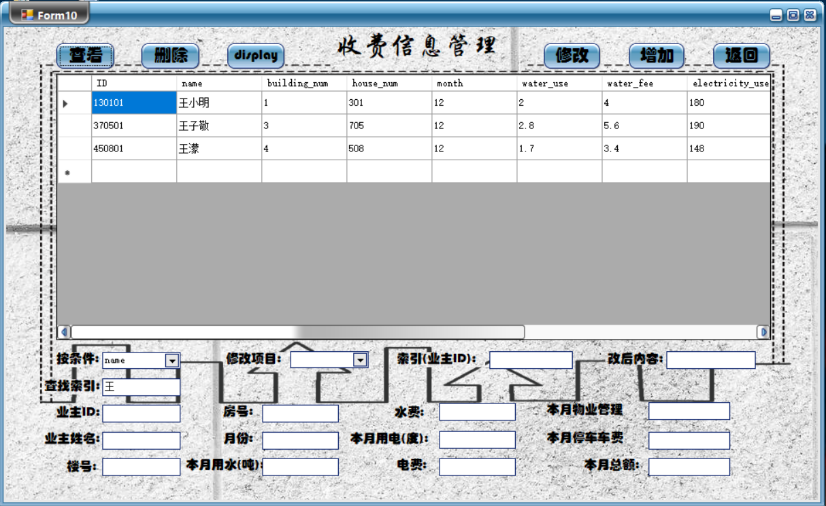

1. 修改

修改业主“王小明”的收费信息月份，索引是业主ID

PS：在此收费表格中，我设计的是显示收费情况是当月的，也就是每过一个月要进行消费结算，物业管理人员只需要手动修改月份、本月用水、本月水费、本月用电、本月电费、本月总额（因为每个月的车费、物业管理费用是固定的）

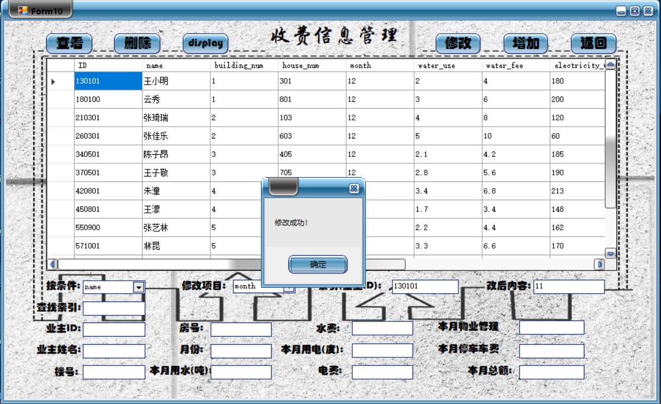

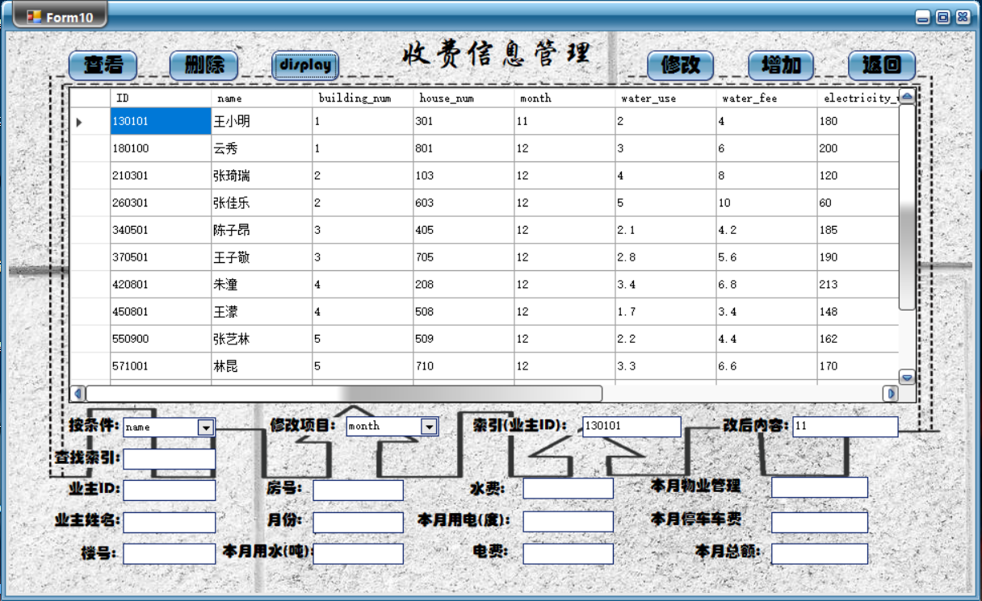

数据库后台：

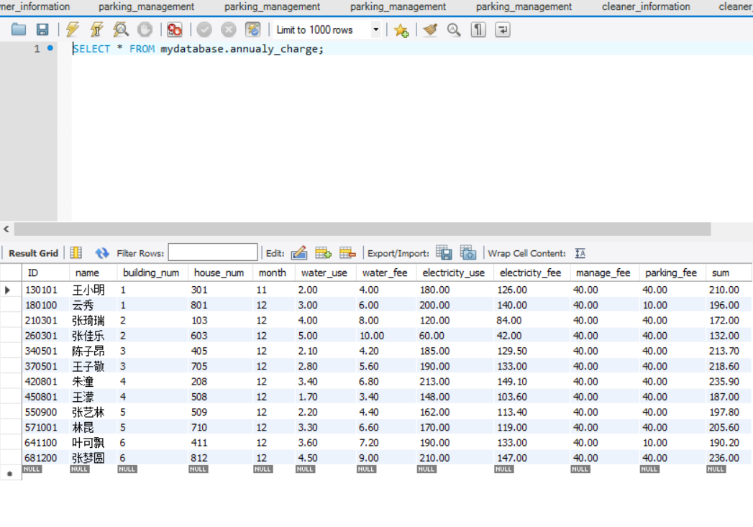

1. 增加

新增业主“可乐”的收费信息：

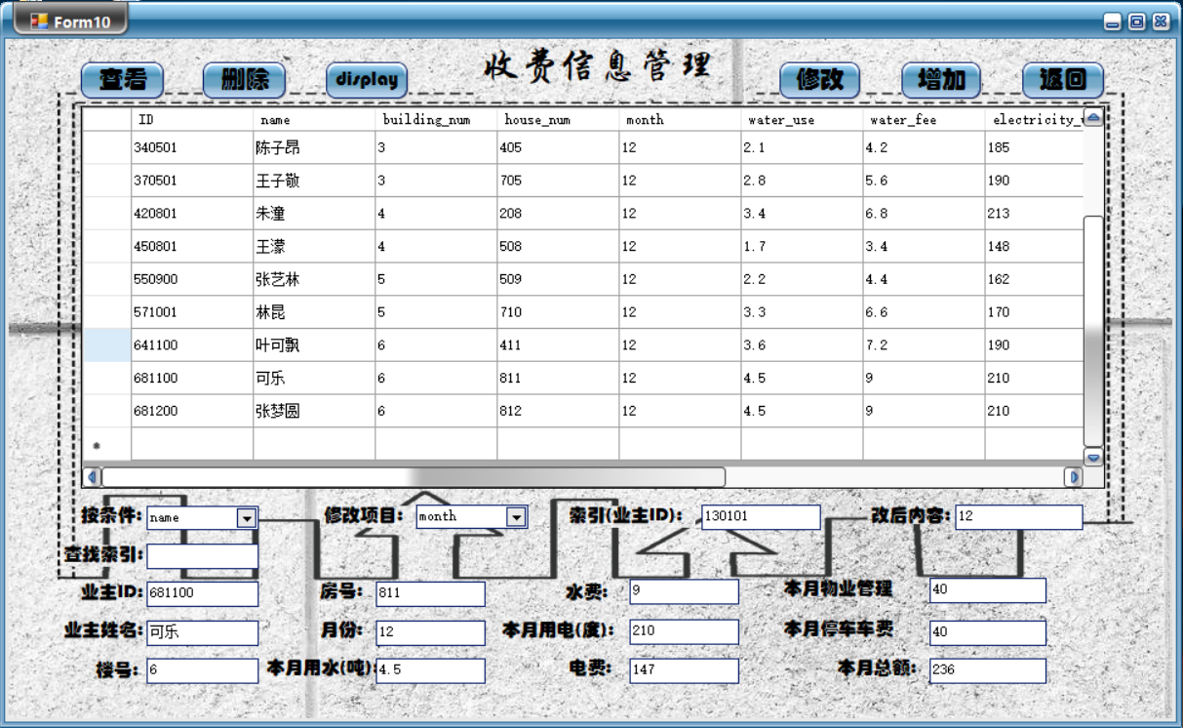

数据库后台：

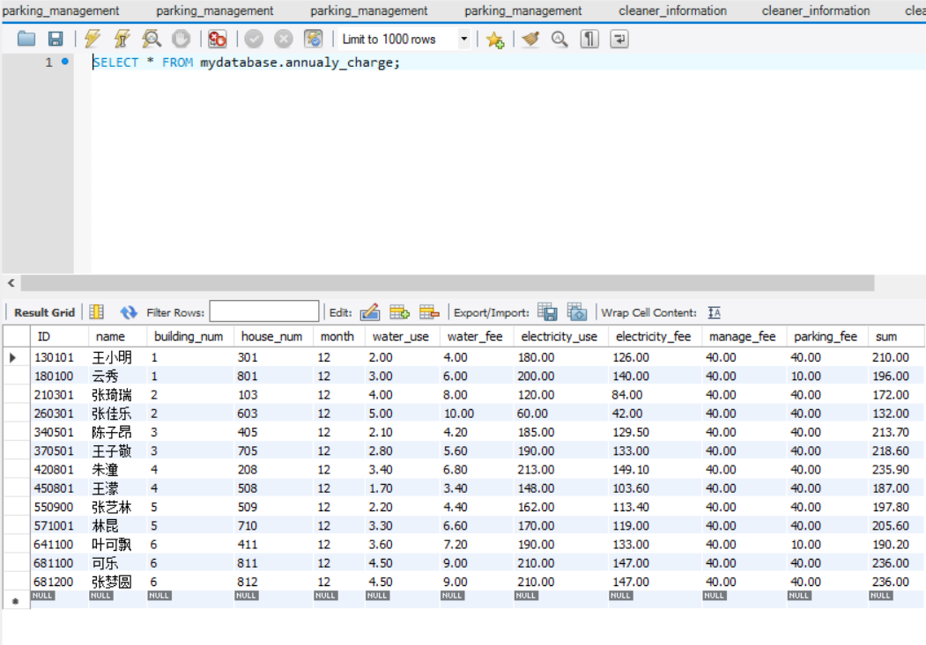

1. 删除

删除业主“可乐”的信息：

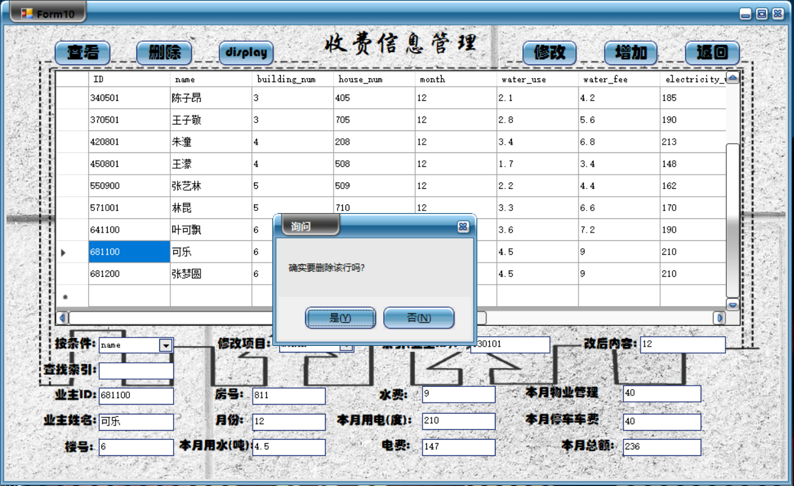

数据库后台：

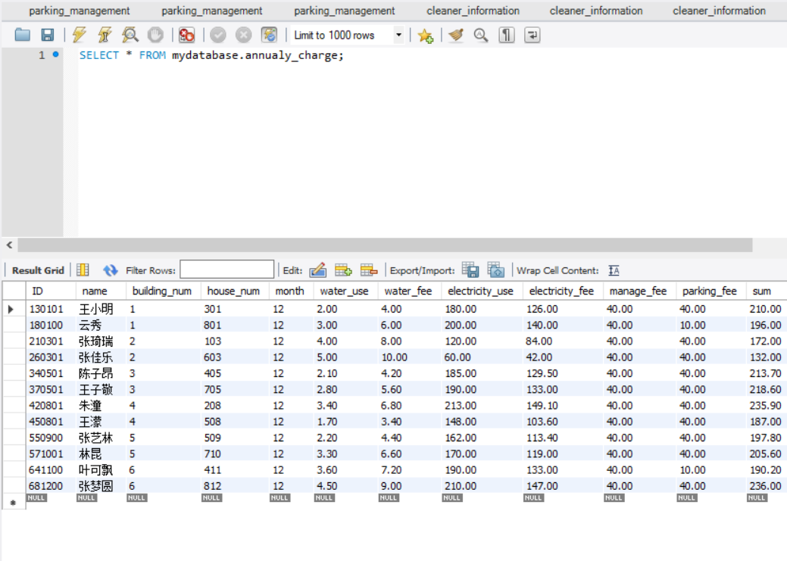

**7.2.8外来人员管理**

外来人员管理的界面如下所示:

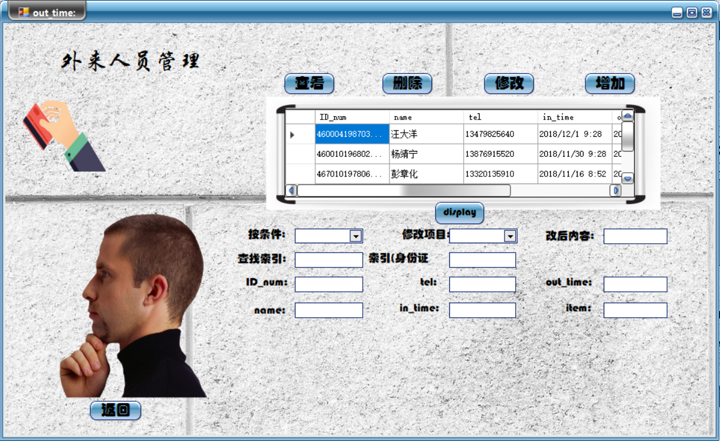

1. 查找

这里查找的是12月的访客

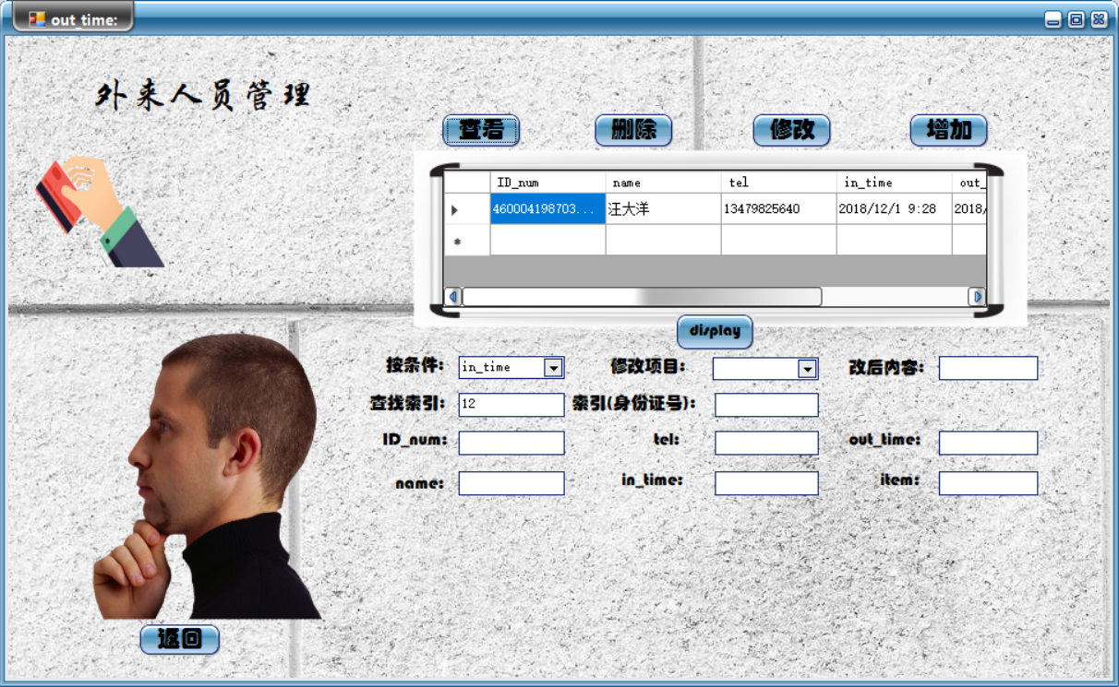

1. 增加

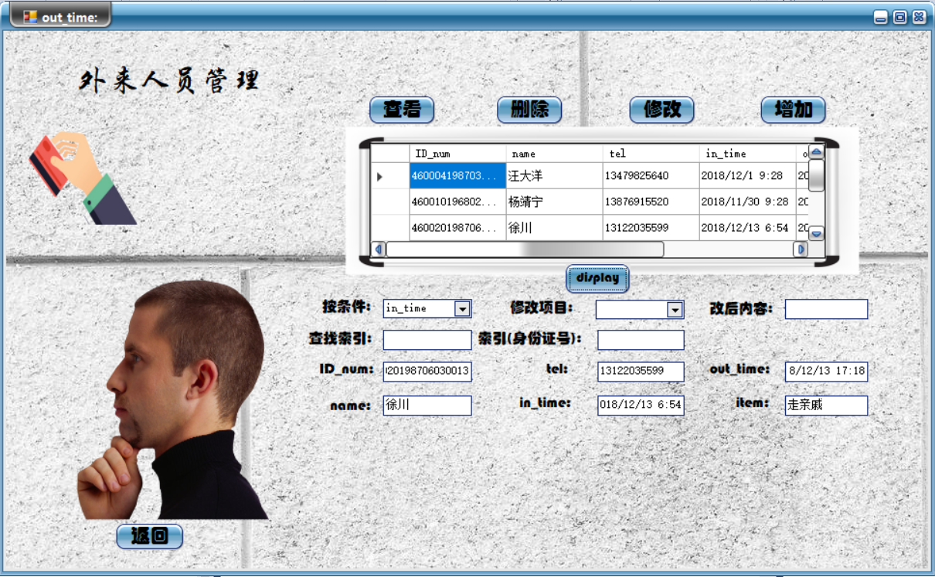

增加了一个名为“徐川”的外来访客

数据库后台：

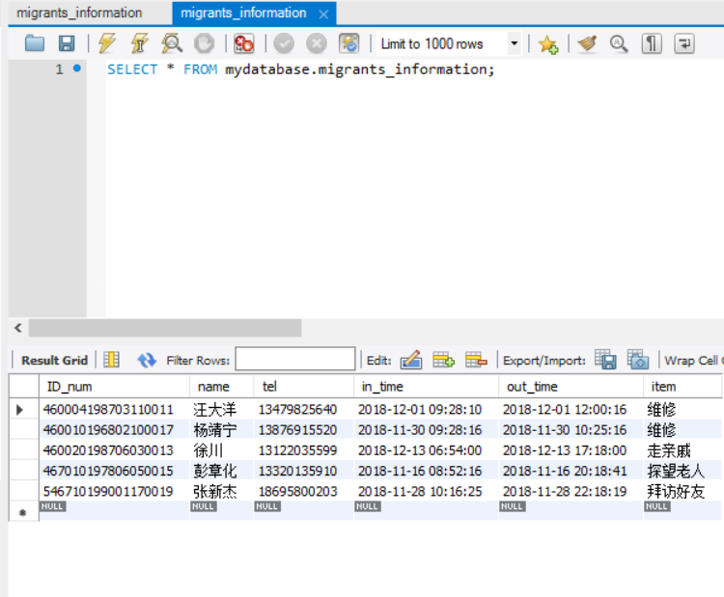

1. 修改

修改“汪大洋”为“汪洋”

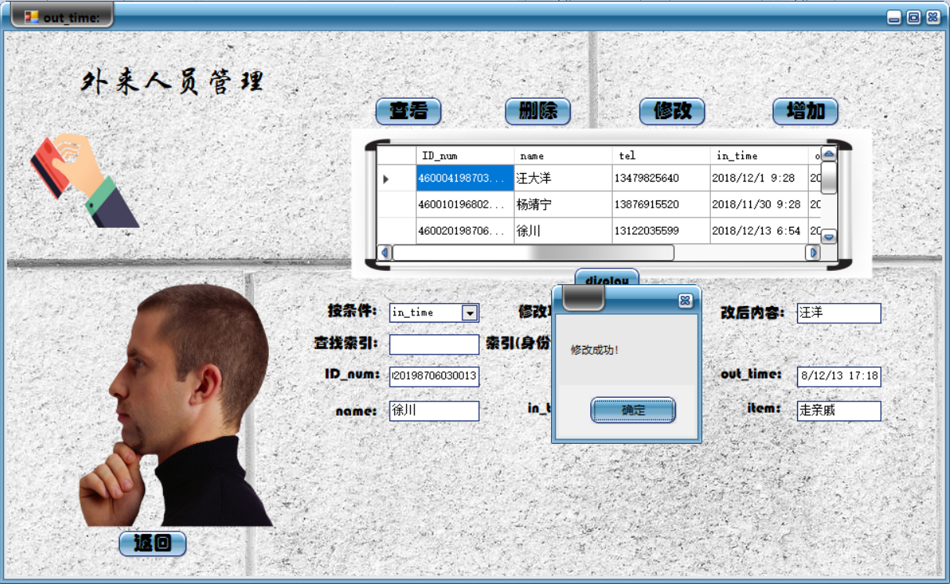

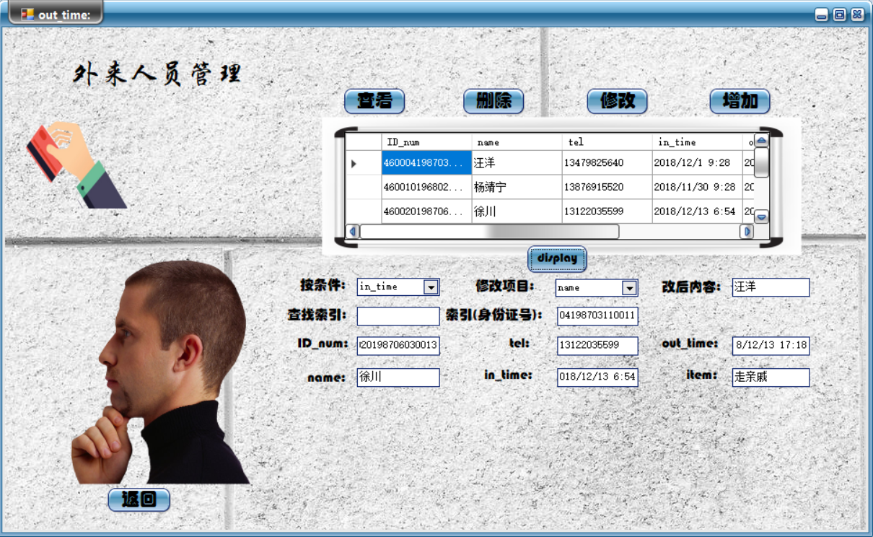

数据库后台：

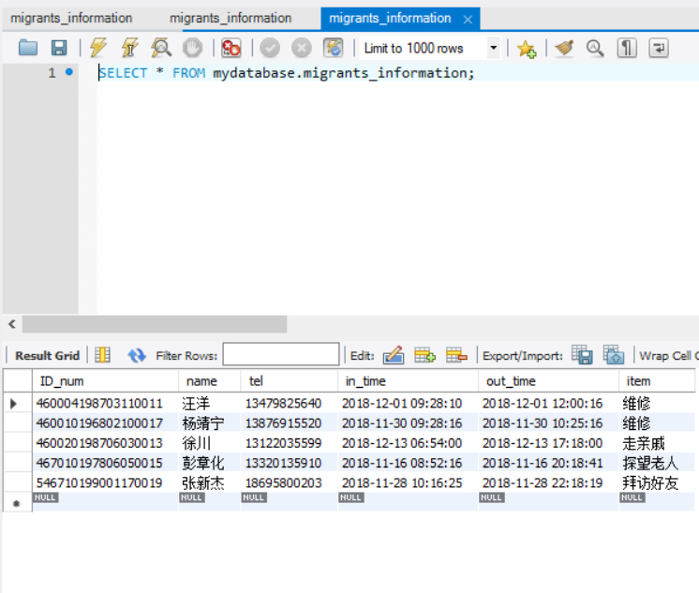

1. 删除

删除外来访客“徐川”的信息



数据库后台：

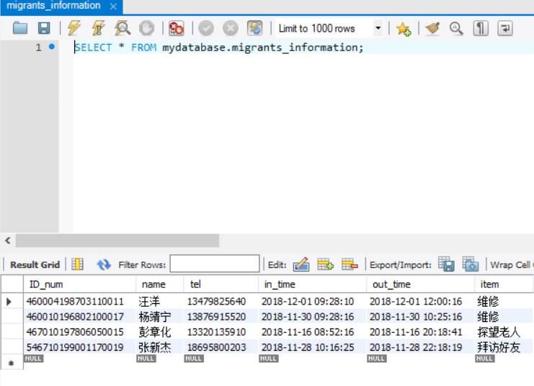

**7.2.9楼宇信息管理**

楼宇信息管理的界面如下所示：

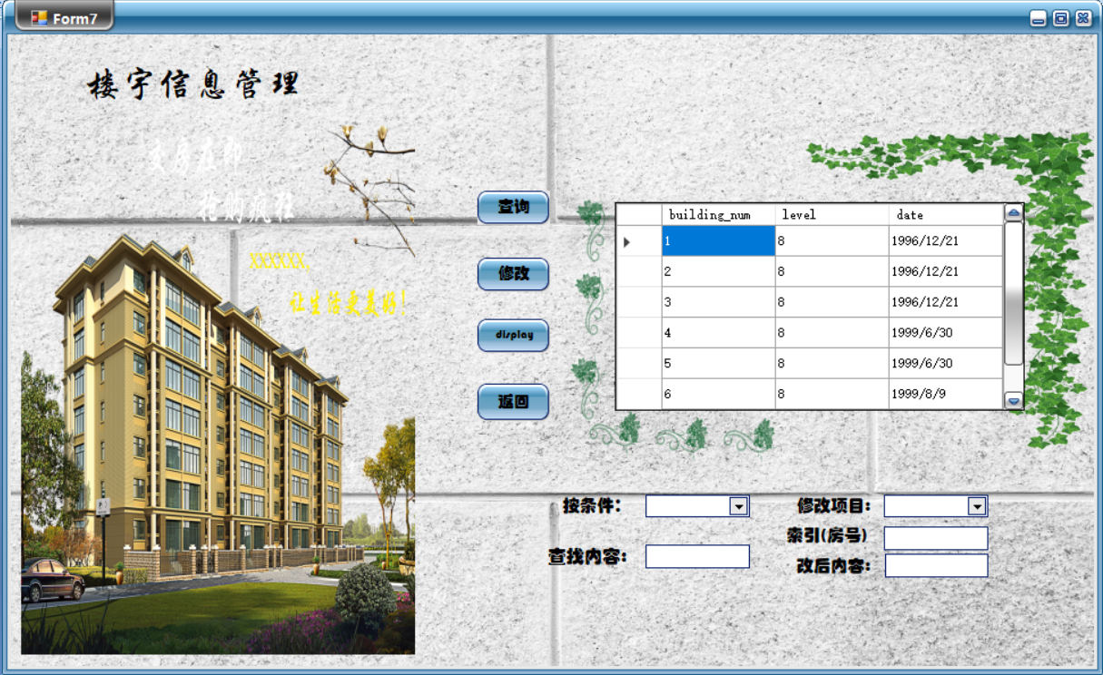

1. 查询

查询5号楼的所有信息：

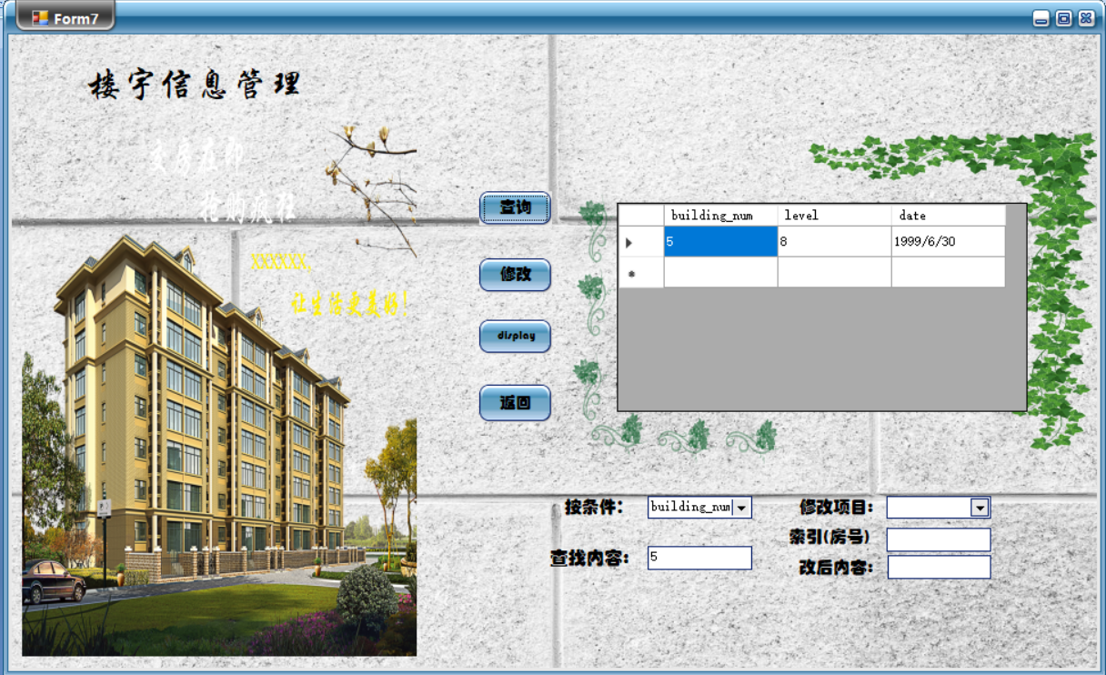

1. 修改

修改6号楼的建成时间（原本是1999/8/9建成，现改为1999/6/30）

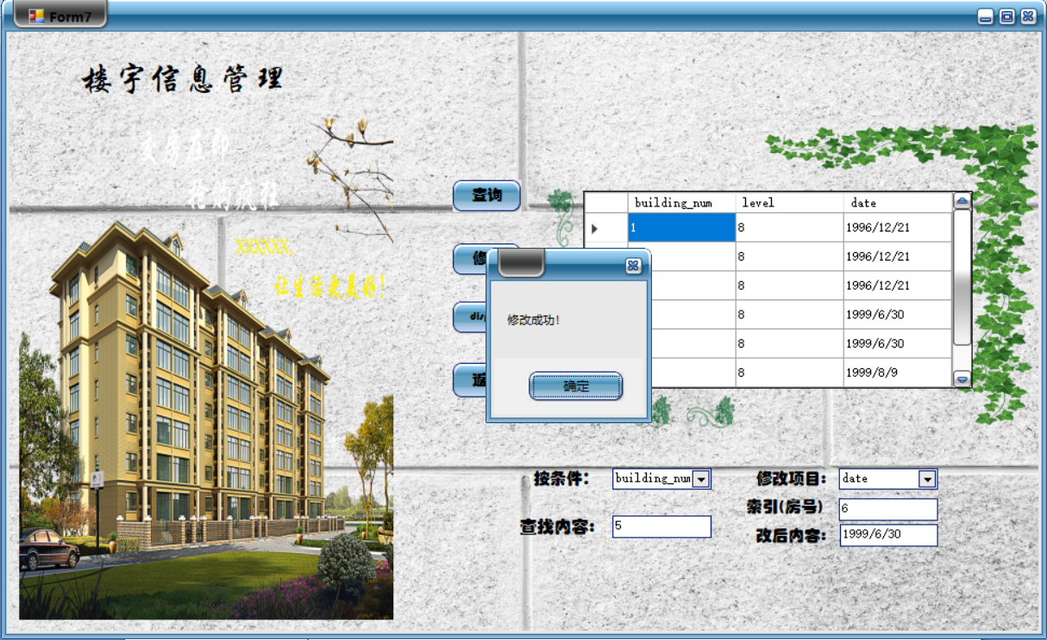

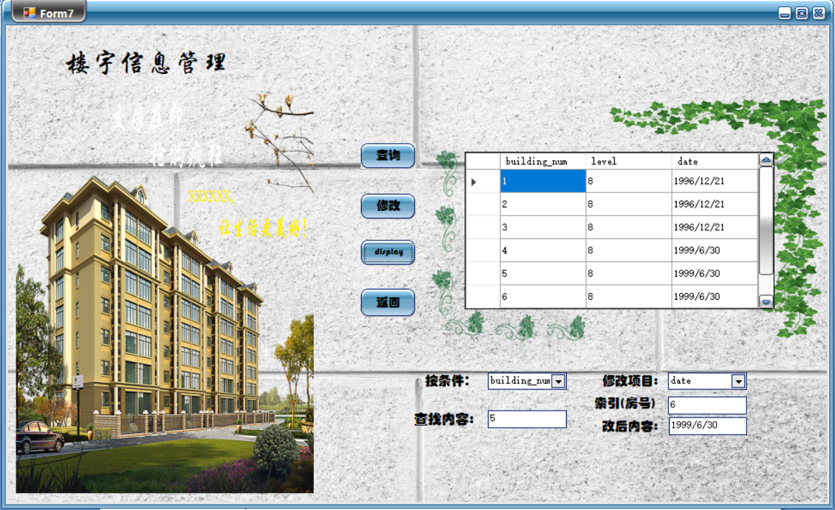

数据库后台：

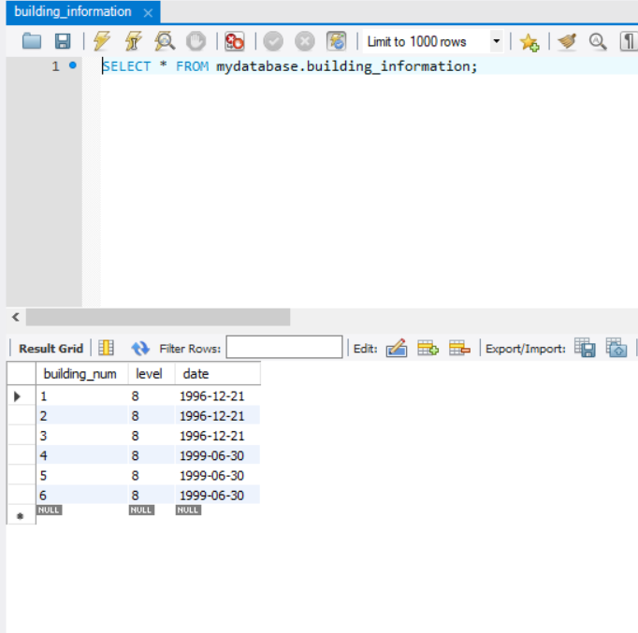

**7.2.10房屋信息管理**

房屋信息管理的界面如下所示：

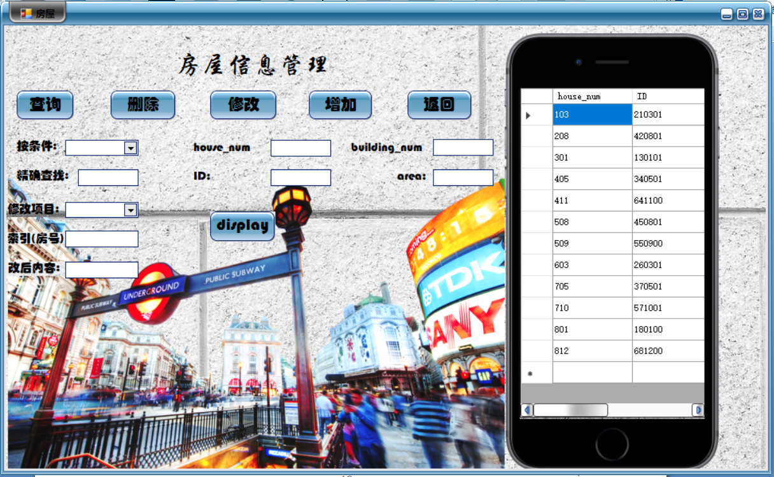

1. 查询

查询103号房

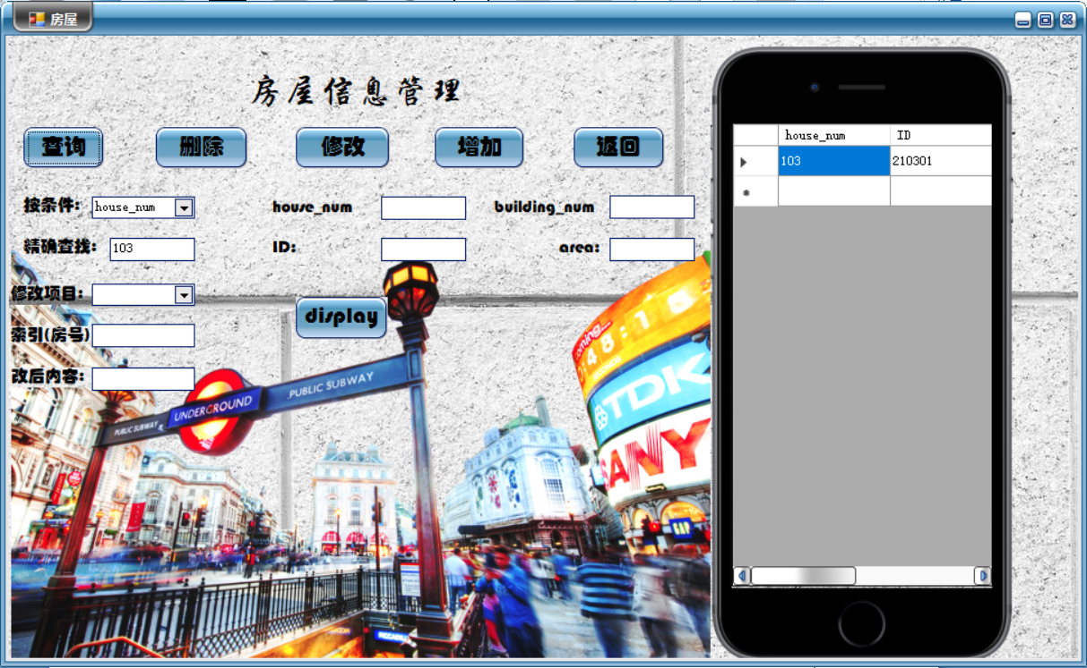

1. 增加

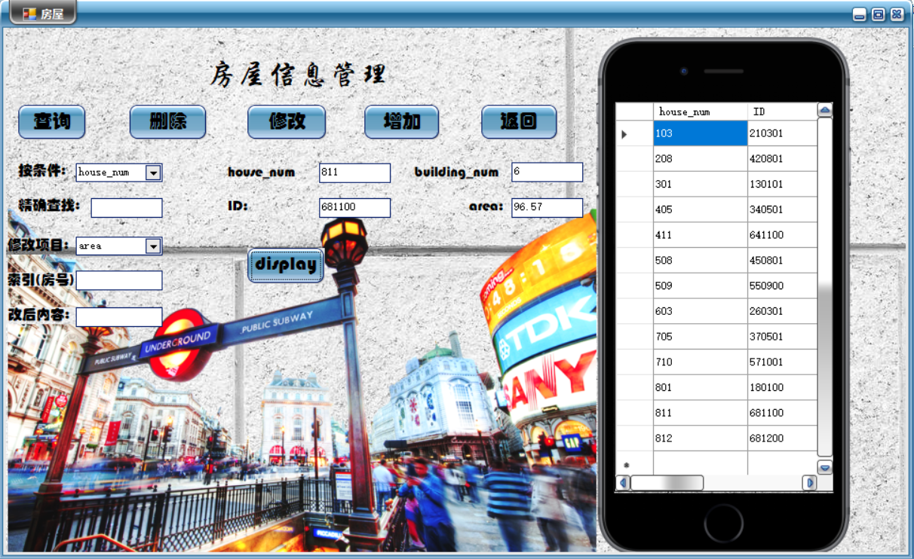

数据库后台

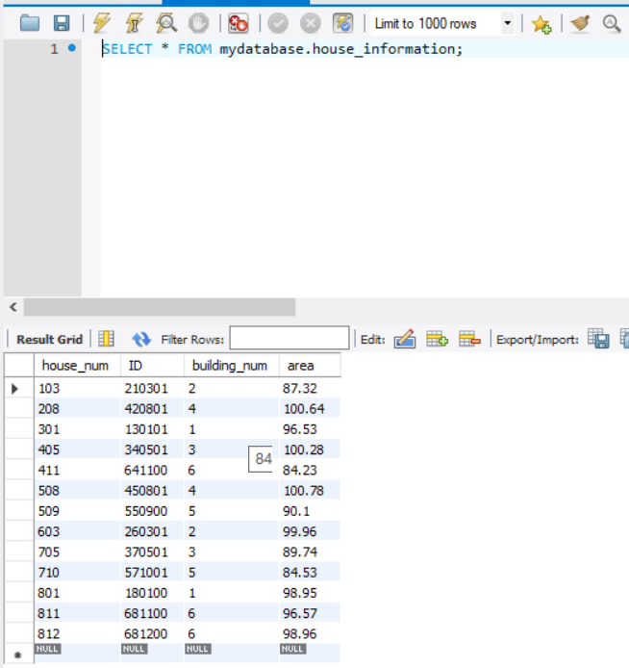

1. 修改

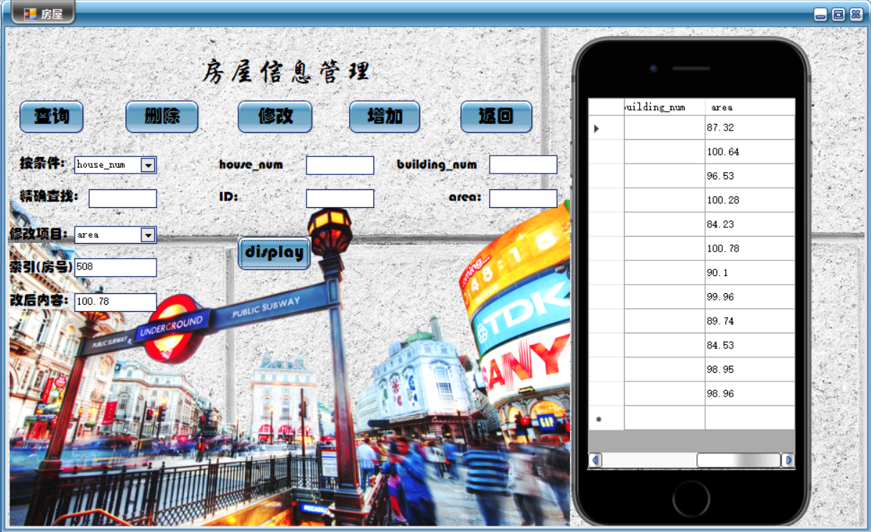

数据库后台：



1. 删除

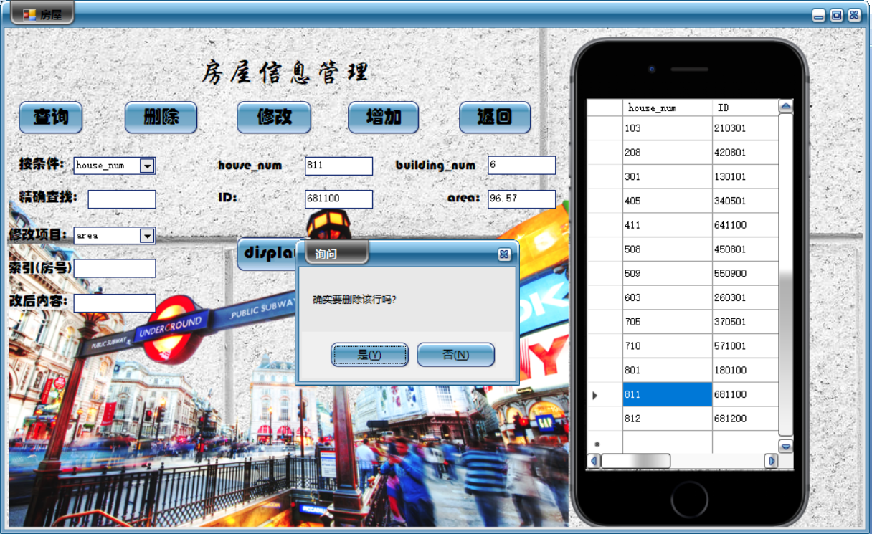

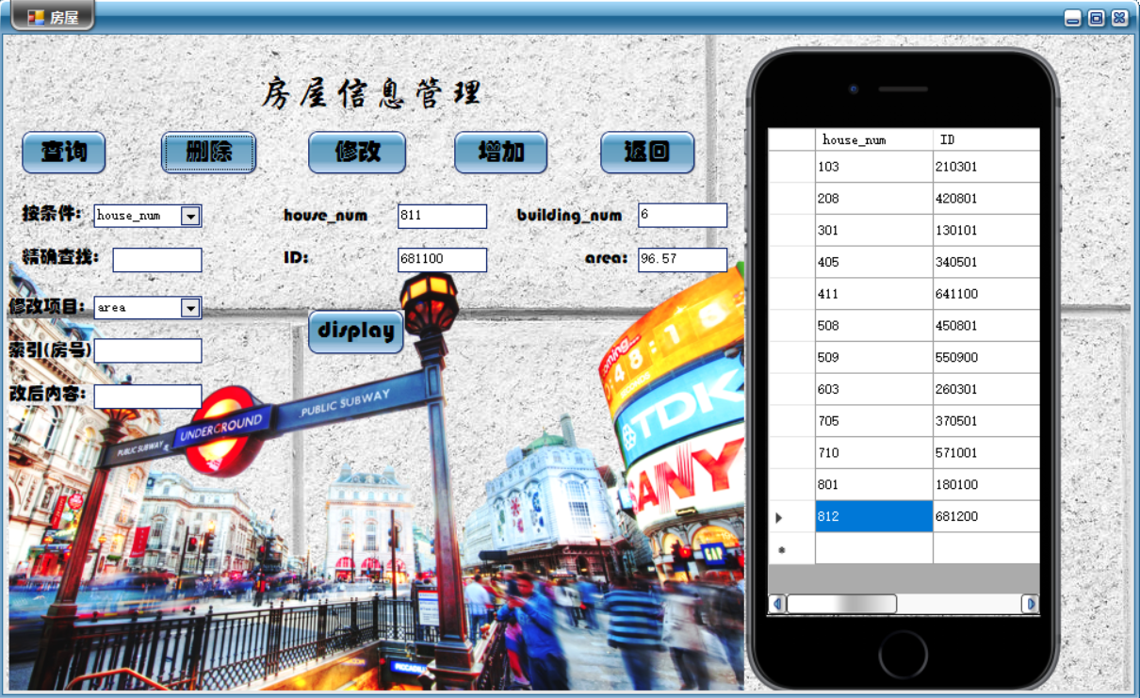

数据库后台：

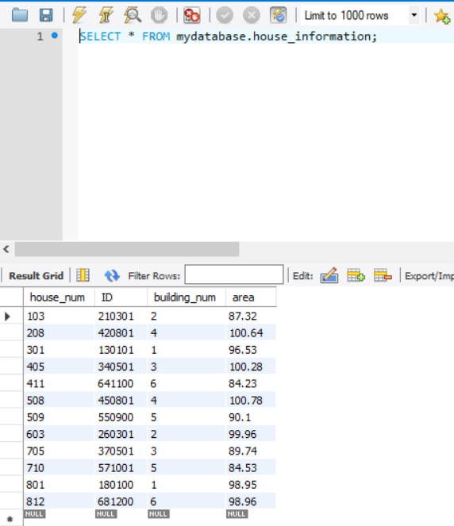

**7.3事务设计**

该系统中，所有关于查询的事务基本上都可以由Select语句实现，而更新的事务则用Update语句，删除的事务用Delete语句实现。

**7.3.1业主信息管理相关事务**

业主信息管理相关事务包括小区业主信息的查看、删除、修改、添加。具体代码如下：

private void button1_Click(object sender, EventArgs e)

{

string connString = "server=127.0.0.1;database=mydatabase;uid=root;pwd= ;charset=utf8";

MySqlConnection conn = new MySqlConnection(connString);

conn.Open();

string sql = "select * from mydatabase.owner_information";

MySqlDataAdapter da = new MySqlDataAdapter();//实例化MysqlDataAdapter

MySqlCommand cmd1 = new MySqlCommand(sql, conn);

da.SelectCommand = cmd1;//设置为已实例化MysqlDataAdapter的查询命令

DataSet ds1 = new DataSet();//实例化DataSet

da.Fill(ds1);

dataGridView1.DataSource = ds1.Tables[0];

conn.Close();

}

private void button2_Click(object sender, EventArgs e)

{

if (MessageBox.Show("确实要删除该行吗?", "询问", MessageBoxButtons.YesNo) == DialogResult.Yes)

{

//获取点击datagridview1的行的 行号

int r = this.dataGridView1.CurrentRow.Index;

//获取此行的值

string yuangong = this.dataGridView1.Rows[r].Cells["ID"].Value.ToString();

//删除 datagridview1 的选中行

this.dataGridView1.Rows.Remove(this.dataGridView1.Rows[r]);

//删除数据库的 house_num) 的对应行

string str = "server=127.0.0.1;database=mydatabase;uid=root;pwd= ;charset=utf8"; //数据库链接字符串

MySqlConnection conn = new MySqlConnection(str); //实例化链接

conn.Open(); //打了链接

string sql = "delete from owner_information where ID='" + yuangong + "'";

MySqlCommand sda = new MySqlCommand(sql, conn);

sda.ExecuteNonQuery();

conn.Close();

}

}

private void button4_Click(object sender, EventArgs e)

{

string constr = "server=127.0.0.1;database=mydatabase;uid=root;pwd= ;charset=utf8";

MySqlConnection conn = new MySqlConnection(constr);//创建数据库连接

conn.Open();//打开连接

//往表 Tittle里插入指定内容。

string str = string.Format("insert into owner_information (ID,name,id_num,tel,building_num,house_num,workplace,vehicle_type,vehicle_num) values ('{0}','{1}','{2}','{3}','{4}','{5}','{6}','{7}','{8}')", textBox2.Text, textBox3.Text, textBox4.Text, textBox5.Text, textBox6.Text, textBox7.Text, textBox8.Text, textBox9.Text, textBox10.Text);

MySqlCommand cmd = new MySqlCommand(str, conn);//对指定的连接conn执行SQL数据操作语句

int i = cmd.ExecuteNonQuery();//执行指定的sql操作语句。数据库表里的数据就被更新了,i表示受影响的行数。

}

private void button6_Click(object sender, EventArgs e)

{

if (this.comboBox1.SelectedIndex == 0)//comboBox2下拉框选择笫一项

            {

conn = new MySqlConnection("server=127.0.0.1;database=mydatabase;uid=root;pwd= ;charset=utf8");

conn.Open();

MySqlCommand cmd = new MySqlCommand("select * from owner_information where ID like '%" + textBox1.Text + "%'", conn);

string sqlSel = "select count(*) from owner_information where ID ='" + textBox1.Text.Trim() + "'";

MySqlCommand com = new MySqlCommand(sqlSel, conn);

if (Convert.ToInt32(com.ExecuteScalar()) <= 0)

{

MessageBox.Show("未找到该户主！显示失败！");

textBox1.Text = " ";

}

MySqlDataAdapter sda = new MySqlDataAdapter();

sda.SelectCommand = cmd;

DataSet ds = new DataSet();

sda.Fill(ds, "owner_information");

dataGridView1.DataSource = ds.Tables["owner_information"];

}

if (this.comboBox1.SelectedIndex == 1)//comboBox2下拉框选择笫二项

            {

conn = new MySqlConnection("server=127.0.0.1;database=mydatabase;uid=root;pwd= ;charset=utf8");

conn.Open();

MySqlCommand cmd = new MySqlCommand("select * from owner_information where name like '%" + textBox1.Text + "%'", conn);

string sqlSel = "select count(*) from owner_information where name ='" + textBox1.Text.Trim() + "'";

MySqlCommand com = new MySqlCommand(sqlSel, conn);

if (Convert.ToInt32(com.ExecuteScalar()) <= 0)

{

MessageBox.Show("未找到该户主！显示失败！");

textBox1.Text = " ";

}

MySqlDataAdapter sda = new MySqlDataAdapter();

sda.SelectCommand = cmd;

DataSet ds = new DataSet();

sda.Fill(ds, "owner_information");

dataGridView1.DataSource = ds.Tables["owner_information"];

}

if (this.comboBox1.SelectedIndex == 2)//comboBox2下拉框选择笫三项

            {

conn = new MySqlConnection("server=127.0.0.1;database=mydatabase;uid=root;pwd= ;charset=utf8");

conn.Open();

MySqlCommand cmd = new MySqlCommand("select * from owner_information where id_num like '%" + textBox1.Text + "%'", conn);

string sqlSel = "select count(*) from owner_information where id_num ='" + textBox1.Text.Trim() + "'";

MySqlCommand com = new MySqlCommand(sqlSel, conn);

if (Convert.ToInt32(com.ExecuteScalar()) <= 0)

{

MessageBox.Show("未找到该户主！显示失败！");

textBox1.Text = " ";

}

MySqlDataAdapter sda = new MySqlDataAdapter();

sda.SelectCommand = cmd;

DataSet ds = new DataSet();

sda.Fill(ds, "owner_information");

dataGridView1.DataSource = ds.Tables["owner_information"];

}

if (this.comboBox1.SelectedIndex == 3)//comboBox2下拉框选择笫四项

            {

conn = new MySqlConnection("server=127.0.0.1;database=mydatabase;uid=root;pwd= ;charset=utf8");

conn.Open();

MySqlCommand cmd = new MySqlCommand("select * from owner_information where tel like '%" + textBox1.Text + "%'", conn);

string sqlSel = "select count(*) from owner_information where tel ='" + textBox1.Text.Trim() + "'";

MySqlCommand com = new MySqlCommand(sqlSel, conn);

if (Convert.ToInt32(com.ExecuteScalar()) <= 0)

{

MessageBox.Show("未找到该户主！显示失败！");

textBox1.Text = " ";

}

MySqlDataAdapter sda = new MySqlDataAdapter();

sda.SelectCommand = cmd;

DataSet ds = new DataSet();

sda.Fill(ds, "owner_information");

dataGridView1.DataSource = ds.Tables["owner_information"];

}

if (this.comboBox1.SelectedIndex == 4)//comboBox2下拉框选择笫五项

            {

conn = new MySqlConnection("server=127.0.0.1;database=mydatabase;uid=root;pwd= ;charset=utf8");

conn.Open();

MySqlCommand cmd = new MySqlCommand("select * from owner_information where building_num like '%" + textBox1.Text + "%'", conn);

string sqlSel = "select count(*) from owner_information where building_num ='" + textBox1.Text.Trim() + "'";

MySqlCommand com = new MySqlCommand(sqlSel, conn);

if (Convert.ToInt32(com.ExecuteScalar()) <= 0)

{

MessageBox.Show("未找到该楼号！显示失败！");

textBox1.Text = " ";

}

MySqlDataAdapter sda = new MySqlDataAdapter();

sda.SelectCommand = cmd;

DataSet ds = new DataSet();

sda.Fill(ds, "owner_information");

dataGridView1.DataSource = ds.Tables["owner_information"];

}

if (this.comboBox1.SelectedIndex == 5)//comboBox2下拉框选择笫六项

            {

conn = new MySqlConnection("server=127.0.0.1;database=mydatabase;uid=root;pwd= ;charset=utf8");

conn.Open();

MySqlCommand cmd = new MySqlCommand("select * from owner_information where house_num like '%" + textBox1.Text + "%'", conn);

string sqlSel = "select count(*) from owner_information where house_num ='" + textBox1.Text.Trim() + "'";

MySqlCommand com = new MySqlCommand(sqlSel, conn);

if (Convert.ToInt32(com.ExecuteScalar()) <= 0)

{

MessageBox.Show("未找到该户主！显示失败！");

textBox1.Text = " ";

}

MySqlDataAdapter sda = new MySqlDataAdapter();

sda.SelectCommand = cmd;

DataSet ds = new DataSet();

sda.Fill(ds, "owner_information");

dataGridView1.DataSource = ds.Tables["owner_information"];

}

}

private void button3_Click(object sender, EventArgs e)

{

if (this.comboBox2.SelectedIndex == 0)//comboBox2下拉框选择笫一项

            {

string str = "server=127.0.0.1;database=mydatabase;uid=root;pwd= ;charset=utf8"; //数据库连接语句

MySqlConnection connection = new MySqlConnection(str); //连接数据库

connection.Open(); //打开数据库连接

string sql = "update owner_information set name='" + textBox12.Text + "' where ID='" + textBox11.Text + "'";

string sqlSel = "select count(*) from owner_information where ID ='" + textBox11.Text.Trim() + "'";

MySqlCommand com = new MySqlCommand(sqlSel, connection);

if (Convert.ToInt32(com.ExecuteScalar()) <= 0)

{

MessageBox.Show("未找到该户主！修改失败！");

textBox11.Text = " ";

}

else

MessageBox.Show("修改成功！");

MySqlCommand command = new MySqlCommand(sql, connection);

command.ExecuteNonQuery();

connection.Close();

}

if (this.comboBox2.SelectedIndex == 1)//comboBox2下拉框选择笫二项

            {

string str = "server=127.0.0.1;database=mydatabase;uid=root;pwd= ;charset=utf8"; //数据库连接语句

MySqlConnection connection = new MySqlConnection(str); //连接数据库

connection.Open(); //打开数据库连接

string sql = "update owner_information set id_num='" + textBox12.Text + "' where ID='" + textBox11.Text + "'";

string sqlSel = "select count(*) from owner_information where ID ='" + textBox11.Text.Trim() + "'";

MySqlCommand com = new MySqlCommand(sqlSel, connection);

if (Convert.ToInt32(com.ExecuteScalar()) <= 0)

{

MessageBox.Show("未找到该户主！修改失败！");

textBox11.Text = " ";

}

else

MessageBox.Show("修改成功！");

MySqlCommand command = new MySqlCommand(sql, connection);

command.ExecuteNonQuery();

connection.Close();

}

if (this.comboBox2.SelectedIndex == 2)//comboBox2下拉框选择笫三项

            {

string str = "server=127.0.0.1;database=mydatabase;uid=root;pwd= ;charset=utf8"; //数据库连接语句

MySqlConnection connection = new MySqlConnection(str); //连接数据库

connection.Open(); //打开数据库连接

string sql = "update owner_information set tel='" + textBox12.Text + "' where ID='" + textBox11.Text + "'";

string sqlSel = "select count(*) from owner_information where ID ='" + textBox11.Text.Trim() + "'";

MySqlCommand com = new MySqlCommand(sqlSel, connection);

if (Convert.ToInt32(com.ExecuteScalar()) <= 0)

{

MessageBox.Show("未找到该户主！修改失败！");

textBox11.Text = " ";

}

else

MessageBox.Show("修改成功！");

MySqlCommand command = new MySqlCommand(sql, connection);

command.ExecuteNonQuery();

connection.Close();

}

if (this.comboBox2.SelectedIndex == 3)//comboBox2下拉框选择笫四项

            {

string str = "server=127.0.0.1;database=mydatabase;uid=root;pwd= ;charset=utf8"; //数据库连接语句

MySqlConnection connection = new MySqlConnection(str); //连接数据库

connection.Open(); //打开数据库连接

string sql = "update owner_information set building_num='" + textBox12.Text + "' where ID='" + textBox11.Text + "'";

string sqlSel = "select count(*) from owner_information where ID ='" + textBox11.Text.Trim() + "'";

MySqlCommand com = new MySqlCommand(sqlSel, connection);

if (Convert.ToInt32(com.ExecuteScalar()) <= 0)

{

MessageBox.Show("未找到该楼号！修改失败！");

textBox11.Text = " ";

}

else

MessageBox.Show("修改成功！");

MySqlCommand command = new MySqlCommand(sql, connection);

command.ExecuteNonQuery();

connection.Close();

}

if (this.comboBox2.SelectedIndex == 4)//comboBox2下拉框选择笫五项

            {

string str = "server=127.0.0.1;database=mydatabase;uid=root;pwd= ;charset=utf8"; //数据库连接语句

MySqlConnection connection = new MySqlConnection(str); //连接数据库

connection.Open(); //打开数据库连接

string sql = "update owner_information set house_num='" + textBox12.Text + "' where ID='" + textBox11.Text + "'";

MySqlCommand command = new MySqlCommand(sql, connection);

command.ExecuteNonQuery();

connection.Close();

MessageBox.Show("修改成功！");

}

if (this.comboBox2.SelectedIndex == 5)//comboBox2下拉框选择笫六项

            {

string str = "server=127.0.0.1;database=mydatabase;uid=root;pwd= ;charset=utf8"; //数据库连接语句

MySqlConnection connection = new MySqlConnection(str); //连接数据库

connection.Open(); //打开数据库连接

string sql = "update owner_information set workplace='" + textBox12.Text + "' where ID='" + textBox11.Text + "'";

string sqlSel = "select count(*) from owner_information where ID ='" + textBox11.Text.Trim() + "'";

MySqlCommand com = new MySqlCommand(sqlSel, connection);

if (Convert.ToInt32(com.ExecuteScalar()) <= 0)

{

MessageBox.Show("未找到该户主！修改失败！");

textBox11.Text = " ";

}

else

MessageBox.Show("修改成功！");

MySqlCommand command = new MySqlCommand(sql, connection);

command.ExecuteNonQuery();

connection.Close();

}

if (this.comboBox2.SelectedIndex == 6)//comboBox2下拉框选择笫七项

            {

string str = "server=127.0.0.1;database=mydatabase;uid=root;pwd= ;charset=utf8"; //数据库连接语句

MySqlConnection connection = new MySqlConnection(str); //连接数据库

connection.Open(); //打开数据库连接

string sql = "update owner_information set vehicle_type='" + textBox12.Text + "' where ID='" + textBox11.Text + "'";

string sqlSel = "select count(*) from owner_information where ID ='" + textBox11.Text.Trim() + "'";

MySqlCommand com = new MySqlCommand(sqlSel, connection);

if (Convert.ToInt32(com.ExecuteScalar()) <= 0)

{

MessageBox.Show("未找到该户主！修改失败！");

textBox11.Text = " ";

}

else

MessageBox.Show("修改成功！");

MySqlCommand command = new MySqlCommand(sql, connection);

command.ExecuteNonQuery();

connection.Close();

}

if (this.comboBox2.SelectedIndex == 7)//comboBox2下拉框选择笫八项

            {

string str = "server=127.0.0.1;database=mydatabase;uid=root;pwd= ;charset=utf8"; //数据库连接语句

MySqlConnection connection = new MySqlConnection(str); //连接数据库

connection.Open(); //打开数据库连接

string sql = "update owner_information set vehicle_num='" + textBox12.Text + "' where ID='" + textBox11.Text + "'";

string sqlSel = "select count(*) from owner_information where ID ='" + textBox11.Text.Trim() + "'";

MySqlCommand com = new MySqlCommand(sqlSel, connection);

if (Convert.ToInt32(com.ExecuteScalar()) <= 0)

{

MessageBox.Show("未找到该户主！修改失败！");

textBox11.Text = " ";

}

else

MessageBox.Show("修改成功！");

MySqlCommand command = new MySqlCommand(sql, connection);

command.ExecuteNonQuery();

connection.Close();

}

}

**7.3.2维修信息管理相关事务**

维修信息管理相关事务包括小区业主报修信息的查看、删除、修改、添加。具体代码如下：

private void button1_Click(object sender, EventArgs e)

{

string connString = "server=127.0.0.1;database=mydatabase;uid=root;pwd= ;charset=utf8";

MySqlConnection conn = new MySqlConnection(connString);

conn.Open();

string sql = "select * from mydatabase.repair";

MySqlDataAdapter da = new MySqlDataAdapter();//实例化MysqlDataAdapter

MySqlCommand cmd1 = new MySqlCommand(sql, conn);

da.SelectCommand = cmd1;//设置为已实例化MysqlDataAdapter的查询命令

DataSet ds1 = new DataSet();//实例化DataSet

da.Fill(ds1);

dataGridView1.DataSource = ds1.Tables[0];

conn.Close();

}

private void Form5_Load(object sender, EventArgs e)

{

MySqlConnection cn = new MySqlConnection("server=127.0.0.1;database=mydatabase;uid=root;pwd= ;charset=utf8");       //连接数据库

            cn.Open();                                                                            //打开连接的数据库

            MySqlDataAdapter dap = new MySqlDataAdapter("SELECT * FROM repair", cn);    //建立SQL语句与数据库的连接

            DataSet ds = new DataSet();                                                                //实例化DataSet类

            dap.Fill(ds, "Table");                                                                     //添加SQL语句并执行

            string[] arylist = new string[ds.Tables[0].Columns.Count];                            //按照列数定义字符串数组

            for (int i = 0; i < 3; i++)                               //遍历列

            {

arylist[i] = ds.Tables[0].Columns[i].ColumnName;                                 //获取数据表中的列名

            }

for (int j = 0; j < 3; j++)

{

comboBox1.Items.Add(arylist[j]);                                                        //将列名添加到comboBox1控件中

            }

for (int t = 1; t < 7; t++)                               //遍历列

            {

arylist[t] = ds.Tables[0].Columns[t].ColumnName;                                 //获取数据表中的列名

            }

for (int a = 1; a < 7; a++)

{

comboBox2.Items.Add(arylist[a]);                                                        //将列名添加到comboBox1控件中

            }

dataGridView1.DataSource = ds.Tables[0].DefaultView;

}

MySqlConnection conn;

private void button6_Click(object sender, EventArgs e)

{

if (this.comboBox1.SelectedIndex == 0)//comboBox2下拉框选择笫一项

            {

conn = new MySqlConnection("server=127.0.0.1;database=mydatabase;uid=root;pwd= ;charset=utf8");

conn.Open();

MySqlCommand cmd = new MySqlCommand("select * from repair where house_num like '%" + textBox1.Text + "%'", conn);

string sqlSel = "select count(*) from repair where house_num ='" + textBox1.Text.Trim() + "'";

MySqlCommand com = new MySqlCommand(sqlSel, conn);

if (Convert.ToInt32(com.ExecuteScalar()) <= 0)

{

MessageBox.Show("未找到该房号！显示失败！");

textBox1.Text = " ";

}

MySqlDataAdapter sda = new MySqlDataAdapter();

sda.SelectCommand = cmd;

DataSet ds = new DataSet();

sda.Fill(ds, "repair");

dataGridView1.DataSource = ds.Tables["repair"];

}

if (this.comboBox1.SelectedIndex == 1)//comboBox2下拉框选择笫二项

            {

conn = new MySqlConnection("server=127.0.0.1;database=mydatabase;uid=root;pwd= ;charset=utf8");

conn.Open();

MySqlCommand cmd = new MySqlCommand("select * from repair where name like '%" + textBox1.Text + "%'", conn);

string sqlSel = "select count(*) from repair where name ='" + textBox1.Text.Trim() + "'";

MySqlCommand com = new MySqlCommand(sqlSel, conn);

if (Convert.ToInt32(com.ExecuteScalar()) <= 0)

{

MessageBox.Show("未找到该业主！显示失败！");

textBox1.Text = " ";

}

MySqlDataAdapter sda = new MySqlDataAdapter();

sda.SelectCommand = cmd;

DataSet ds = new DataSet();

sda.Fill(ds, "repair");

dataGridView1.DataSource = ds.Tables["repair"];

}

if (this.comboBox1.SelectedIndex == 2)//comboBox2下拉框选择笫三项

            {

conn = new MySqlConnection("server=127.0.0.1;database=mydatabase;uid=root;pwd= ;charset=utf8");

conn.Open();

MySqlCommand cmd = new MySqlCommand("select * from repair where building_num like '%" + textBox1.Text + "%'", conn);

string sqlSel = "select count(*) from repair where building_num ='" + textBox1.Text.Trim() + "'";

MySqlCommand com = new MySqlCommand(sqlSel, conn);

if (Convert.ToInt32(com.ExecuteScalar()) <= 0)

{

MessageBox.Show("未找到该楼号！显示失败！");

textBox1.Text = " ";

}

MySqlDataAdapter sda = new MySqlDataAdapter();

sda.SelectCommand = cmd;

DataSet ds = new DataSet();

sda.Fill(ds, "repair");

dataGridView1.DataSource = ds.Tables["repair"];

}

}

private void button2_Click(object sender, EventArgs e)

{

if (MessageBox.Show("确实要删除该行吗?", "询问", MessageBoxButtons.YesNo) == DialogResult.Yes)

{

//获取点击datagridview1的行的 行号

int r = this.dataGridView1.CurrentRow.Index;

//获取此行的 员工编号 的值

string yuangong = this.dataGridView1.Rows[r].Cells["house_num"].Value.ToString();

//删除 datagridview1 的选中行

this.dataGridView1.Rows.Remove(this.dataGridView1.Rows[r]);

//删除数据库的 house_num) 的对应行

string str = "server=127.0.0.1;database=mydatabase;uid=root;pwd= ;charset=utf8"; //数据库链接字符串

MySqlConnection conn = new MySqlConnection(str); //实例化链接

conn.Open(); //打了链接

string sql = "delete from repair where house_num='" + yuangong + "'";

MySqlCommand sda = new MySqlCommand(sql, conn);

sda.ExecuteNonQuery();

conn.Close();

}

}

private void button4_Click(object sender, EventArgs e)

{

string constr = "server=127.0.0.1;database=mydatabase;uid=root;pwd= ;charset=utf8";

MySqlConnection conn = new MySqlConnection(constr);//创建数据库连接

conn.Open();//打开连接

//往表 Tittle里插入指定内容。

string str = string.Format("insert into repair (name,building_num,house_num,tel,project,date,attendant) values ('{0}','{1}','{2}','{3}','{4}','{5}','{6}')", textBox2.Text, textBox3.Text, textBox5.Text, textBox4.Text, textBox6.Text, textBox7.Text, textBox8.Text);

MySqlCommand cmd = new MySqlCommand(str, conn);//对指定的连接conn执行SQL数据操作语句

int i = cmd.ExecuteNonQuery();//执行指定的sql操作语句。数据库表里的数据就被更新了,i表示受影响的行数。

}

private void button4_Click(object sender, EventArgs e)

{

string constr = "server=127.0.0.1;database=mydatabase;uid=root;pwd= ;charset=utf8";

MySqlConnection conn = new MySqlConnection(constr);//创建数据库连接

conn.Open();//打开连接

//往表 Tittle里插入指定内容。

string str = string.Format("insert into repair (house_num,name,building_num,tel,project,date,attendant) values ('{0}','{1}','{2}','{3}','{4}','{5}','{6}')", textBox2.Text, textBox3.Text, textBox5.Text, textBox4.Text, textBox6.Text, textBox7.Text, textBox8.Text);

MySqlCommand cmd = new MySqlCommand(str, conn);//对指定的连接conn执行SQL数据操作语句

int i = cmd.ExecuteNonQuery();//执行指定的sql操作语句。数据库表里的数据就被更新了,i表示受影响的行数。

}

private void button3_Click(object sender, EventArgs e)

{

if (this.comboBox2.SelectedIndex == 0)//comboBox2下拉框选择笫一项

            {

string str = "server=127.0.0.1;database=mydatabase;uid=root;pwd= ;charset=utf8"; //数据库连接语句

MySqlConnection connection = new MySqlConnection(str); //连接数据库

connection.Open(); //打开数据库连接

string sql = "update repair set name='" + textBox10.Text + "' where house_num='" + textBox9.Text + "'";

string sqlSel = "select count(*) from repair where house_num ='" + textBox9.Text.Trim() + "'";

MySqlCommand com = new MySqlCommand(sqlSel, connection);

if (Convert.ToInt32(com.ExecuteScalar()) <= 0)

{

MessageBox.Show("未找到该房号！修改失败！");

textBox9.Text = " ";

}

else

MessageBox.Show("修改成功！");

MySqlCommand command = new MySqlCommand(sql, connection);

command.ExecuteNonQuery();

connection.Close();

}

if (this.comboBox2.SelectedIndex == 1)//comboBox2下拉框选择笫二项

            {

string str = "server=127.0.0.1;database=mydatabase;uid=root;pwd= ;charset=utf8"; //数据库连接语句

MySqlConnection connection = new MySqlConnection(str); //连接数据库

connection.Open(); //打开数据库连接

string sql = "update repair set building_num='" + textBox10.Text + "' where house_num='" + textBox9.Text + "'";

string sqlSel = "select count(*) from repair where house_num ='" + textBox9.Text.Trim() + "'";

MySqlCommand com = new MySqlCommand(sqlSel, connection);

if (Convert.ToInt32(com.ExecuteScalar()) <= 0)

{

MessageBox.Show("未找到该房号！修改失败！");

textBox9.Text = " ";

}

else

MessageBox.Show("修改成功！");

MySqlCommand command = new MySqlCommand(sql, connection);

command.ExecuteNonQuery();

connection.Close();

}

if (this.comboBox2.SelectedIndex == 2)//comboBox2下拉框选择笫三项

            {

string str = "server=127.0.0.1;database=mydatabase;uid=root;pwd= ;charset=utf8"; //数据库连接语句

MySqlConnection connection = new MySqlConnection(str); //连接数据库

connection.Open(); //打开数据库连接

string sql = "update repair set tel='" + textBox10.Text + "' where house_num='" + textBox9.Text + "'";

string sqlSel = "select count(*) from repair where house_num ='" + textBox9.Text.Trim() + "'";

MySqlCommand com = new MySqlCommand(sqlSel, connection);

if (Convert.ToInt32(com.ExecuteScalar()) <= 0)

{

MessageBox.Show("未找到该房号！修改失败！");

textBox9.Text = " ";

}

else

MessageBox.Show("修改成功！");

MySqlCommand command = new MySqlCommand(sql, connection);

command.ExecuteNonQuery();

connection.Close();

}

if (this.comboBox2.SelectedIndex == 3)//comboBox2下拉框选择笫四项

            {

string str = "server=127.0.0.1;database=mydatabase;uid=root;pwd= ;charset=utf8"; //数据库连接语句

MySqlConnection connection = new MySqlConnection(str); //连接数据库

connection.Open(); //打开数据库连接

string sql = "update repair set project='" + textBox10.Text + "' where house_num='" + textBox9.Text + "'";

string sqlSel = "select count(*) from repair where house_num ='" + textBox9.Text.Trim() + "'";

MySqlCommand com = new MySqlCommand(sqlSel, connection);

if (Convert.ToInt32(com.ExecuteScalar()) <= 0)

{

MessageBox.Show("未找到该房号！修改失败！");

textBox9.Text = " ";

}

else

MessageBox.Show("修改成功！");

MySqlCommand command = new MySqlCommand(sql, connection);

command.ExecuteNonQuery();

connection.Close();

}

if (this.comboBox2.SelectedIndex == 4)//comboBox2下拉框选择笫五项

            {

string str = "server=127.0.0.1;database=mydatabase;uid=root;pwd= ;charset=utf8"; //数据库连接语句

MySqlConnection connection = new MySqlConnection(str); //连接数据库

connection.Open(); //打开数据库连接

string sql = "update repair set date='" + textBox10.Text + "' where house_num='" + textBox9.Text + "'";

string sqlSel = "select count(*) from repair where house_num ='" + textBox9.Text.Trim() + "'";

MySqlCommand com = new MySqlCommand(sqlSel, connection);

if (Convert.ToInt32(com.ExecuteScalar()) <= 0)

{

MessageBox.Show("未找到该房号！修改失败！");

textBox9.Text = " ";

}

else

MessageBox.Show("修改成功！");

MySqlCommand command = new MySqlCommand(sql, connection);

command.ExecuteNonQuery();

connection.Close();

}

if (this.comboBox2.SelectedIndex == 5)//comboBox2下拉框选择笫六项

            {

string str = "server=127.0.0.1;database=mydatabase;uid=root;pwd= ;charset=utf8"; //数据库连接语句

MySqlConnection connection = new MySqlConnection(str); //连接数据库

connection.Open(); //打开数据库连接

string sql = "update repair set attendant='" + textBox10.Text + "' where house_num='" + textBox9.Text + "'";

string sqlSel = "select count(*) from repair where house_num ='" + textBox9.Text.Trim() + "'";

MySqlCommand com = new MySqlCommand(sqlSel, connection);

if (Convert.ToInt32(com.ExecuteScalar()) <= 0)

{

MessageBox.Show("未找到该房号！修改失败！");

textBox9.Text = " ";

}

else

MessageBox.Show("修改成功！");

MySqlCommand command = new MySqlCommand(sql, connection);

command.ExecuteNonQuery();

connection.Close();

}

}

**7.3.3车位信息管理相关事务**

车位信息管理相关事务包括小区车位信息的查看、删除、修改、添加。具体代码如下：

private void button1_Click(object sender, EventArgs e)

{

string connString = "server=127.0.0.1;database=mydatabase;uid=root;pwd= ;charset=utf8";

MySqlConnection conn = new MySqlConnection(connString);

conn.Open();

string sql = "select * from parking_management";

MySqlDataAdapter da = new MySqlDataAdapter();//实例化MysqlDataAdapter

MySqlCommand cmd1 = new MySqlCommand(sql, conn);

da.SelectCommand = cmd1;//设置为已实例化MysqlDataAdapter的查询命令

DataSet ds1 = new DataSet();//实例化DataSet

da.Fill(ds1);

dataGridView1.DataSource = ds1.Tables[0];

conn.Close();

}

private void button3_Click(object sender, EventArgs e)

{

if (MessageBox.Show("确实要删除该行吗?", "询问", MessageBoxButtons.YesNo) == DialogResult.Yes)

{

//获取点击datagridview1的行的 行号

int r = this.dataGridView1.CurrentRow.Index;

//获取此行的值

string yuangong = this.dataGridView1.Rows[r].Cells["vehicle_ID"].Value.ToString();

//删除 datagridview1 的选中行

this.dataGridView1.Rows.Remove(this.dataGridView1.Rows[r]);

//删除数据库的 house_num) 的对应行

string str = "server=127.0.0.1;database=mydatabase;uid=root;pwd= ;charset=utf8"; //数据库链接字符串

MySqlConnection conn = new MySqlConnection(str); //实例化链接

conn.Open(); //打了链接

string sql = "delete from parking_management where vehicle_ID='" + yuangong + "'";

MySqlCommand sda = new MySqlCommand(sql, conn);

sda.ExecuteNonQuery();

conn.Close();

}

}

private void button5_Click(object sender, EventArgs e)

{

string constr = "server=127.0.0.1;database=mydatabase;uid=root;pwd= ;charset=utf8";

MySqlConnection conn = new MySqlConnection(constr);//创建数据库连接

conn.Open();//打开连接

//往表 Tittle里插入指定内容。

string str = string.Format("insert into parking_management (vehicle_ID,vehicle_type,vehicle_num,ID,name,tel,fee) values ('{0}','{1}','{2}','{3}','{4}','{5}','{6}')", textBox2.Text, textBox3.Text, textBox4.Text, textBox5.Text, textBox6.Text, textBox7.Text, textBox8.Text);

MySqlCommand cmd = new MySqlCommand(str, conn);//对指定的连接conn执行SQL数据操作语句

int i = cmd.ExecuteNonQuery();//执行指定的sql操作语句。数据库表里的数据就被更新了,i表示受影响的行数。

}

private void Form6_Load(object sender, EventArgs e)

{

MySqlConnection cn = new MySqlConnection("server=127.0.0.1;database=mydatabase;uid=root;pwd= ;charset=utf8");       //连接数据库

            cn.Open();                                                                            //打开连接的数据库

            MySqlDataAdapter dap = new MySqlDataAdapter("SELECT * FROM parking_management", cn);    //建立SQL语句与数据库的连接

            DataSet ds = new DataSet();                                                                //实例化DataSet类

            dap.Fill(ds, "Table");                                                                     //添加SQL语句并执行

            string[] arylist = new string[ds.Tables[0].Columns.Count];                            //按照列数定义字符串数组

            for (int i = 0; i < 4; i++)                               //遍历列

            {

arylist[i] = ds.Tables[0].Columns[i].ColumnName;                                 //获取数据表中的列名

            }

for (int j = 0; j < 4; j++)

{

comboBox1.Items.Add(arylist[j]);                                                        //将列名添加到comboBox1控件中

            }

for (int t = 0; t < 4; t++)                               //遍历列

            {

arylist[t] = ds.Tables[0].Columns[t].ColumnName;                                 //获取数据表中的列名

            }

for (int a = 0; a < 4; a++)

{

comboBox1.Items.Add(arylist[a]);                                                        //将列名添加到comboBox1控件中

            }

dataGridView1.DataSource = ds.Tables[0].DefaultView;

}

MySqlConnection conn;

private void button2_Click(object sender, EventArgs e)

{

if (this.comboBox1.SelectedIndex == 0)//comboBox2下拉框选择笫一项

            {

conn = new MySqlConnection("server=127.0.0.1;database=mydatabase;uid=root;pwd= ;charset=utf8");

conn.Open();

MySqlCommand cmd = new MySqlCommand("select * from parking_management where vehicle_ID like '%" + textBox1.Text + "%'", conn);

string sqlSel = "select count(*) from parking_management where vehicle_ID ='" + textBox1.Text.Trim() + "'";

MySqlCommand com = new MySqlCommand(sqlSel, conn);

if (Convert.ToInt32(com.ExecuteScalar()) <= 0)

{

MessageBox.Show("未找到该车位号！显示失败！");

textBox1.Text = " ";

}

MySqlDataAdapter sda = new MySqlDataAdapter();

sda.SelectCommand = cmd;

DataSet ds = new DataSet();

sda.Fill(ds, "parking_management");

dataGridView1.DataSource = ds.Tables["parking_management"];

}

if (this.comboBox1.SelectedIndex == 1)//comboBox2下拉框选择笫二项

            {

conn = new MySqlConnection("server=127.0.0.1;database=mydatabase;uid=root;pwd= ;charset=utf8");

conn.Open();

MySqlCommand cmd = new MySqlCommand("select * from parking_management where vehicle_type like '%" + textBox1.Text + "%'", conn);

string sqlSel = "select count(*) from parking_management where vehicle_type ='" + textBox1.Text.Trim() + "'";

MySqlCommand com = new MySqlCommand(sqlSel, conn);

if (Convert.ToInt32(com.ExecuteScalar()) <= 0)

{

MessageBox.Show("未找到该车型！显示失败！");

textBox1.Text = " ";

}

MySqlDataAdapter sda = new MySqlDataAdapter();

sda.SelectCommand = cmd;

DataSet ds = new DataSet();

sda.Fill(ds, "parking_management");

dataGridView1.DataSource = ds.Tables["parking_management"];

}

if (this.comboBox1.SelectedIndex == 2)//comboBox2下拉框选择笫三项

            {

conn = new MySqlConnection("server=127.0.0.1;database=mydatabase;uid=root;pwd= ;charset=utf8");

conn.Open();

MySqlCommand cmd = new MySqlCommand("select * from parking_management where vehicle_num like '%" + textBox1.Text + "%'", conn);

string sqlSel = "select count(*) from parking_management where vehicle_num ='" + textBox1.Text.Trim() + "'";

MySqlCommand com = new MySqlCommand(sqlSel, conn);

if (Convert.ToInt32(com.ExecuteScalar()) <= 0)

{

MessageBox.Show("未找到该车牌号！显示失败！");

textBox1.Text = " ";

}

MySqlDataAdapter sda = new MySqlDataAdapter();

sda.SelectCommand = cmd;

DataSet ds = new DataSet();

sda.Fill(ds, "parking_management");

dataGridView1.DataSource = ds.Tables["parking_management"];

}

if (this.comboBox1.SelectedIndex == 3)//comboBox2下拉框选择笫四项

            {

conn = new MySqlConnection("server=127.0.0.1;database=mydatabase;uid=root;pwd= ;charset=utf8");

conn.Open();

MySqlCommand cmd = new MySqlCommand("select * from parking_management where ID like '%" + textBox1.Text + "%'", conn);

string sqlSel = "select count(*) from parking_management where ID ='" + textBox1.Text.Trim() + "'";

MySqlCommand com = new MySqlCommand(sqlSel, conn);

if (Convert.ToInt32(com.ExecuteScalar()) <= 0)

{

MessageBox.Show("未找到该业主！显示失败！");

textBox1.Text = " ";

}

MySqlDataAdapter sda = new MySqlDataAdapter();

sda.SelectCommand = cmd;

DataSet ds = new DataSet();

sda.Fill(ds, "parking_management");

dataGridView1.DataSource = ds.Tables["parking_management"];

}

}

private void button4_Click(object sender, EventArgs e)

{

if (this.comboBox2.SelectedIndex == 0)//comboBox2下拉框选择笫一项

            {

string str = "server=127.0.0.1;database=mydatabase;uid=root;pwd= ;charset=utf8"; //数据库连接语句

MySqlConnection connection = new MySqlConnection(str); //连接数据库

connection.Open(); //打开数据库连接

string sql = "update parking_management set vehicle_ID='" + textBox10.Text + "' where vehicle_ID='" + textBox9.Text + "'";

string sqlSel = "select count(*) from parking_management where vehicle_ID ='" + textBox9.Text.Trim() + "'";

MySqlCommand com = new MySqlCommand(sqlSel, connection);

if (Convert.ToInt32(com.ExecuteScalar()) <= 0)

{

MessageBox.Show("未找到该车位号！修改失败！");

textBox9.Text = "";

}

else

MessageBox.Show("修改成功！");

MySqlCommand command = new MySqlCommand(sql, connection);

command.ExecuteNonQuery();

connection.Close();

}

if (this.comboBox2.SelectedIndex == 1)//comboBox2下拉框选择笫二项

            {

string str = "server=127.0.0.1;database=mydatabase;uid=root;pwd= ;charset=utf8"; //数据库连接语句

MySqlConnection connection = new MySqlConnection(str); //连接数据库

connection.Open(); //打开数据库连接

string sql = "update parking_management set vehicle_num='" + textBox10.Text + "' where vehicle_ID='" + textBox9.Text + "'";

string sqlSel = "select count(*) from parking_management where vehicle_ID ='" + textBox9.Text.Trim() + "'";

MySqlCommand com = new MySqlCommand(sqlSel, connection);

if (Convert.ToInt32(com.ExecuteScalar()) <= 0)

{

MessageBox.Show("未找到该车位号！修改失败！");

textBox9.Text = "";

}

else

MessageBox.Show("修改成功！");

MySqlCommand command = new MySqlCommand(sql, connection);

command.ExecuteNonQuery();

connection.Close();

}

if (this.comboBox2.SelectedIndex == 2)//comboBox2下拉框选择笫三项

            {

string str = "server=127.0.0.1;database=mydatabase;uid=root;pwd= ;charset=utf8"; //数据库连接语句

MySqlConnection connection = new MySqlConnection(str); //连接数据库

connection.Open(); //打开数据库连接

string sql = "update parking_management set ID='" + textBox10.Text + "' where vehicle_ID'" + textBox9.Text + "'";

string sqlSel = "select count(*) from parking_management where vehicle_ID ='" + textBox9.Text.Trim() + "'";

MySqlCommand com = new MySqlCommand(sqlSel, connection);

if (Convert.ToInt32(com.ExecuteScalar()) <= 0)

{

MessageBox.Show("未找到该车位号！修改失败！");

textBox9.Text = "";

}

else

MessageBox.Show("修改成功！");

MySqlCommand command = new MySqlCommand(sql, connection);

command.ExecuteNonQuery();

connection.Close();

}

if (this.comboBox2.SelectedIndex == 3)//comboBox2下拉框选择笫四项

            {

string str = "server=127.0.0.1;database=mydatabase;uid=root;pwd= ;charset=utf8"; //数据库连接语句

MySqlConnection connection = new MySqlConnection(str); //连接数据库

connection.Open(); //打开数据库连接

string sql = "update parking_management set name='" + textBox10.Text + "' where vehicle_ID='" + textBox9.Text + "'";

string sqlSel = "select count(*) from parking_management where vehicle_ID ='" + textBox9.Text.Trim() + "'";

MySqlCommand com = new MySqlCommand(sqlSel, connection);

if (Convert.ToInt32(com.ExecuteScalar()) <= 0)

{

MessageBox.Show("未找到该车位号！修改失败！");

textBox9.Text = "";

}

else

MessageBox.Show("修改成功！");

MySqlCommand command = new MySqlCommand(sql, connection);

command.ExecuteNonQuery();

connection.Close();

}

if (this.comboBox2.SelectedIndex == 4)//comboBox2下拉框选择笫五项

            {

string str = "server=127.0.0.1;database=mydatabase;uid=root;pwd= ;charset=utf8"; //数据库连接语句

MySqlConnection connection = new MySqlConnection(str); //连接数据库

connection.Open(); //打开数据库连接

string sql = "update parking_management set tel='" + textBox10.Text + "' where vehicle_ID='" + textBox9.Text + "'";

string sqlSel = "select count(*) from parking_management where vehicle_ID ='" + textBox9.Text.Trim() + "'";

MySqlCommand com = new MySqlCommand(sqlSel, connection);

if (Convert.ToInt32(com.ExecuteScalar()) <= 0)

{

MessageBox.Show("未找到该车位号！修改失败！");

textBox9.Text = "";

}

else

MessageBox.Show("修改成功！");

MySqlCommand command = new MySqlCommand(sql, connection);

command.ExecuteNonQuery();

connection.Close();

}

if (this.comboBox2.SelectedIndex == 5)//comboBox2下拉框选择笫六项

            {

string str = "server=127.0.0.1;database=mydatabase;uid=root;pwd= ;charset=utf8"; //数据库连接语句

MySqlConnection connection = new MySqlConnection(str); //连接数据库

connection.Open(); //打开数据库连接

string sql = "update parking_management set fee='" + textBox10.Text + "' where vehicle_ID='" + textBox9.Text + "'";

string sqlSel = "select count(*) from parking_management where vehicle_ID ='" + textBox9.Text.Trim() + "'";

MySqlCommand com = new MySqlCommand(sqlSel, connection);

if (Convert.ToInt32(com.ExecuteScalar()) <= 0)

{

MessageBox.Show("未找到该车位号！修改失败！");

textBox9.Text = "";

}

else

MessageBox.Show("修改成功！");

MySqlCommand command = new MySqlCommand(sql, connection);

command.ExecuteNonQuery();

connection.Close();

}

}

**7.3.4保洁信息管理相关事务**

保洁信息管理相关事务包括小区保洁人员信息的查看、删除、修改、添加。具体代码如下：

private void button6_Click(object sender, EventArgs e)

{

string connString = "server=127.0.0.1;database=mydatabase;uid=root;pwd= ;charset=utf8";

MySqlConnection conn = new MySqlConnection(connString);

conn.Open();

string sql = "select * from cleaner_information";

MySqlDataAdapter da = new MySqlDataAdapter();//实例化MysqlDataAdapter

MySqlCommand cmd1 = new MySqlCommand(sql, conn);

da.SelectCommand = cmd1;//设置为已实例化MysqlDataAdapter的查询命令

DataSet ds1 = new DataSet();//实例化DataSet

da.Fill(ds1);

dataGridView1.DataSource = ds1.Tables[0];

conn.Close();

}

private void button2_Click(object sender, EventArgs e)

{

if (MessageBox.Show("确实要删除该行吗?", "询问", MessageBoxButtons.YesNo) == DialogResult.Yes)

{

//获取点击datagridview1的行的 行号

int r = this.dataGridView1.CurrentRow.Index;

//获取此行的值

string yuangong = this.dataGridView1.Rows[r].Cells["cleaner_ID"].Value.ToString();

//删除 datagridview1 的选中行

this.dataGridView1.Rows.Remove(this.dataGridView1.Rows[r]);

//删除数据库的 house_num) 的对应行

string str = "server=127.0.0.1;database=mydatabase;uid=root;pwd= ;charset=utf8"; //数据库链接字符串

MySqlConnection conn = new MySqlConnection(str); //实例化链接

conn.Open(); //打了链接

string sql = "delete from cleaner_information where cleaner_ID='" + yuangong + "'";

MySqlCommand sda = new MySqlCommand(sql, conn);

sda.ExecuteNonQuery();

conn.Close();

}

}

private void Form8_Load(object sender, EventArgs e)

{

MySqlConnection cn = new MySqlConnection("server=127.0.0.1;database=mydatabase;uid=root;pwd= ;charset=utf8");       //连接数据库

            cn.Open();                                                                            //打开连接的数据库

            MySqlDataAdapter dap = new MySqlDataAdapter("SELECT * FROM cleaner_information", cn);    //建立SQL语句与数据库的连接

            DataSet ds = new DataSet();                                                                //实例化DataSet类

            dap.Fill(ds, "Table");                                                                     //添加SQL语句并执行

            string[] arylist = new string[ds.Tables[0].Columns.Count];                            //按照列数定义字符串数组

            for (int i = 0; i < 4; i++)                               //遍历列

            {

arylist[i] = ds.Tables[0].Columns[i].ColumnName;                                 //获取数据表中的列名

            }

for (int j = 0; j < 4; j++)

{

comboBox1.Items.Add(arylist[j]);                                                        //将列名添加到comboBox1控件中

            }

for (int t = 1; t < 6; t++)

{

arylist[t] = ds.Tables[0].Columns[t].ColumnName;

}

for (int a = 1; a < 6; a++)

{

comboBox2.Items.Add(arylist[a]);

}

dataGridView1.DataSource = ds.Tables[0].DefaultView;

}

MySqlConnection conn;

private void button1_Click(object sender, EventArgs e)

{

if (this.comboBox1.SelectedIndex == 0)//comboBox2下拉框选择笫一项

            {

conn = new MySqlConnection("server=127.0.0.1;database=mydatabase;uid=root;pwd= ;charset=utf8");

conn.Open();

MySqlCommand cmd = new MySqlCommand("select * from cleaner_information where cleaner_ID like '%" + textBox1.Text + "%'", conn);

string sqlSel = "select count(*) from cleaner_information where cleaner_ID ='" + textBox1.Text.Trim() + "'";

MySqlCommand com = new MySqlCommand(sqlSel, conn);

if (Convert.ToInt32(com.ExecuteScalar()) <= 0)

{

MessageBox.Show("未找到该清洁工工号！显示失败！");

textBox1.Text = " ";

}

MySqlDataAdapter sda = new MySqlDataAdapter();

sda.SelectCommand = cmd;

DataSet ds = new DataSet();

sda.Fill(ds, "cleaner_information");

dataGridView1.DataSource = ds.Tables["cleaner_information"];

}

if (this.comboBox1.SelectedIndex == 1)//comboBox2下拉框选择笫二项

            {

conn = new MySqlConnection("server=127.0.0.1;database=mydatabase;uid=root;pwd= ;charset=utf8");

conn.Open();

MySqlCommand cmd = new MySqlCommand("select * from cleaner_information where cleaner_name like '%" + textBox1.Text + "%'", conn);

string sqlSel = "select count(*) from cleaner_information where cleaner_name ='" + textBox1.Text.Trim() + "'";

MySqlCommand com = new MySqlCommand(sqlSel, conn);

if (Convert.ToInt32(com.ExecuteScalar()) <= 0)

{

MessageBox.Show("未找到该清洁工！显示失败！");

textBox1.Text = " ";

}

MySqlDataAdapter sda = new MySqlDataAdapter();

sda.SelectCommand = cmd;

DataSet ds = new DataSet();

sda.Fill(ds, "cleaner_information");

dataGridView1.DataSource = ds.Tables["cleaner_information"];

}

if (this.comboBox1.SelectedIndex == 2)//comboBox2下拉框选择笫三项

            {

conn = new MySqlConnection("server=127.0.0.1;database=mydatabase;uid=root;pwd= ;charset=utf8");

conn.Open();

MySqlCommand cmd = new MySqlCommand("select * from cleaner_information where building_num like '%" + textBox1.Text + "%'", conn);

string sqlSel = "select count(*) from cleaner_information where building_num ='" + textBox1.Text.Trim() + "'";

MySqlCommand com = new MySqlCommand(sqlSel, conn);

if (Convert.ToInt32(com.ExecuteScalar()) <= 0)

{

MessageBox.Show("未找到该楼号！显示失败！");

textBox1.Text = " ";

}

MySqlDataAdapter sda = new MySqlDataAdapter();

sda.SelectCommand = cmd;

DataSet ds = new DataSet();

sda.Fill(ds, "cleaner_information");

dataGridView1.DataSource = ds.Tables["cleaner_information"];

}

if (this.comboBox1.SelectedIndex == 3)//comboBox2下拉框选择笫四项

            {

conn = new MySqlConnection("server=127.0.0.1;database=mydatabase;uid=root;pwd= ;charset=utf8");

conn.Open();

MySqlCommand cmd = new MySqlCommand("select * from cleaner_information where time like '%" + textBox1.Text + "%'", conn);

string sqlSel = "select count(*) from cleaner_information where time ='" + textBox1.Text.Trim() + "'";

MySqlCommand com = new MySqlCommand(sqlSel, conn);

if (Convert.ToInt32(com.ExecuteScalar()) <= 0)

{

MessageBox.Show("未找到该时段！显示失败！");

textBox1.Text = " ";

}

MySqlDataAdapter sda = new MySqlDataAdapter();

sda.SelectCommand = cmd;

DataSet ds = new DataSet();

sda.Fill(ds, "cleaner_information");

dataGridView1.DataSource = ds.Tables["cleaner_information"];

}

}

private void button4_Click(object sender, EventArgs e)

{

string constr = "server=127.0.0.1;database=mydatabase;uid=root;pwd= ;charset=utf8";

MySqlConnection conn = new MySqlConnection(constr);//创建数据库连接

conn.Open();//打开连接

//往表 Tittle里插入指定内容。

string str = string.Format("insert into cleaner_information (cleaner_ID,cleaner_name,building_num,time,wages,tel) values ('{0}','{1}','{2}','{3}','{4}','{5}')", textBox2.Text, textBox3.Text, textBox4.Text, textBox5.Text, textBox6.Text, textBox7.Text);

MySqlCommand cmd = new MySqlCommand(str, conn);//对指定的连接conn执行SQL数据操作语句

int i = cmd.ExecuteNonQuery();//执行指定的sql操作语句。数据库表里的数据就被更新了,i表示受影响的行数。

}

private void button3_Click(object sender, EventArgs e)

{

if (this.comboBox2.SelectedIndex == 0)//comboBox2下拉框选择笫一项

            {

string str = "server=127.0.0.1;database=mydatabase;uid=root;pwd= ;charset=utf8"; //数据库连接语句

MySqlConnection connection = new MySqlConnection(str); //连接数据库

connection.Open(); //打开数据库连接

string sql = "update cleaner_information set cleaner_name='" + textBox9.Text + "' where cleaner_ID='" + textBox8.Text + "'";

string sqlSel = "select count(*) from cleaner_information where cleaner_ID ='" + textBox8.Text.Trim() + "'";

MySqlCommand com = new MySqlCommand(sqlSel, connection);

if (Convert.ToInt32(com.ExecuteScalar()) <= 0)

{

MessageBox.Show("未找到该清洁工ID！修改失败！");

textBox8.Text = " ";

}

else

MessageBox.Show("修改成功！");

MySqlCommand command = new MySqlCommand(sql, connection);

command.ExecuteNonQuery();

connection.Close();

}

if (this.comboBox2.SelectedIndex == 1)//comboBox2下拉框选择笫二项

            {

string str = "server=127.0.0.1;database=mydatabase;uid=root;pwd= ;charset=utf8"; //数据库连接语句

MySqlConnection connection = new MySqlConnection(str); //连接数据库

connection.Open(); //打开数据库连接

string sql = "update cleaner_information set building_num='" + textBox9.Text + "' where cleaner_ID='" + textBox8.Text + "'";

string sqlSel = "select count(*) from cleaner_information where cleaner_ID ='" + textBox8.Text.Trim() + "'";

MySqlCommand com = new MySqlCommand(sqlSel, connection);

if (Convert.ToInt32(com.ExecuteScalar()) <= 0)

{

MessageBox.Show("未找到该清洁工ID！修改失败！");

textBox8.Text = " ";

}

else

MessageBox.Show("修改成功！");

MySqlCommand command = new MySqlCommand(sql, connection);

command.ExecuteNonQuery();

connection.Close();

}

if (this.comboBox2.SelectedIndex == 2)//comboBox2下拉框选择笫三项

            {

string str = "server=127.0.0.1;database=mydatabase;uid=root;pwd= ;charset=utf8"; //数据库连接语句

MySqlConnection connection = new MySqlConnection(str); //连接数据库

connection.Open(); //打开数据库连接

string sql = "update cleaner_information set time='" + textBox9.Text + "' where cleaner_ID='" + textBox8.Text + "'";

string sqlSel = "select count(*) from cleaner_information where cleaner_ID ='" + textBox8.Text.Trim() + "'";

MySqlCommand com = new MySqlCommand(sqlSel, connection);

if (Convert.ToInt32(com.ExecuteScalar()) <= 0)

{

MessageBox.Show("未找到该清洁工ID！修改失败！");

textBox8.Text = " ";

}

else

MessageBox.Show("修改成功！");

MySqlCommand command = new MySqlCommand(sql, connection);

command.ExecuteNonQuery();

connection.Close();

}

if (this.comboBox2.SelectedIndex == 3)//comboBox2下拉框选择笫四项

            {

string str = "server=127.0.0.1;database=mydatabase;uid=root;pwd= ;charset=utf8"; //数据库连接语句

MySqlConnection connection = new MySqlConnection(str); //连接数据库

connection.Open(); //打开数据库连接

string sql = "update cleaner_information set wages='" + textBox9.Text + "' where cleaner_ID='" + textBox8.Text + "'";

string sqlSel = "select count(*) from cleaner_information where cleaner_ID ='" + textBox8.Text.Trim() + "'";

MySqlCommand com = new MySqlCommand(sqlSel, connection);

if (Convert.ToInt32(com.ExecuteScalar()) <= 0)

{

MessageBox.Show("未找到该清洁工ID！修改失败！");

textBox8.Text = " ";

}

else

MessageBox.Show("修改成功！");

MySqlCommand command = new MySqlCommand(sql, connection);

command.ExecuteNonQuery();

connection.Close();

}

if (this.comboBox2.SelectedIndex == 4)//comboBox2下拉框选择笫五项

            {

string str = "server=127.0.0.1;database=mydatabase;uid=root;pwd= ;charset=utf8"; //数据库连接语句

MySqlConnection connection = new MySqlConnection(str); //连接数据库

connection.Open(); //打开数据库连接

string sql = "update cleaner_information set tel='" + textBox9.Text + "' where cleaner_ID='" + textBox8.Text + "'";

string sqlSel = "select count(*) from cleaner_information where cleaner_ID ='" + textBox8.Text.Trim() + "'";

MySqlCommand com = new MySqlCommand(sqlSel, connection);

if (Convert.ToInt32(com.ExecuteScalar()) <= 0)

{

MessageBox.Show("未找到该清洁工ID！修改失败！");

textBox8.Text = " ";

}

else

MessageBox.Show("修改成功！");

MySqlCommand command = new MySqlCommand(sql, connection);

command.ExecuteNonQuery();

connection.Close();

}

}

**7.3.5收费信息管理相关事务**

收费信息管理相关事务包括小区对业主收费信息的查看、删除、修改、添加。具体代码如下：

private void button3_Click(object sender, EventArgs e)

{

string connString = "server=127.0.0.1;database=mydatabase;uid=root;pwd= ;charset=utf8";

MySqlConnection conn = new MySqlConnection(connString);

conn.Open();

string sql = "select * from annualy_charge";

MySqlDataAdapter da = new MySqlDataAdapter();//实例化MysqlDataAdapter

MySqlCommand cmd1 = new MySqlCommand(sql, conn);

da.SelectCommand = cmd1;//设置为已实例化MysqlDataAdapter的查询命令

DataSet ds1 = new DataSet();//实例化DataSet

da.Fill(ds1);

dataGridView1.DataSource = ds1.Tables[0];

conn.Close();

}

private void button2_Click(object sender, EventArgs e)

{

if (MessageBox.Show("确实要删除该行吗?", "询问", MessageBoxButtons.YesNo) == DialogResult.Yes)

{

//获取点击datagridview1的行的 行号

int r = this.dataGridView1.CurrentRow.Index;

//获取此行的 员工编号 的值

string yuangong = this.dataGridView1.Rows[r].Cells["ID"].Value.ToString();

//删除 datagridview1 的选中行

this.dataGridView1.Rows.Remove(this.dataGridView1.Rows[r]);

//删除数据库的 house_num) 的对应行

string str = "server=127.0.0.1;database=mydatabase;uid=root;pwd= ;charset=utf8"; //数据库链接字符串

MySqlConnection conn = new MySqlConnection(str); //实例化链接

conn.Open(); //打了链接

string sql = "delete from annualy_charge where ID='" + yuangong + "'";

MySqlCommand sda = new MySqlCommand(sql, conn);

sda.ExecuteNonQuery();

conn.Close();

}

}

private void Form10_Load(object sender, EventArgs e)

{

MySqlConnection cn = new MySqlConnection("server=127.0.0.1;database=mydatabase;uid=root;pwd= ;charset=utf8");       //连接数据库

            cn.Open();                                                                            //打开连接的数据库

            MySqlDataAdapter dap = new MySqlDataAdapter("SELECT * FROM annualy_charge", cn);    //建立SQL语句与数据库的连接

            DataSet ds = new DataSet();                                                                //实例化DataSet类

            dap.Fill(ds, "Table");                                                                     //添加SQL语句并执行

            string[] arylist = new string[ds.Tables[0].Columns.Count];                            //按照列数定义字符串数组

            for (int i = 0; i < 4; i++)                               //遍历列

            {

arylist[i] = ds.Tables[0].Columns[i].ColumnName;                                 //获取数据表中的列名

            }

for (int j = 0; j < 4; j++)

{

comboBox1.Items.Add(arylist[j]);                                                        //将列名添加到comboBox1控件中

            }

//combobox2内容

for (int t = 4; t < 9; t++)                               //遍历列

            {

arylist[t] = ds.Tables[0].Columns[t].ColumnName;                                 //获取数据表中的列名

            }

for (int j = 4; j < 9; j++)

{

comboBox2.Items.Add(arylist[j]);                                                        //将列名添加到comboBox1控件中

            }

arylist[11] = ds.Tables[0].Columns[11].ColumnName;

comboBox2.Items.Add(arylist[11]);

dataGridView1.DataSource = ds.Tables[0].DefaultView;

}

MySqlConnection conn;

private void button1_Click(object sender, EventArgs e)

{

if (this.comboBox1.SelectedIndex == 0)//comboBox2下拉框选择笫1项

            {

conn = new MySqlConnection("server=127.0.0.1;database=mydatabase;uid=root;pwd= ;charset=utf8");

conn.Open();

MySqlCommand cmd = new MySqlCommand("select * from annualy_charge where ID like '%" + textBox1.Text + "%'", conn);

string sqlSel = "select count(*) from annualy_charge where ID ='" + textBox1.Text.Trim() + "'";

MySqlCommand com = new MySqlCommand(sqlSel, conn);

if (Convert.ToInt32(com.ExecuteScalar()) <= 0)

{

MessageBox.Show("未找到该业主ID！显示失败！");

textBox1.Text = " ";

}

MySqlDataAdapter sda = new MySqlDataAdapter();

sda.SelectCommand = cmd;

DataSet ds = new DataSet();

sda.Fill(ds, "annualy_charge");

dataGridView1.DataSource = ds.Tables["annualy_charge"];

}

if (this.comboBox1.SelectedIndex == 1)//comboBox2下拉框选择笫2项

            {

conn = new MySqlConnection("server=127.0.0.1;database=mydatabase;uid=root;pwd= ;charset=utf8");

conn.Open();

MySqlCommand cmd = new MySqlCommand("select * from annualy_charge where name like '%" + textBox1.Text + "%'", conn);

string sqlSel = "select count(*) from annualy_charge where name ='" + textBox1.Text.Trim() + "'";

MySqlCommand com = new MySqlCommand(sqlSel, conn);

if (Convert.ToInt32(com.ExecuteScalar()) <= 0)

{

MessageBox.Show("未找到该业主姓名！显示失败！");

textBox1.Text = " ";

}

MySqlDataAdapter sda = new MySqlDataAdapter();

sda.SelectCommand = cmd;

DataSet ds = new DataSet();

sda.Fill(ds, "annualy_charge");

dataGridView1.DataSource = ds.Tables["annualy_charge"];

}

if (this.comboBox1.SelectedIndex == 2)//comboBox2下拉框选择笫3项

            {

conn = new MySqlConnection("server=127.0.0.1;database=mydatabase;uid=root;pwd= ;charset=utf8");

conn.Open();

MySqlCommand cmd = new MySqlCommand("select * from annualy_charge where building_num like '%" + textBox1.Text + "%'", conn);

string sqlSel = "select count(*) from annualy_charge where building_num ='" + textBox1.Text.Trim() + "'";

MySqlCommand com = new MySqlCommand(sqlSel, conn);

if (Convert.ToInt32(com.ExecuteScalar()) <= 0)

{

MessageBox.Show("未找到该楼号！显示失败！");

textBox1.Text = " ";

}

MySqlDataAdapter sda = new MySqlDataAdapter();

sda.SelectCommand = cmd;

DataSet ds = new DataSet();

sda.Fill(ds, "annualy_charge");

dataGridView1.DataSource = ds.Tables["annualy_charge"];

}

if (this.comboBox1.SelectedIndex == 3)//comboBox2下拉框选择笫4项

            {

conn = new MySqlConnection("server=127.0.0.1;database=mydatabase;uid=root;pwd= ;charset=utf8");

conn.Open();

MySqlCommand cmd = new MySqlCommand("select * from annualy_charge where house_num like '%" + textBox1.Text + "%'", conn);

string sqlSel = "select count(*) from annualy_charge where house_num ='" + textBox1.Text.Trim() + "'";

MySqlCommand com = new MySqlCommand(sqlSel, conn);

if (Convert.ToInt32(com.ExecuteScalar()) <= 0)

{

MessageBox.Show("未找到该房号！显示失败！");

textBox1.Text = " ";

}

MySqlDataAdapter sda = new MySqlDataAdapter();

sda.SelectCommand = cmd;

DataSet ds = new DataSet();

sda.Fill(ds, "annualy_charge");

dataGridView1.DataSource = ds.Tables["annualy_charge"];

}

}

private void button5_Click(object sender, EventArgs e)

{

string constr = "server=127.0.0.1;database=mydatabase;uid=root;pwd= ;charset=utf8";

MySqlConnection conn = new MySqlConnection(constr);//创建数据库连接

conn.Open();//打开连接

//往表 Tittle里插入指定内容。

string str = string.Format("insert into annualy_charge (ID,name,building_num,house_num,month,water_use,water_fee,electricity_use,electricity_fee,manage_fee,parking_fee,sum) values ('{0}','{1}','{2}','{3}','{4}','{5}','{6}','{7}','{8}','{9}','{10}','{11}')", textBox2.Text,textBox3.Text,textBox4.Text,textBox5.Text,textBox6.Text,textBox7.Text,textBox8.Text,textBox9.Text,textBox10.Text,textBox11.Text,textBox12.Text,textBox13.Text);

MySqlCommand cmd = new MySqlCommand(str, conn);//对指定的连接conn执行SQL数据操作语句

int i = cmd.ExecuteNonQuery();//执行指定的sql操作语句。数据库表里的数据就被更新了,i表示受影响的行数。

}

private void button4_Click(object sender, EventArgs e)

{

if (this.comboBox2.SelectedIndex == 0)//comboBox2下拉框选择笫一项

            {

string str = "server=127.0.0.1;database=mydatabase;uid=root;pwd= ;charset=utf8"; //数据库连接语句

MySqlConnection connection = new MySqlConnection(str); //连接数据库

connection.Open(); //打开数据库连接

string sql = "update annualy_charge set month='" + textBox15.Text + "' where ID='" + textBox14.Text + "'";

string sqlSel = "select count(*) from annualy_charge where ID ='" + textBox14.Text.Trim() + "'";

MySqlCommand com = new MySqlCommand(sqlSel, conn);

if (Convert.ToInt32(com.ExecuteScalar()) <= 0)

{

MessageBox.Show("未找到该业主ID！修改失败！");

textBox14.Text = " ";

}

else

MessageBox.Show("修改成功！");

MySqlCommand command = new MySqlCommand(sql, connection);

command.ExecuteNonQuery();

connection.Close();

}

if (this.comboBox2.SelectedIndex == 1)//comboBox2下拉框选择笫二项

            {

string str = "server=127.0.0.1;database=mydatabase;uid=root;pwd= ;charset=utf8"; //数据库连接语句

MySqlConnection connection = new MySqlConnection(str); //连接数据库

connection.Open(); //打开数据库连接

string sql = "update annualy_charge set water_use='" + textBox15.Text + "' where ID='" + textBox14.Text + "'";

string sqlSel = "select count(*) from annualy_charge where ID ='" + textBox14.Text.Trim() + "'";

MySqlCommand com = new MySqlCommand(sqlSel, conn);

if (Convert.ToInt32(com.ExecuteScalar()) <= 0)

{

MessageBox.Show("未找到该业主ID！修改失败！");

textBox14.Text = " ";

}

else

MessageBox.Show("修改成功！");

MySqlCommand command = new MySqlCommand(sql, connection);

command.ExecuteNonQuery();

connection.Close();

}

if (this.comboBox2.SelectedIndex == 2)//comboBox2下拉框选择笫三项

            {

string str = "server=127.0.0.1;database=mydatabase;uid=root;pwd= ;charset=utf8"; //数据库连接语句

MySqlConnection connection = new MySqlConnection(str); //连接数据库

connection.Open(); //打开数据库连接

string sql = "update annualy_charge set water_fee='" + textBox15.Text + "' where ID='" + textBox14.Text + "'";

string sqlSel = "select count(*) from annualy_charge where ID ='" + textBox14.Text.Trim() + "'";

MySqlCommand com = new MySqlCommand(sqlSel, conn);

if (Convert.ToInt32(com.ExecuteScalar()) <= 0)

{

MessageBox.Show("未找到该业主ID！修改失败！");

textBox14.Text = " ";

}

else

MessageBox.Show("修改成功！");

MySqlCommand command = new MySqlCommand(sql, connection);

command.ExecuteNonQuery();

connection.Close();

}

if (this.comboBox2.SelectedIndex == 3)//comboBox2下拉框选择笫四项

            {

string str = "server=127.0.0.1;database=mydatabase;uid=root;pwd= ;charset=utf8"; //数据库连接语句

MySqlConnection connection = new MySqlConnection(str); //连接数据库

connection.Open(); //打开数据库连接

string sql = "update annualy_charge set electricity_use='" + textBox15.Text + "' where ID='" + textBox14.Text + "'";

string sqlSel = "select count(*) from annualy_charge where ID ='" + textBox14.Text.Trim() + "'";

MySqlCommand com = new MySqlCommand(sqlSel, conn);

if (Convert.ToInt32(com.ExecuteScalar()) <= 0)

{

MessageBox.Show("未找到该业主ID！修改失败！");

textBox14.Text = " ";

}

else

MessageBox.Show("修改成功！");

MySqlCommand command = new MySqlCommand(sql, connection);

command.ExecuteNonQuery();

connection.Close();

}

if (this.comboBox2.SelectedIndex == 4)//comboBox2下拉框选择笫五项

            {

string str = "server=127.0.0.1;database=mydatabase;uid=root;pwd= ;charset=utf8"; //数据库连接语句

MySqlConnection connection = new MySqlConnection(str); //连接数据库

connection.Open(); //打开数据库连接

string sql = "update annualy_charge set electricity_fee='" + textBox15.Text + "' where ID='" + textBox14.Text + "'";

string sqlSel = "select count(*) from annualy_charge where ID ='" + textBox14.Text.Trim() + "'";

MySqlCommand com = new MySqlCommand(sqlSel, conn);

if (Convert.ToInt32(com.ExecuteScalar()) <= 0)

{

MessageBox.Show("未找到该业主ID！修改失败！");

textBox14.Text = " ";

}

else

MessageBox.Show("修改成功！");

MySqlCommand command = new MySqlCommand(sql, connection);

command.ExecuteNonQuery();

connection.Close();

}

if (this.comboBox2.SelectedIndex == 4)//comboBox2下拉框选择笫六项

            {

string str = "server=127.0.0.1;database=mydatabase;uid=root;pwd= ;charset=utf8"; //数据库连接语句

MySqlConnection connection = new MySqlConnection(str); //连接数据库

connection.Open(); //打开数据库连接

string sql = "update annualy_charge set sum='" + textBox15.Text + "' where ID='" + textBox14.Text + "'";

string sqlSel = "select count(*) from annualy_charge where ID ='" + textBox14.Text.Trim() + "'";

MySqlCommand com = new MySqlCommand(sqlSel, conn);

if (Convert.ToInt32(com.ExecuteScalar()) <= 0)

{

MessageBox.Show("未找到该业主ID！修改失败！");

textBox14.Text = " ";

}

else

MessageBox.Show("修改成功！");

MySqlCommand command = new MySqlCommand(sql, connection);

command.ExecuteNonQuery();

connection.Close();

}

}

**7.3.6外来人员管理相关事务**

外来人员管理相关事务包括小区外来人员信息的查看、删除、修改、添加。具体代码如下：

private void Form9_Load(object sender, EventArgs e)

{

MySqlConnection cn = new MySqlConnection("server=127.0.0.1;database=mydatabase;uid=root;pwd= ;charset=utf8");       //连接数据库

            cn.Open();                                                                            //打开连接的数据库

            MySqlDataAdapter dap = new MySqlDataAdapter("SELECT * FROM migrants_information", cn);    //建立SQL语句与数据库的连接

            DataSet ds = new DataSet();                                                                //实例化DataSet类

            dap.Fill(ds, "Table");                                                                     //添加SQL语句并执行

            string[] arylist = new string[ds.Tables[0].Columns.Count];                            //按照列数定义字符串数组

            for (int i = 3; i < 4; i++)                               //遍历列

            {

arylist[i] = ds.Tables[0].Columns[i].ColumnName;                                 //获取数据表中的列名

            }

for (int j = 3; j < 4; j++)

{

comboBox1.Items.Add(arylist[j]);                                                        //将列名添加到comboBox1控件中

            }

for (int t = 1; t < 6; t++)                               //遍历列

            {

arylist[t] = ds.Tables[0].Columns[t].ColumnName;                                 //获取数据表中的列名

            }

for (int a = 1; a < 6; a++)

{

comboBox2.Items.Add(arylist[a]);                                                        //将列名添加到comboBox1控件中

            }

dataGridView1.DataSource = ds.Tables[0].DefaultView;

}

MySqlConnection conn;

private void button3_Click(object sender, EventArgs e)

{

if (MessageBox.Show("确实要删除该行吗?", "询问", MessageBoxButtons.YesNo) == DialogResult.Yes)

{

//获取点击datagridview1的行的 行号

int r = this.dataGridView1.CurrentRow.Index;

//获取此行的 员工编号 的值

string yuangong = this.dataGridView1.Rows[r].Cells["ID_num"].Value.ToString();

//删除 datagridview1 的选中行

this.dataGridView1.Rows.Remove(this.dataGridView1.Rows[r]);

//删除数据库的 house_num) 的对应行

string str = "server=127.0.0.1;database=mydatabase;uid=root;pwd= ;charset=utf8"; //数据库链接字符串

MySqlConnection conn = new MySqlConnection(str); //实例化链接

conn.Open(); //打了链接

string sql = "delete from migrants_information where ID_num='" + yuangong + "'";

MySqlCommand sda = new MySqlCommand(sql, conn);

sda.ExecuteNonQuery();

conn.Close();

}

}

private void button5_Click(object sender, EventArgs e)

{

string constr = "server=127.0.0.1;database=mydatabase;uid=root;pwd= ;charset=utf8";

MySqlConnection conn = new MySqlConnection(constr);//创建数据库连接

conn.Open();//打开连接

//往表 Tittle里插入指定内容。

string str = string.Format("insert into migrants_information (ID_num,name,tel,in_time,out_time,item) values ('{0}','{1}','{2}','{3}','{4}','{5}')", textBox2.Text, textBox3.Text, textBox4.Text, textBox5.Text, textBox6.Text, textBox7.Text);

MySqlCommand cmd = new MySqlCommand(str, conn);//对指定的连接conn执行SQL数据操作语句

int i = cmd.ExecuteNonQuery();//执行指定的sql操作语句。数据库表里的数据就被更新了,i表示受影响的行数。

}

private void button2_Click(object sender, EventArgs e)

{

if (this.comboBox1.SelectedIndex == 0)//comboBox2下拉框选择笫一项

            {

conn = new MySqlConnection("server=127.0.0.1;database=mydatabase;uid=root;pwd= ;charset=utf8");

conn.Open();

MySqlCommand cmd = new MySqlCommand("select * from migrants_information where in_time like '%" + textBox1.Text + "%'", conn);

string sqlSel = "select count(*) from migrants_information where in_time ='" + textBox1.Text.Trim() + "'";

MySqlCommand com = new MySqlCommand(sqlSel, conn);

if (Convert.ToInt32(com.ExecuteScalar()) <= 0)

{

MessageBox.Show("未找到该时间！显示失败！");

textBox1.Text = " ";

}

MySqlDataAdapter sda = new MySqlDataAdapter();

sda.SelectCommand = cmd;

DataSet ds = new DataSet();

sda.Fill(ds, "migrants_information");

dataGridView1.DataSource = ds.Tables["migrants_information"];

}

}

private void button4_Click(object sender, EventArgs e)

{

if (this.comboBox2.SelectedIndex == 0)//comboBox2下拉框选择笫一项

            {

string str = "server=127.0.0.1;database=mydatabase;uid=root;pwd= ;charset=utf8"; //数据库连接语句

MySqlConnection connection = new MySqlConnection(str); //连接数据库

connection.Open(); //打开数据库连接

string sql = "update migrants_information set name='" + textBox9.Text + "' where ID_num='" + textBox8.Text + "'";

string sqlSel = "select count(*) from migrants_information where ID_num ='" + textBox8.Text.Trim() + "'";

MySqlCommand com = new MySqlCommand(sqlSel, connection);

if (Convert.ToInt32(com.ExecuteScalar()) <= 0)

{

MessageBox.Show("未找到该身份证号！修改失败！");

textBox8.Text = " ";

}

else

MessageBox.Show("修改成功！");

MySqlCommand command = new MySqlCommand(sql, connection);

command.ExecuteNonQuery();

connection.Close();

}

if (this.comboBox2.SelectedIndex == 1)//comboBox2下拉框选择笫二项

            {

string str = "server=127.0.0.1;database=mydatabase;uid=root;pwd= ;charset=utf8"; //数据库连接语句

MySqlConnection connection = new MySqlConnection(str); //连接数据库

connection.Open(); //打开数据库连接

string sql = "update migrants_information set building_num='" + textBox9.Text + "' where ID_num='" + textBox8.Text + "'";

string sqlSel = "select count(*) from migrants_information where ID_num ='" + textBox8.Text.Trim() + "'";

MySqlCommand com = new MySqlCommand(sqlSel, connection);

if (Convert.ToInt32(com.ExecuteScalar()) <= 0)

{

MessageBox.Show("未找到该身份证号！修改失败！");

textBox8.Text = " ";

}

else

MessageBox.Show("修改成功！");

MySqlCommand command = new MySqlCommand(sql, connection);

command.ExecuteNonQuery();

connection.Close();

}

if (this.comboBox2.SelectedIndex == 2)//comboBox2下拉框选择笫三项

            {

string str = "server=127.0.0.1;database=mydatabase;uid=root;pwd= ;charset=utf8"; //数据库连接语句

MySqlConnection connection = new MySqlConnection(str); //连接数据库

connection.Open(); //打开数据库连接

string sql = "update migrants_information set tel='" + textBox9.Text + "' where ID_num='" + textBox8.Text + "'";

string sqlSel = "select count(*) from migrants_information where ID_num ='" + textBox8.Text.Trim() + "'";

MySqlCommand com = new MySqlCommand(sqlSel, connection);

if (Convert.ToInt32(com.ExecuteScalar()) <= 0)

{

MessageBox.Show("未找到该身份证号！修改失败！");

textBox8.Text = " ";

}

else

MessageBox.Show("修改成功！");

MySqlCommand command = new MySqlCommand(sql, connection);

command.ExecuteNonQuery();

connection.Close();

}

if (this.comboBox2.SelectedIndex == 3)//comboBox2下拉框选择笫四项

            {

string str = "server=127.0.0.1;database=mydatabase;uid=root;pwd= ;charset=utf8"; //数据库连接语句

MySqlConnection connection = new MySqlConnection(str); //连接数据库

connection.Open(); //打开数据库连接

string sql = "update migrants_information set project='" + textBox9.Text + "' where ID_num='" + textBox8.Text + "'";

string sqlSel = "select count(*) from migrants_information where ID_num ='" + textBox8.Text.Trim() + "'";

MySqlCommand com = new MySqlCommand(sqlSel, connection);

if (Convert.ToInt32(com.ExecuteScalar()) <= 0)

{

MessageBox.Show("未找到该身份证号！修改失败！");

textBox8.Text = " ";

}

else

MessageBox.Show("修改成功！");

MySqlCommand command = new MySqlCommand(sql, connection);

command.ExecuteNonQuery();

connection.Close();

}

if (this.comboBox2.SelectedIndex == 4)//comboBox2下拉框选择笫五项

            {

string str = "server=127.0.0.1;database=mydatabase;uid=root;pwd= ;charset=utf8"; //数据库连接语句

MySqlConnection connection = new MySqlConnection(str); //连接数据库

connection.Open(); //打开数据库连接

string sql = "update migrants_information set date='" + textBox9.Text + "' where ID_num='" + textBox8.Text + "'";

string sqlSel = "select count(*) from migrants_information where ID_num ='" + textBox8.Text.Trim() + "'";

MySqlCommand com = new MySqlCommand(sqlSel, connection);

if (Convert.ToInt32(com.ExecuteScalar()) <= 0)

{

MessageBox.Show("未找到该身份证号！修改失败！");

textBox8.Text = " ";

}

else

MessageBox.Show("修改成功！");

MySqlCommand command = new MySqlCommand(sql, connection);

command.ExecuteNonQuery();

connection.Close();

}

}

private void button6_Click(object sender, EventArgs e)

{

string connString = "server=127.0.0.1;database=mydatabase;uid=root;pwd= ;charset=utf8";

MySqlConnection conn = new MySqlConnection(connString);

conn.Open();

string sql = "select * from migrants_information";

MySqlDataAdapter da = new MySqlDataAdapter();//实例化MysqlDataAdapter

MySqlCommand cmd1 = new MySqlCommand(sql, conn);

da.SelectCommand = cmd1;//设置为已实例化MysqlDataAdapter的查询命令

DataSet ds1 = new DataSet();//实例化DataSet

da.Fill(ds1);

dataGridView1.DataSource = ds1.Tables[0];

conn.Close();

}

**7.3.7楼宇信息管理相关事务**

楼宇信息管理相关事务包括小区楼宇信息的查看、修改。具体代码如下：

private void button3_Click(object sender, EventArgs e)

{

string connString = "server=127.0.0.1;database=mydatabase;uid=root;pwd= ;charset=utf8";

MySqlConnection conn = new MySqlConnection(connString);

conn.Open();

string sql = "select * from building_information";

MySqlDataAdapter da = new MySqlDataAdapter();//实例化MysqlDataAdapter

MySqlCommand cmd1 = new MySqlCommand(sql, conn);

da.SelectCommand = cmd1;//设置为已实例化MysqlDataAdapter的查询命令

DataSet ds1 = new DataSet();//实例化DataSet

da.Fill(ds1);

dataGridView1.DataSource = ds1.Tables[0];

conn.Close();

}

private void Form7_Load(object sender, EventArgs e)

{

MySqlConnection cn = new MySqlConnection("server=127.0.0.1;database=mydatabase;uid=root;pwd= ;charset=utf8");       //连接数据库

            cn.Open();                                                                            //打开连接的数据库

            MySqlDataAdapter dap = new MySqlDataAdapter("SELECT * FROM building_information", cn);    //建立SQL语句与数据库的连接

            DataSet ds = new DataSet();                                                                //实例化DataSet类

            dap.Fill(ds, "Table");                                                                     //添加SQL语句并执行

            string[] arylist = new string[ds.Tables[0].Columns.Count];                            //按照列数定义字符串数组

            for (int i = 0; i < 1; i++)                               //遍历列

            {

arylist[i] = ds.Tables[0].Columns[i].ColumnName;                                 //获取数据表中的列名

            }

for (int j = 0; j < 1; j++)

{

comboBox1.Items.Add(arylist[j]);                                                        //将列名添加到comboBox1控件中

            }

for (int t = 2; t < 3; t++)                               //遍历列

            {

arylist[t] = ds.Tables[0].Columns[t].ColumnName;                                 //获取数据表中的列名

            }

for (int a = 2; a < 3; a++)

{

comboBox2.Items.Add(arylist[a]);                                                        //将列名添加到comboBox1控件中

            }

dataGridView1.DataSource = ds.Tables[0].DefaultView;

}

MySqlConnection conn;

private void button1_Click(object sender, EventArgs e)

{

if (this.comboBox1.SelectedIndex == 0)//comboBox2下拉框选择笫一项

            {

/*MySqlConnection cn = new MySqlConnection("server=127.0.0.1;database=mydatabase;uid=root;pwd= ;charset=utf8"); //连接数据库

cn.Open();*/

conn = new MySqlConnection("server=127.0.0.1;database=mydatabase;uid=root;pwd= ;charset=utf8");

conn.Open();

MySqlCommand cmd = new MySqlCommand("select * from building_information where building_num like '%" + textBox1.Text + "%'", conn);

string sqlSel = "select count(*) from building_information where building_num ='" + textBox1.Text.Trim() + "'";

MySqlCommand com = new MySqlCommand(sqlSel, conn);

if(Convert.ToInt32(com.ExecuteScalar()) <= 0)

{

MessageBox.Show("未找到该楼号！显示失败！");

textBox1.Text = " ";

}

MySqlDataAdapter sda = new MySqlDataAdapter();

sda.SelectCommand = cmd;

DataSet ds = new DataSet();

sda.Fill(ds, "building_information");

dataGridView1.DataSource = ds.Tables["building_information"];

}

}

private void button2_Click(object sender, EventArgs e)

{

if (this.comboBox2.SelectedIndex == 0)//comboBox2下拉框选择笫一项

            {

string str = "server=127.0.0.1;database=mydatabase;uid=root;pwd= ;charset=utf8"; //数据库连接语句

MySqlConnection connection = new MySqlConnection(str); //连接数据库

connection.Open(); //打开数据库连接

string sql = "update building_information set date='" + textBox3.Text + "' where building_num='" + textBox2.Text + "'";

MySqlCommand command = new MySqlCommand(sql, connection);

string sqlSel = "select count(*) from building_information where building_num ='" + textBox2.Text.Trim() + "'";

MySqlCommand com = new MySqlCommand(sqlSel, connection);

if (Convert.ToInt32(com.ExecuteScalar()) <= 0)

{

MessageBox.Show("未找到该楼号！修改失败！");

textBox2.Text = " ";

}

else

MessageBox.Show("修改成功！");

command.ExecuteNonQuery();

connection.Close();

}

}

**7.3.8房屋信息管理相关事务**

房屋信息管理相关事务包括小区房屋信息的查看、删除、修改、添加。具体代码如下：

private void button1_Click(object sender, EventArgs e)

{

string connString = "server=127.0.0.1;database=mydatabase;uid=root;pwd= ";

MySqlConnection conn = new MySqlConnection(connString);

conn.Open();

string sql = "select * from mydatabase.house_information";

MySqlDataAdapter da = new MySqlDataAdapter();//实例化MysqlDataAdapter

MySqlCommand cmd1 = new MySqlCommand(sql, conn);

da.SelectCommand = cmd1;//设置为已实例化MysqlDataAdapter的查询命令

DataSet ds1 = new DataSet();//实例化DataSet

da.Fill(ds1);

dataGridView1.DataSource = ds1.Tables[0];

conn.Close();

}

private void button6_Click(object sender, EventArgs e)

{

if (this.comboBox1.SelectedIndex == 0)//comboBox2下拉框选择笫一项

            {

conn = new MySqlConnection("server=127.0.0.1;database=mydatabase;uid=root;pwd= ;charset=utf8");

conn.Open();

MySqlCommand cmd = new MySqlCommand("select * from house_information where house_num like '%" + textBox1.Text + "%'", conn);

string sqlSel = "select count(*) from house_information where house_num ='" + textBox1.Text.Trim() + "'";

MySqlCommand com = new MySqlCommand(sqlSel, conn);

if (Convert.ToInt32(com.ExecuteScalar()) <= 0)

{

MessageBox.Show("未找到该房屋！显示失败！");

textBox1.Text = " ";

}

MySqlDataAdapter sda = new MySqlDataAdapter();

sda.SelectCommand = cmd;

DataSet ds = new DataSet();

sda.Fill(ds, "house_information");

dataGridView1.DataSource = ds.Tables["house_information"];

}

if (this.comboBox1.SelectedIndex == 1)//comboBox2下拉框选择笫2项

            {

conn = new MySqlConnection("server=127.0.0.1;database=mydatabase;uid=root;pwd= ;charset=utf8");

conn.Open();

MySqlCommand cmd = new MySqlCommand("select * from house_information where ID like '%" + textBox1.Text + "%'", conn);

string sqlSel = "select count(*) from house_information where ID ='" + textBox1.Text.Trim() + "'";

MySqlCommand com = new MySqlCommand(sqlSel, conn);

if (Convert.ToInt32(com.ExecuteScalar()) <= 0)

{

MessageBox.Show("未找到该业主！显示失败！");

textBox1.Text = " ";

}

MySqlDataAdapter sda = new MySqlDataAdapter();

sda.SelectCommand = cmd;

DataSet ds = new DataSet();

sda.Fill(ds, "house_information");

dataGridView1.DataSource = ds.Tables["house_information"];

}

}

private void button2_Click(object sender, EventArgs e)

{

if (MessageBox.Show("确实要删除该行吗?", "询问", MessageBoxButtons.YesNo) == DialogResult.Yes)

{

//获取点击datagridview1的行的 行号

int r = this.dataGridView1.CurrentRow.Index;

//获取此行的值

string yuangong = this.dataGridView1.Rows[r].Cells["house_num"].Value.ToString();

//删除 datagridview1 的选中行

this.dataGridView1.Rows.Remove(this.dataGridView1.Rows[r]);

//删除数据库的 house_num) 的对应行

string str = "server=127.0.0.1;database=mydatabase;uid=root;pwd= ;charset=utf8"; //数据库链接字符串

MySqlConnection conn = new MySqlConnection(str); //实例化链接

conn.Open(); //打了链接

string sql = "delete from house_information where house_num='" + yuangong + "'";

MySqlCommand sda = new MySqlCommand(sql, conn);

sda.ExecuteNonQuery();

conn.Close();

}

}

private void button4_Click(object sender, EventArgs e)

{

string constr = "server=127.0.0.1;database=mydatabase;uid=root;pwd= ;charset=utf8";

MySqlConnection conn = new MySqlConnection(constr);//创建数据库连接

conn.Open();//打开连接

//往表 Tittle里插入指定内容。

string str = string.Format("insert into house_information (house_num,ID,building_num,area) values ('{0}','{1}','{2}','{3}')", textBox2.Text, textBox3.Text, textBox4.Text, textBox5.Text);

MySqlCommand cmd = new MySqlCommand(str, conn);//对指定的连接conn执行SQL数据操作语句

int i = cmd.ExecuteNonQuery();//执行指定的sql操作语句。数据库表里的数据就被更新了,i表示受影响的行数。

}

private void Form4_Load(object sender, EventArgs e)

{

MySqlConnection cn = new MySqlConnection("server=127.0.0.1;database=mydatabase;uid=root;pwd= ;charset=utf8");       //连接数据库

            cn.Open();                                                                            //打开连接的数据库

            MySqlDataAdapter dap = new MySqlDataAdapter("SELECT * FROM house_information", cn);    //建立SQL语句与数据库的连接

            DataSet ds = new DataSet();                                                                //实例化DataSet类

            dap.Fill(ds, "Table");                                                                     //添加SQL语句并执行

            string[] arylist = new string[ds.Tables[0].Columns.Count];                            //按照列数定义字符串数组

            for (int i = 0; i < 2; i++)                               //遍历列

            {

arylist[i] = ds.Tables[0].Columns[i].ColumnName;                                 //获取数据表中的列名

            }

for (int j = 0; j < 2; j++)

{

comboBox1.Items.Add(arylist[j]);                                                        //将列名添加到comboBox1控件中

            }

for (int t = 1; t < 4; t++)

{

arylist[t] = ds.Tables[0].Columns[t].ColumnName;

}

for (int a = 1; a < 4; a++)

{

comboBox2.Items.Add(arylist[a]);

}

dataGridView1.DataSource = ds.Tables[0].DefaultView;

}

MySqlConnection conn;

private void button3_Click(object sender, EventArgs e)

{

if (this.comboBox2.SelectedIndex == 0)//comboBox2下拉框选择笫一项

            {

string str = "server=127.0.0.1;database=mydatabase;uid=root;pwd= ;charset=utf8"; //数据库连接语句

MySqlConnection connection = new MySqlConnection(str); //连接数据库

connection.Open(); //打开数据库连接

string sql = "update house_information set ID='" + textBox7.Text + "' where house_num='" + textBox6.Text + "'";

string sqlSel = "select count(*) from house_information where house_num ='" + textBox6.Text.Trim() + "'";

MySqlCommand com = new MySqlCommand(sqlSel, connection);

if (Convert.ToInt32(com.ExecuteScalar()) <= 0)

{

MessageBox.Show("未找到该房屋！修改失败！");

textBox6.Text = " ";

}

else

MessageBox.Show("修改成功！");

MySqlCommand command = new MySqlCommand(sql, connection);

command.ExecuteNonQuery();

connection.Close();

}

if (this.comboBox2.SelectedIndex == 1)//comboBox2下拉框选择笫二项

            {

string str = "server=127.0.0.1;database=mydatabase;uid=root;pwd= ;charset=utf8"; //数据库连接语句

MySqlConnection connection = new MySqlConnection(str); //连接数据库

connection.Open(); //打开数据库连接

string sql = "update house_information set building_num='" + textBox7.Text + "' where house_num='" + textBox6.Text + "'";

string sqlSel = "select count(*) from house_information where house_num ='" + textBox6.Text.Trim() + "'";

MySqlCommand com = new MySqlCommand(sqlSel, connection);

if (Convert.ToInt32(com.ExecuteScalar()) <= 0)

{

MessageBox.Show("未找到该房屋！修改失败！");

textBox6.Text = " ";

}

else

MessageBox.Show("修改成功！");

MySqlCommand command = new MySqlCommand(sql, connection);

command.ExecuteNonQuery();

connection.Close();

}

if (this.comboBox2.SelectedIndex == 2)//comboBox2下拉框选择笫三项

            {

string str = "server=127.0.0.1;database=mydatabase;uid=root;pwd= ;charset=utf8"; //数据库连接语句

MySqlConnection connection = new MySqlConnection(str); //连接数据库

connection.Open(); //打开数据库连接

string sql = "update house_information set area='" + textBox7.Text + "' where house_num='" + textBox6.Text + "'";

string sqlSel = "select count(*) from house_information where house_num ='" + textBox6.Text.Trim() + "'";

MySqlCommand com = new MySqlCommand(sqlSel, connection);

if (Convert.ToInt32(com.ExecuteScalar()) <= 0)

{

MessageBox.Show("未找到该房屋！修改失败！");

textBox6.Text = " ";

}

else

MessageBox.Show("修改成功！");

MySqlCommand command = new MySqlCommand(sql, connection);

command.ExecuteNonQuery();

connection.Close();

}

}

八、测试和运行

**测试阶段实际上已经在7.2界面设计部分就已经同时进行了**，现在做的是对测试阶段的补充。在自我测试我的物业管理系统后我发现我的系统还有一个特别大的问题——我的异常没有做好。我认为一个好的界面应该满足良好的人机交互。就比如在查询和修改时我们都会遇上输入的查询索引在数据库现有记录中不存在的情况。而我初始设计中没有在查询时找不到内容而出现“查找不到”的提示，只是datagridview中显示空白，这会让用户感觉到困惑，不明白是什么意思。并且在修改的时候，我让用户输入一个查找索引进而通过它确定元组来修改用户想要修改的地方，当时当时我忽略了一点，如果用户输入错误，怎么办？我试验了一下，如果不小心输入了错误的查找索引，系统就会提示有一个没有处理的异常。于是后期我都对查找和修改功能加上了异常处理。查找的时候如果查找不到用户想找的内容，就出现一下提示：“查找不到XX，无法显示！”修改的时候亦是如此：“XX查找不到，修改失败！”

新修改后的代码已经贴上。以下是选取某个功能模块来演示我的异常处理：

在业主信息管理中，想查找业主号00000的业主，但他并不存在于数据库现有数据中，所以是查找不到的，查找失败，无法显示：

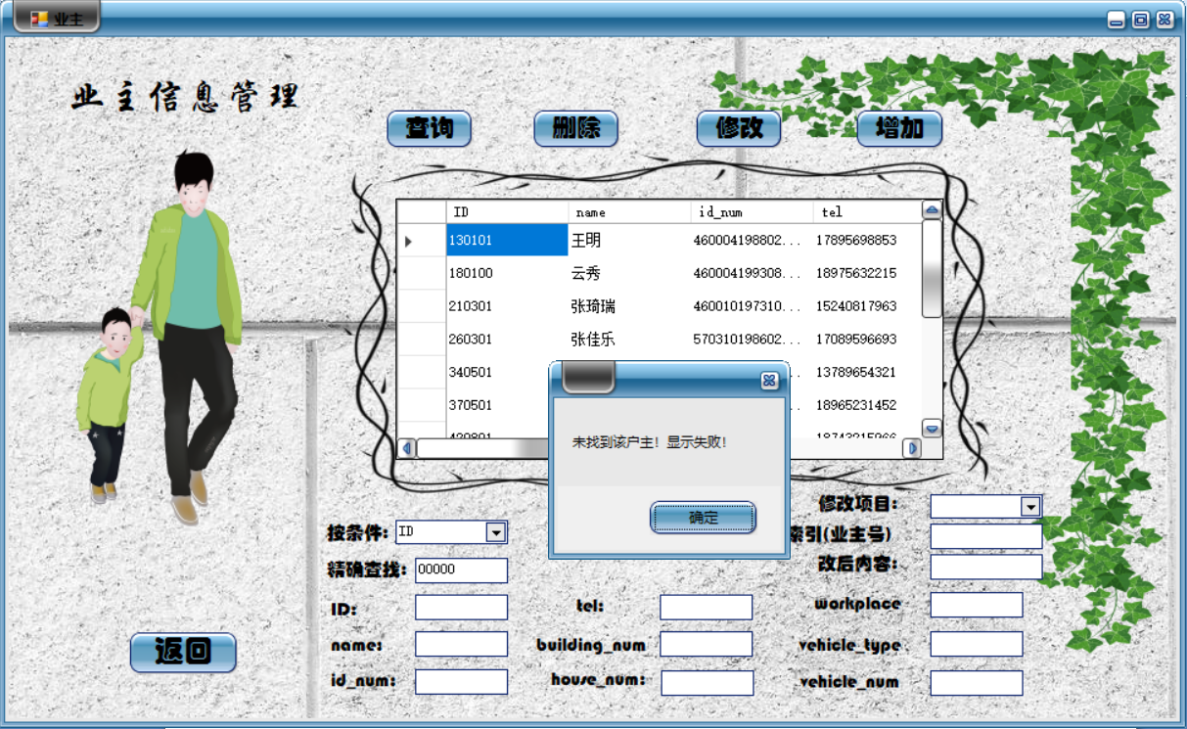

修改业主号0000的业主姓名，但是他也不存在于数据库中，修改失败了：

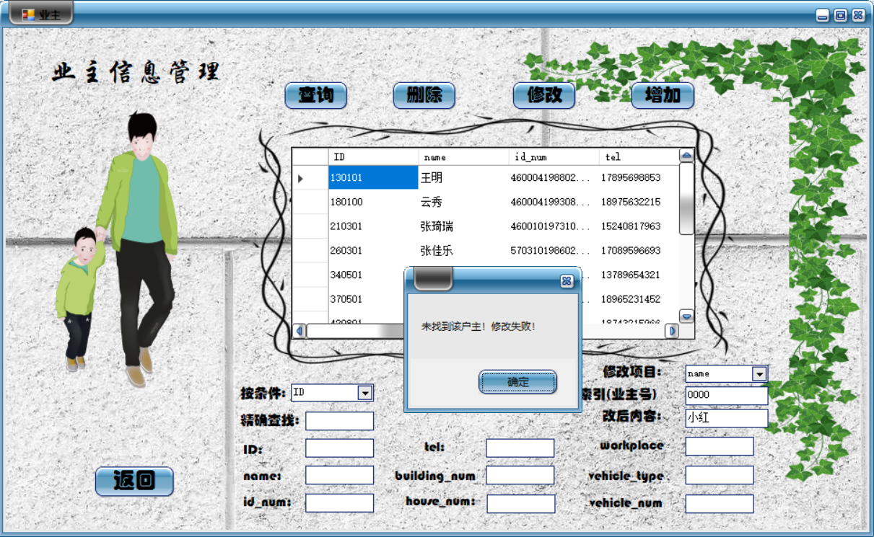

九、总结

**9.1系统优点**

我对我自己设计的这个物业管理系统还是挺满意的，原因有以下几条：

1. 界面美观：我打听了一下，班里很多同学用的是php\html来做的界面，C#与VS的合作来绘制窗体做界面还是班里面一个同学推荐给我用的，我一开始以为我的这个方法可能没有他们PHP做的美观，但是事实却出乎我意料。原来C#做窗体挺方便的，而且控件的拖拽绘制也很容易上手。我的界面相信必然是美观的，毕竟我很用心地上网找了好多壁纸背景素材以及透明背景的剪贴画，就是想打造出一个界面美观有趣的物业管理系统。而且我有一个相信是与其他也是用了C#绘制界面的同学不同的地方在于——我自己下载了皮肤插件，并且下载了皮肤，运行起来也能看到我的窗体边框按钮皮肤颜色都很漂亮啦。
2. 功能有新意：我是做的物业管理系统没错，可是有一天我突发奇想：既然是物业管理系统，何不增加一个地图功能呢？当初正处于界面设计入手阶段，什么创意都挺有心去实现的。我熬夜了一个晚上，查看了别人的基于VS与C#绘制窗体的地图实现，并且查了好多合并不同解决方案窗体的方法，终于实现了这个功能。有意思的是，这是个仿百度地图，具有测绘功能，通过鼠标滚轮可实现地图的放大缩小。虽然这个地图并不是我绘制的，而是我从网站上下载下来的素材，但实现了这个功能我是很开心的。
3. 异常基本都有处理，基本功能都得以实现。

**9.2系统不足**

任何事物都不会是十全十美的，就更不用说我的这个物业管理系统了。

1. 每个表之间的联系还不是很大，没有彻底地优化系统使用者的工作量。例如：在业主信息管理中新增加了一个业主的有关信息时，其余表跟这个新业主有关的可直接得的信息还需要该用户再次手动输入。
2. 在textBox太多的情况下，查询相关的、修改相关的、添加相关的选项栏与输入信息栏没有很好的划分区域，太过于集中于某一处，有时用户会填错地方。
3. 各信息管理添加成功后没有报有关信息“添加成功”。
4. 完成一个基本功能后，除了“删除”，其他功能没有在执行后立即在datagridview中显示完成有关操作后新的数据内容。
5. 窗体的大小还不够一致，比如我的登录界面，一开始并不是打开后就窗体最大化的，但是我增加了滚动文字就这样了，也不会改……
6. 不同按钮按下后窗体显示的位置不够一致。
7. 最开始最严重的问题——异常没处理好。

**9.3系统改进**

目前也就解决了异常的问题。具体的见八。

**9.4经验与收获**

数据库的课程设计我前前后后的时间累加在一起也大约有两周，这个过程中的百般滋味也是只有我自己才能体会到的，这个课程设计里面所涉及到的相关知识也是只有我真真切切动手实践了才能收获到的。我见识到了数据库设计从理论跨越到时间的难度，也更加深刻地明白了“道虽学不行不至，事虽小不为不成”的这样一个道理。

在这个物业管理系统的设计和实现过程中，我更加深刻的了解了一个相对成熟的系统的开发流程，也意识到了前期准备和学会网上搜罗资源与借助网络论坛与他人交流分析并解决问题的重要性。并且，通过对C#语言的使用以及基于VS的窗体开发设计，我更加认识到了这一个方法进行界面设计的方便与快捷之处，并且在设计与实现的过程中我遇上形形色色的问题，我都通过网上查找相关的问题并且看大神如何指教的也自己去解决好了它们，这一系列的操作也让我开启了一个新的技能点吧！

当然，由于时间的限制，本次课程设计我制作的系统还是有不够好的地方的，我在“系统缺点”里也一一分析了，所以在之后我有空了可能会把它拿出来再好好地优化它，相信后期学习的东西多了，优化的程度也会更上一个档次的。

附：参考文献、网络资料

1. Abraham Silberschatz,Henry F.Korth，《数据库系统概念》，机械工业出版社
2. 
3. 
4. 
5. 
6. 
7. 
8. 
9. 
10. 
11. 